[](http://www.google.be/url?sa=i&rct=j&q=&esrc=s&source=images&cd=&cad=rja&docid=kBNcEOi-HWY42M&tbnid=IqmYvrjKP1o8hM:&ved=0CAUQjRw&url=http://www.europeanshoulderconference.ugent.be/venue.html&ei=SzOxUsWKAuWg0QX83YF4&bvm=bv.58187178,d.bGQ&psig=AFQjCNH0umYUz46DU3SobK8e7yCpEjBKcQ&ust=1387431089413689)

Eindverslag Ingenieursproject Informatica

Een escape game ontwerpen

A Tale of Crimson

door

groep 4

Bryan Van Huyneghem   
Simon Van den Bossche

Michiel Mortier

Robbe De Bisschop

Arthur Casteels

Coach: Ann Van Overberghe

Universiteit Gent  
Faculteit Ingenieurswetenschappen en architectuur  
Opleiding Industriële wetenschappen   
Academiejaar 2015-2016

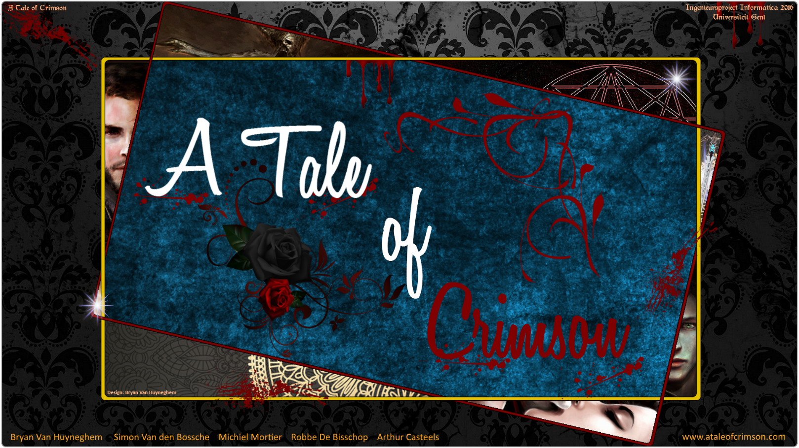

**“If you know the enemy and know yourself, you need not fear the result of a hundred battles.**

**If you know yourself but not the enemy, for every victory gained you will also suffer a defeat.**

**If you know neither the enemy nor yourself, you will succumb in every battle.”**

**― Sun Tzu, The Art of War**

Inhoudsopgave

Lijst figuren en/of lijst met tabellen 6

Lijst met symbolen en verklarende woordenlijst 7

Inleiding 8

1. De escape game 9

1.1 Wat is een escape game? 9

1.2 Een origineel concept 9

1.3 De eerste stappen 9

1.4 Implementatie van het concept in de game 10

1.5 De inventory 13

1.6 Optionele en verplichte stappen 14

2. Het verhaal 15

2.1 Een verhaal uit duizenden 15

2.2 Een korte inleiding tot het verhaal 17

3. Zoom op de code 18

3.1 Leren werken met Processing 18

3.2 Orde en structuur binnen de code 19

3.2.1 Het gebruik van classes 19

3.2.2 Het gebruik van de switch en cases 19

3.3 Functionele code 21

3.3.1 Het verzamelen van objecten 21

3.3.2 De inventory 21

3.3.3 Jump scares 21

4. Samenwerking binnen en buiten de groep 22

4.1 Samenwerking is een onmisbaar onderdeel van succes 22

4.2 Communicatietools 23

4.3 Logboeken behouden een globaal overzicht 24

4.4 Overleg met de coach 24

5. De website als handleiding 25

Conclusie 27

Referenties 28

Bijlage 1: Scan tussentijds verslag ingenieursproject informatica 40

Bijlage 2: Reflectie over de Belbintest 44

Bijlage 3: Onderteken verslag voor akkoord d.d. 12/05/2016 46

Bijlage 4: Het verhaal (Lore books) 47

Bijlage 5: Note to self 78

Bijlage 6: War notes 79

Bijlage 7: Diary entries 81

Bijlage 8: Guide 85

Bijlage 9: Instructions 91

Bijlage 10: Manual 94

Bijlage 11: UML diagrammen 117

Bijlage 12: PowerPoint presentatie (slides) 122

# Lijst figuren en/of lijst met tabellen

|  |  |  |
| --- | --- | --- |
| Figuur | Pagina | Beschrijving |
| Figuur 1 | 10 | De eerste kamer, The Observatory, in het herenhuis |
| Figuur 2 | 11 | De kamerstructuur van “A Tale of Crimson” |
| Figuur 3 | 12 | Het selectiemenu voor de moeilijkheidsgraad |
| Figuur 4 | 13 | De inventory vervult meerdere rollen |
| Figuur 5 | 14 | De achievements |
| Figuur 6 | 15 | Bovenaan: Eden; linksonder: Olivia; rechtsonder: Crimson |
| Figuur 7 | 16 | Links: een Diary entry; rechts: een War note |
| Figuur 8 | 18 | Het vertrouwde scherm van de programmeeromgeving Processing |
| Figuur 9 | 20 | De switch in de main class |
| Figuur 10 | 20 | Het gebruik van cases in de methode showText |
| Figuur 11 | 20 | Rechts timer2 en links timer1 |
| Figuur 12 | 21 | Het principe van een jump scare |
| Figuur 13 | 23 | Overzicht van de rootmap op de Google Drive |
| Figuur 14 | 26 | De website als fundering van de game |

# Lijst met symbolen en verklarende woordenlijst

|  |  |
| --- | --- |
| **Broncode** | De broncode of *source code* van een computerprogramma is de leesbare tekst die door een programmeur in een *tekst editor* (hier: Processing) in een welbepaalde programmeertaal is geschreven. Deze code wordt vervolgens gecompileerd met een *compiler* die deze broncode omzet naar machine code. Deze laatste is binaire code die de computer kan begrijpen. (source code, 2015) |
| **IDE** | Integrated development environment |
| **Processing** | Processing is een IDE die gebruikt wordt om code in te schrijven en deze onmiddellijk te visualiseren. Het biedt de mogelijkheid om de fundamenten van het programmeren in Java binnen een visuele context te leren. |
| **Greenfoot** | Greenfoot is een IDE waarmee coderen in de lessen Informatica I werd aangeleerd. Het is een introductie tot het programmeren met Java. |
| **Java** | Java is de objectgeöriënteerde programmeertaal waarin de game is geschreven. Java is onafhankelijk van het besturingssysteem (Windows, Unix, Mac OS X etc.) waarop het draait, wat wil zeggen dat de programmeertaal op eender welke computer gebruikt kan worden. |
| **Lovecraft Manor** | Het herenhuis waarin het verhaal zich afspeelt. |
| **Minigames** | Kleine spelen binnen de game die deze uitdagender maken. Een voorbeeld hiervan is de *shuffle puzzle*. |
| **Constructor** | Een constructor initialiseert de data van een object. |
| **Millis** | Dit is de afkorting voor milliseconden. |

# Inleiding

In dit verslag zal toegelicht worden hoe het ingenieursproject informatica, met als doel het ontwikkelen van een *escape game*, verwezenlijkt werd. De leden van groep vier, namelijk Bryan Van Huyneghem, Simon Van den Bossche, Michiel Mortier, Robbe De Bisschop en Arthur Casteels gingen deze uitdaging met veel plezier aan. De richtlijnen in verband met de benodigde tijd voor het afwerken van het project lagen rond een 90-tal uur, maar deze tijd werd in grote mate overschreden.

De inhoud van het project zal in de corpus van het verslag uitgebreid besproken worden. Eerst wordt uitleg gegeven over wat een escape game precies inhoudt en wat de streefdoelen en initiële, prangende vragen van de groep precies waren. Het woord *immersion* of onderdompeling zal hierin een sleutelrol vervullen en verschillende keren gedurende de beschrijving van het project aan bod komen. Uit verscheidene brainstormsessies kwam een concept voort dat vandaag de titel *A Tale of Crimson* draagt.

Vervolgens zal een verklaring worden gegeven voor de keuze om een verhaal aan de game te linken en wordt de inhoud van dit verhaal toegelicht. De verschillende concepten en ideeën van de game werden dankzij het programmeren met *Java* een realiteit. In het onderdeel *Zoom op de code* wordt in een eerste partim verteld hoe de leden met het gebruikte programma *Processing* hebben leren werken en hoe de code tot stand is gekomen. In twee daaropvolgende partims wordt een blik geworpen op de Javacode en worden in het bijzonder enkele methodes behandeld. Ter verduidelijking van de verklarende tekst worden hier enkele voorbeelden geïllustreerd aan de hand van *snippets* uit de broncode.

Hierna wordt een toelichting gegeven over de samenwerking binnen de groep. Een groepsproject kan pas succesvol zijn indien er een gezonde samenwerking bestaat. In dit onderdeel wordt verklaard waarom goede samenwerking en communicatie zo essentieel zijn en hoe het overleg met de coach verliep.

Een laatste onderdeel behandelt de website die voor dit project werd ontwikkeld. Deze website is de basis of “fundering” van de game. Hij dient zowel voor het publiceren van de game over het hele web, als voor het ter beschikking stellen van de achtergrond en essentiële informatie van de game.

# De escape game

## Wat is een escape game?

*A Tale of Crimson* behoort tot het genre *escape games*. Een escape game is een game waarin de speler moet trachten ontsnappen uit een huis, een kamer of een welbepaalde ruimte. In vele gevallen voorzien de ontwikkelaars van dit soort games ook een timer met als functie een extra druk te leggen op de speler. Het oplossen van raadsels en puzzels, en het verzamelen van objecten die de speler kunnen helpen zijn missie tot een goed einde te brengen, zijn slechts enkele voorbeelden van concepten die binnen de ontwikkeling van een escape game centraal staan.

## Een origineel concept

De opdracht “Ontwerp een escape game” bracht een aantal prangende vragen met zich mee die in dit hoofdstuk verduidelijkt zullen worden. In het prille begin vonden verscheidene brainstormsessies plaatst die antwoorden moesten trachten bieden op deze vragen. Allereerst werd beslist om de escape game van een extra “dimensie” te voorzien, om zo de originaliteit van dit project te bevorderen.

Wat *A Tale of Crimson* in vergelijking met zijn broers en zussen zo uniek maakt, is dat achter de game een heus en diepgaand verhaal verborgen zit. De bedoeling van zo’n verhaal is om de speler volledig onder te dompelen in de plotlijnen, mythes en epische legendes, en zo een gevoel van identificatie te scheppen tussen de speler en het personage – of in bredere zin de game. Dankzij deze extra dimensie geeft het de speler een *immersive* *effect*, wat letterlijk onderdompelend effect betekent. Bovendien roept dit betrokkenheid en nieuwsgierigheid op bij de speler. Het geeft betekenis aan de reden waarom de speler moet pogen te ontsnappen, wat een cruciaal element in de escape game is.

Het project kan in zijn totaalbeeld vergeleken worden met het lichaam van de mens. Het verhaal wordt beschouwd als zijnde het weefsel of de huid; de *IDE*, *Processing*, is het skelet dat zorgt voor de ondersteuning en stabiliteit; en de code vervult de rol van de vitale organen. De verschillende uitdagingen en transities gedurende de game zijn niets meer dan de bloedbanen en zenuwen die alle delen met elkaar verbinden en het geheel optimaal laat functioneren.

## De eerste stappen

Alvorens het programmeren van de game en het schrijven van het verhaal, kwam de groep samen om te brainstormen over een eerste prangende vraag, nl. het thema van de game. Al snel werd duidelijk dat de game een psychologische thriller zou worden die het concept van de escape game tot het uiterste zou gaan drijven. Aan de hand van dit gekozen thema werd het verhaal uitgewerkt tot een kladversie en werd een omgeving, om dit verhaal tot leven in te laten komen, gecreëerd. Onder de vorm van *Lore books*, *War notes* en *Diary entries*, welke te verzamelen zijn doorheen de game, kan de speler de rijke geschiedenis van dit verhaal ervaren. Muziek en muziekeffecten zouden pas later een centrale rol spelen, dit gedurende de verfijningsfase.

Een tweede vraag stelde zich toen er een keuze moest worden gemaakt tussen 2D of 3D. De keuze om deze game tweedimensionaal te maken kwam voort uit het feit dat een driedimensionale game niet te realiseren viel met de huidige kennis van het ontwikkelingsteam. Hiervoor beschikten de groepsleden over te weinig ervaring en kennis van programmeren met Java in de IDE Processing.

Een derde, initiële vraag die voorlopig nog onbeantwoord zou blijven, omvatte de keuze om al dan niet de optie *fullscreen* te voorzien in de game.

## Implementatie van het concept in de game

*A Tale of Crimson* speelt zich af in het vijftiende-eeuwse Engeland en wordt verrijkt door de geschiedenis van fictieve en non-fictieve personages uit het oosten van Europa. Hun verhalen zijn ook onlosmakelijk verbonden met *A* *Tale of Crimson*. Wanneer de speler het spel start, bevindt hij zich in de eerste kamer van het herenhuis *Lovecraft Manor*. Deze kamer is weergegeven in Figuur 1.

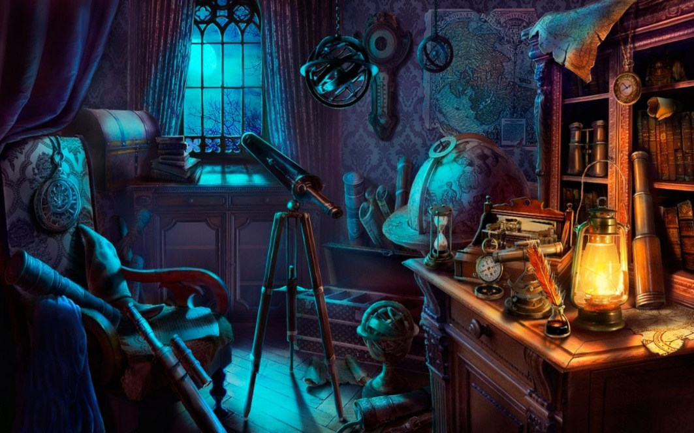

Figuur 1: de eerste kamer, *The Observatory*, in het herenhuis

De kamers in dit herenhuis worden met behulp van afbeeldingen gevisualiseerd, wat van dit computerspel een 2D-game maakt. Een voordeel van deze 2D-weergave is dat de speler het spel door de ogen van het hoofdpersonage ziet en dit een onderdompelend effect creëert voor de speler.

De speler kan zich doorheen het herenhuis verplaatsen door gebruik te maken van de muis. Dit doet hij door op de verbindingswegen (deuren, ladders, pijlen etc.) tussen de verschillende kamers van het herenhuis te klikken. Wanneer een verbinding tussen twee kamers beschikbaar is of beschikbaar is geworden, wordt dit zo goed als altijd in het spel vermeld of aangeduid. Sommige kamers zijn enkel beschikbaar wanneer er een zekere progressie binnen de game is gemaakt. Deze voortgang vloeit voort uit het aantal uitdagingen die door de speler werden getrotseerd en opgelost. Het voltooien van puzzels en raadsels betekent voor de speler het ontsluiten van nieuwe omgevingen en *content* of inhoud.

De kamerstructuur van het herenhuis Lovecraft Manor, die op Figuur 2 te zien is, alsook het verloop van de game, zijn beide niet lineair. Dit betekent dat de game niet in één vlotte beweging of lijn kan worden uitgespeeld. De meeste kamers hebben doorgaans meer dan twee verbindingen met andere kamers, wat de speler verplicht om naar reeds bezochte kamers terug te keren en met nieuwe objecten nieuwe ruimtes of uitdagingen te ontsluiten. De notaties boven de pijlen wijzen op de connecties tussen de verschillende kamers en visualiseren de complexiteit van de game.

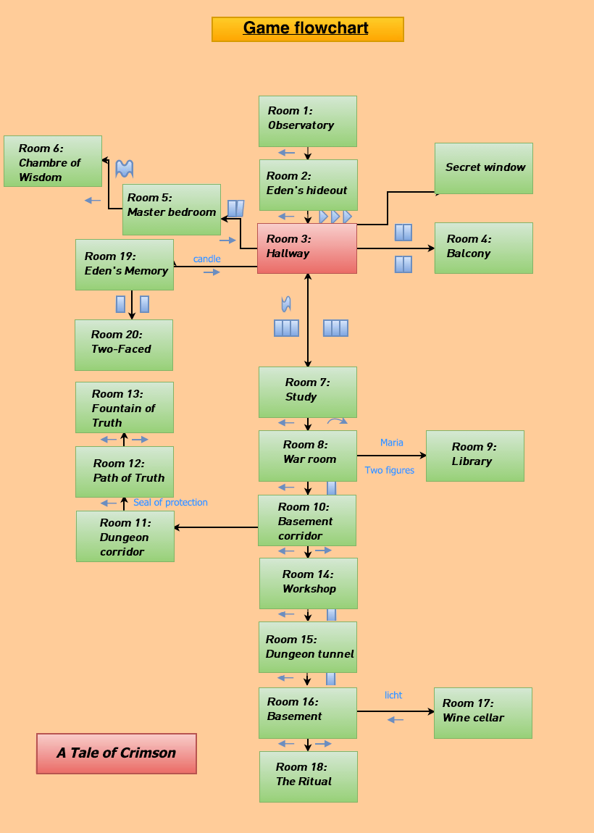

Figuur 2: de kamerstructuur van “A Tale of Crimson”

De speler kan op een aantal uitdagende manieren vooruitgang boeken doorheen de game. Enerzijds kan dit gerealiseerd worden door verscheidene objecten te verzamelen of door kennis vanuit zijn onmiddellijke omgeving op te doen. Anderzijds kan dit gerealiseerd worden door enkele *minigames* en raadsels op te lossen. Naargelang de moeilijkheidsgraad die aan het begin van de game geselecteerd werd door de speler, zullen al dan niet hints aanwezig zijn om een helpende hand te verschaffen bij het oplossen van de moeilijke opdrachten. Deze hints geven de speler extra informatie over de respectievelijke kamer: wat er in deze kamer moet gebeuren en waar bepaalde objecten zich kunnen bevinden binnen deze kamer. Zoals eerder vermeld, zijn deze hints enkel beschikbaar indien de speler voor de moeilijkheidsgraad *novice* koos.

Deze graad is een van de drie beschikbare graden en tevens ook de eenvoudigste. Novice *difficulty* wordt vooral aangeraden voor nieuwe spelers (beginners) of ongeduldige gamers die eerder geïnteresseerd zijn in het uitspelen van de game of lezen van het verhaal. Wanneer alle essentiële handelingen binnen een kamer uitgevoerd worden door de speler, verschijnt een notificatie op het scherm. Dit laat de speler weten dat de respectievelijke room *cleared* of volledig uitgespeeld is.

De twee andere moeilijkheidsgraden die beschikbaar zijn, zijn in stijgende volgorde van moeilijkheid *Seasoned gamer* en *Hardcore*. In deze twee gevallen zijn de eerder vermeldde hints niet beschikbaar. Indien de speler de keuze gemaakt heeft om op Hardcore te spelen, verdwijnt ook de notificatie *cleared* uit de game. De speler staat er in deze modus moederziel alleen voor en moeten alles zelf trachten uit te vissen. Het selectiemenu voor de moeilijkheid van de game wordt weergegeven in Figuur 3.

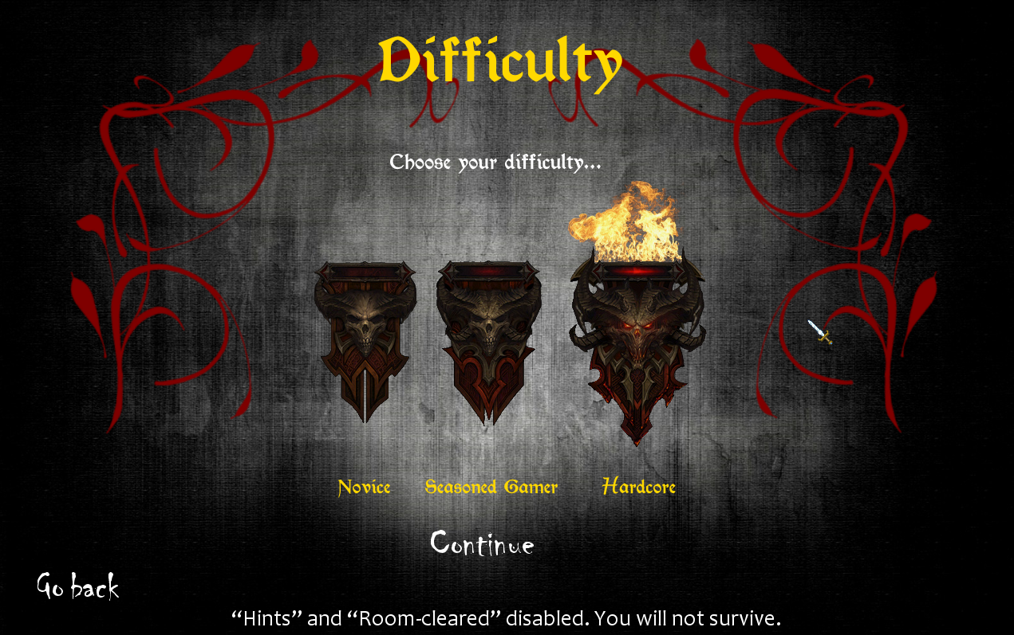

Figuur 3: het selectiemenu voor de moeilijkheidsgraad

Ongeacht de moeilijkheidsgraad waarop de speler besluit te spelen, is er gedurende de game een *timer* actief die ingesteld staat op twee uur en begint af te lopen van zodra de speler zich in *Lovecraft Manor* bevindt. Dit tijdslimiet is in de game geïmplementeerd met als doel een zekere druk op de schouders van de speler te leggen, wat hand in hand gaat met het aspect dat zorgt voor een intensere ervaring van de game. Wanneer de tijd om is, wordt de game beëindigd en verliest de speler – hij sterft.

## De inventory

Het succes van een game berust naast de immersion en de structuur ook op het behoud van overzicht. Hiermee wordt bedoeld dat de speler te alle tijde in staat moet zijn om zijn progressie te volgen. De *inventory* laat dit toe en betreft bijgevolg een sleutelfunctie in de game.

De inventory vervult in *A Tale of Crimson* verscheidene rollen. Het is een overzicht van alle verzamelde objecten, alsook de toegangspoort naar de boeken die alle geschreven teksten (zoals het verhaal) bevatten. Daarnaast zijn ook twee knoppen aanwezig die zowel de bekeken portretten, dewelke een bepaalde functie binnen het spel vervullen en ook een achievement ontsluiten, als de achievements weergeven. Figuur 4 is een voorbeeld van de inventory van een speler gedurende het spelen van de game.

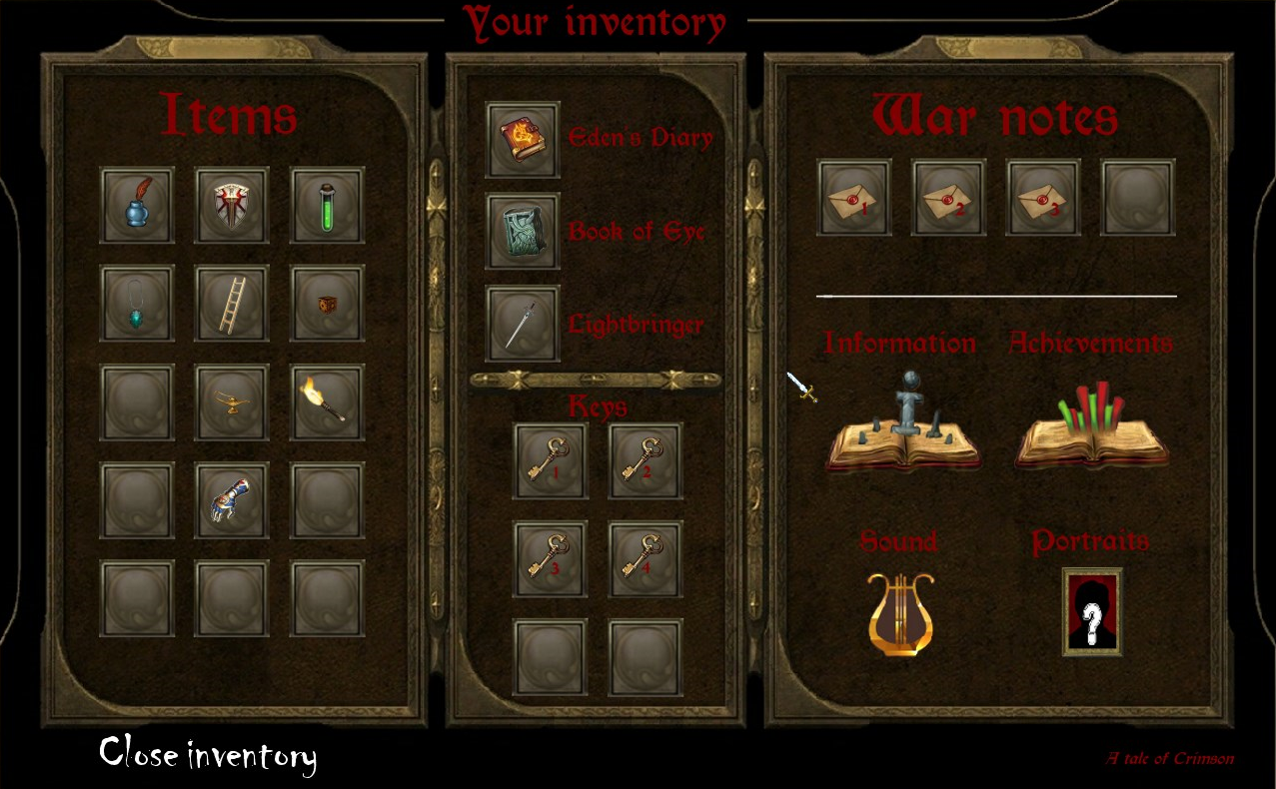

Figuur 4: de inventory vervult meerdere rollen

## Optionele en verplichte stappen

De dynamiek van een game komt pas echt tot leven wanneer er *features* of speciale kenmerken aanwezig zijn die niet per se voltooid hoeven te worden om de game tot een goed einde te brengen. Aan de hand van *achievements* of verwezenlijkingen wordt de speler gestimuleerd om actief op zoek te gaan naar verborgen documenten die het verhaal vertellen (Lore books), sleutels, War notes, een *Pyre* (of demon) etc.

Het behalen van deze achievements resulteert in het ontsluiten van een icoon dat respectievelijk bij de verwezenlijking hoort en voorziet de speler van extra punten in de *hiscores* of topscore. Deze hiscores, welke op het einde van de game worden weergegeven, worden berekend per formule (1) en zijn een manier om competitiviteit aan te moedigen onder de spelers. In Figuur 5 zijn de achievements te zien zoals ze beschikbaar zijn in de inventory.

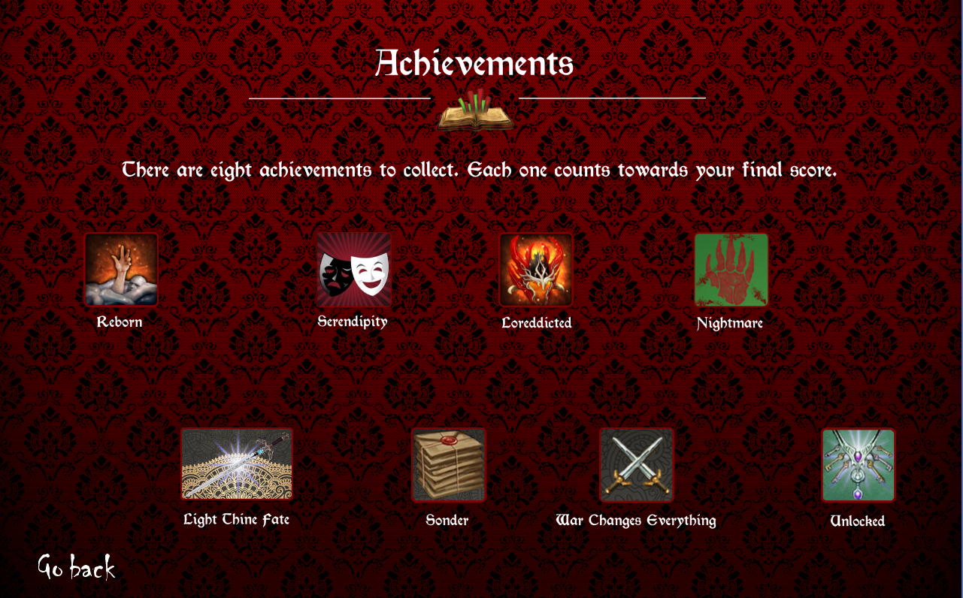

Figuur 5: de achievements

$Hs=\left(100∙timeLeft\right)+n∙(a_{1}+a_{2}+a_{3}+a_{4}+a_{5}+a_{6}+a_{7}+a_{8})$ (1)

*met*

$timeLeft=aantalUren∙100+\frac{aantalMinuten ∙ 100}{60}+\frac{aantalSeconden}{60}$

$n=aantalAchievementsUnlocked$

* $a_{1} t.e.m. a_{8}$ de acht achievements en punten voor de achievements:
* Achievement 1: 1000 punten; Achievement 2: 1000 punten; Achievement 3: 1500 punten; Achievement 4: 1000 punten; Achievement 5: 2500 punten; Achievement 6: 1500 punten; Achievement 7: 1500 punten; Achievement 8: 3000 punten.

# Het verhaal

## Een verhaal uit duizenden

Zoals in *1.2 Een origineel concept* reeds vermeld werd, onderscheidt *A Tale of Crimson* zich in grote mate van de gewone escape game dankzij het bijzondere verhaal. De bedoeling van zo’n verhaal is om een speler volledig onder te dompelen in de game of dus immersion te creëren. Bovendien roept dit betrokkenheid en nieuwsgierigheid op bij de spelers en geeft het betekenis aan de reden waarom de speler moet proberen ontsnappen. Dit laatste is een cruciaal element in de succesvolle escape game.

Het schrijven van een verhaal genereert heel wat obstakels die de schrijver moet proberen te overbruggen. De meest voorkomende problemen waren chronologie, logicafouten en personageontwikkeling. Alhoewel het vanaf het begin duidelijk was dat een aantal personages, zoals Eden, Olivia en Crimson (zie Figuur 6), zeker zouden verschijnen in het verhaal, werden deze gedurende de schrijfsessies verder uitgediept. Zij leerden ook nieuwe personages kennen, die elk op hun beurt een verhaal te vertellen hadden. Hierbij moet het generieke schrijven van deze achtergrondinformatie te alle tijde vermeden worden en moet steeds gestreefd worden naar een originele implementatie van de informatie die de nieuwe personages schetsen.

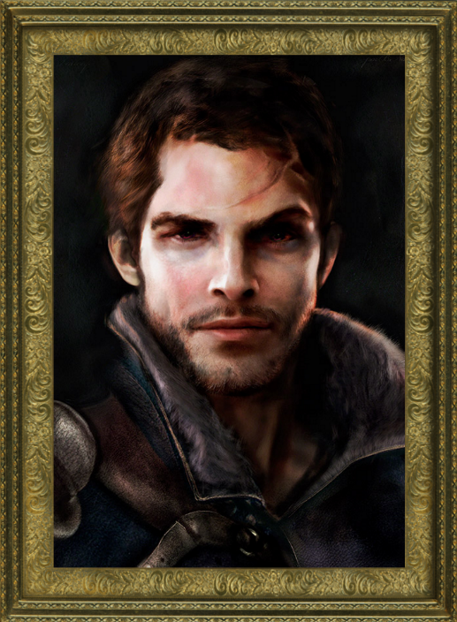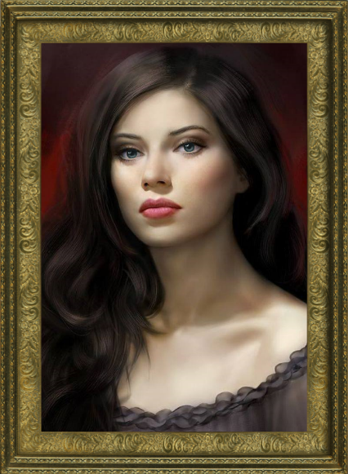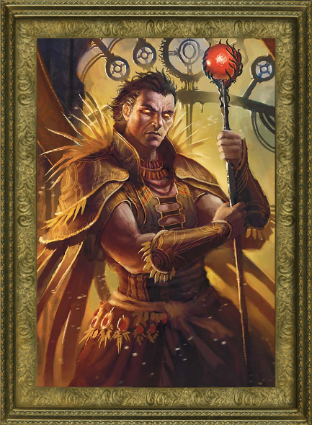

Figuur 6: bovenaan: Eden; linksonder: Olivia; rechtsonder: Crimson

Een ander probleem dat zich voordeed, was de complexiteit van de taal. Een eerste partim van deze complexiteit stelde dat het verhaal initieel geen dialogen zou bevatten en slechts op letterlijk verhalende wijze de inhoud zou overbrengen. Al snel werd duidelijk dat dit bijzonder moeilijk was om vol te houden en werd er toch naar dialogen overgegaan in combinatie met proza. Dit liet de schrijver toe om veel creatiever om te gaan met het schrijven van de inhoud.

In een tweede partim is de complexiteit van de taal letterlijk te nemen. Het verhaal werd geschreven in het Engels door een lid die tevens leerkracht Engels en Nederlands is. Hij had reeds ervaring met het schrijven van proza en poëzie, maar het continu aanhouden van een diversiteit in woordenschat en zinsbouw en –constructie bleef gedurende alle schrijfsessies een steeds evoluerende uitdaging.

Desalniettemin was het verhaal een creatieve uitlaatklep die bovendien zeer veel van de ideeën die in de game zijn geïmplementeerd, heeft helpen realiseren tot concepten die potentiële kandidaten waren om in de game voor te komen. Te alle tijde moest de schrijver bereid zijn en durf tonen om stukken tekst te schrappen die niet helemaal naar wens waren. In vele gevallen boden herwerkte varianten van deze stukken tekst een algemene oplossing.

Verder bood het opstellen van een tijdslijn een oplossing voor de chronologieproblemen. Dit betekende dat voorvallen, overlijdens, geboorten, belangrijke gebeurtenissen etc. overzichtelijk konden worden geraadpleegd zonder het verhaal te hoeven doorzoeken en opnieuw in elkaar te proberen puzzelen.

Het verhaal *A Tale of Crimson* kan geraadpleegd worden in Bijlage 4. In de game werd dit verhaal ingevoegd onder de vorm van Lore books. Extra informatie zoals persoonlijke brieven, wat eigenlijk aparte, korten teksten zijn die wat achtergrond schetsen over de persoonlijke belevingen van het hoofdpersonage Eden, werden in de game geïmplementeerd onder de vorm van Diary entries en War notes. Een voorbeeld van een Diary entry en een War note is te zien in Figuur 7. Alle War notes en Diary entries kunnen respectievelijk in Bijlagen 6 en 7 gelezen worden.

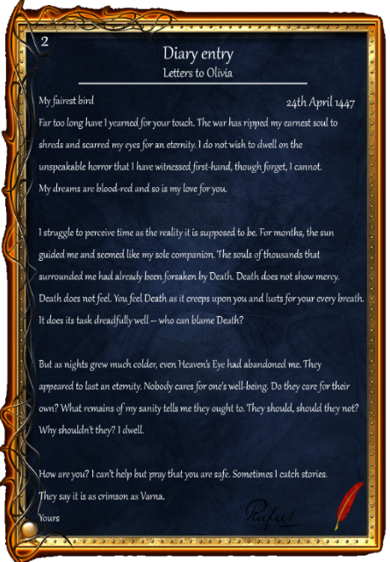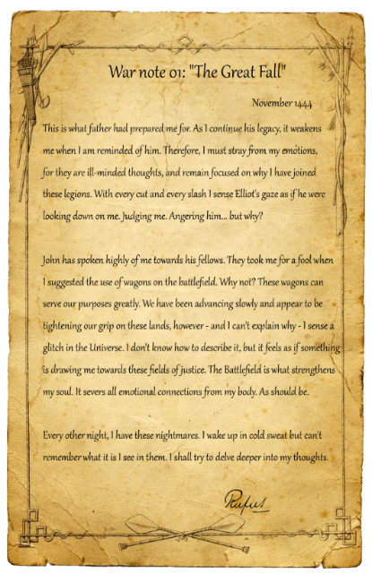

Figuur 7: links: een Diary entry; rechts: een War note

## Een korte inleiding tot het verhaal

Ter illustratie volgt nu een korte inleiding tot het verhaal *A Tale of Crimson* die dient om lezers warm te maken voor de game en het verhaal.

*“Escape games. Ontsnappen. Het hoofd. De gedachten.*

*Marcus Aetherius maakt met het zwaard Lightbringer een einde aan het bestaan van de Pyre Malice Crimson. Een laatste schokgolf, uitgezonden door Crimson, doodt alles wat zich rondom hem bevindt. Maar is dit wel het einde van Crimson? Elders op deze wereld wordt op datzelfde moment Eden geboren.*

*We schrijven met onze veerpennen 1442, achttien jaar na deze gebeurtenissen. Lucius, de vader van de achttienjarige Eden sterft. Eden besluit Engeland achter zich te laten en zijn geluk te zoeken in het Oostelijke deel van het Oost-Romeinse Rijk. Daar komt hij terecht onder de hoede van John Hunyadi, aanvoerder van de Christelijke legers die tegen de invallende Ottomanen strijden.*

*Hij leert er ook Olivia kennen die snel het slachtoffer zou gaan worden van de vijand. Er zijn hier hogere machten aan het werk en Eden besluit zich bij de rangen van The Order of Fellows te voegen – een groep elite strijders en diplomaten die meesters zijn in The Arts of War. Zij strijden tegen het kwade en sturen Eden erop uit om een einde te maken aan de Djinn Sultan Murad, aanvoerder van de Ottomanen.*

*Eden keert pas jaren later terug. Gek. Vol nachtmerries. Wat is er precies gebeurd? Waar is Olivia? En hoe is Crimson kunnen terugkeren?*

*We schrijven nu het jaar 1463. Eden is terug in Engeland in zijn herenhuis “Lovecraft Manor” om met zichzelf en met Crimson af te rekenen.*

*Of het einde al dan niet goed afloopt, hangt volledig van de speler af. Weet alleen dat wanneer je als speler doorheen het huis wandelt, je eigenlijk ook de herinneringen en gedachten van Eden aan het bekijken bent. Dit is de werkelijke, psychologische thriller van een escape game.”*

# Zoom op de code

## Leren werken met Processing

Een eerste moeilijkheid waarmee de groep geconfronteerd werd, was de volledig onbekende software en programmeeromgeving Processing. Bij aanvang van het project werden nog maar net de eerste stappen in het programmeren met *Greenfoot* gezet, waardoor de toenmalige kennis over het coderen en programmeren in Java in het algemeen vrij gering was. Greenfoot is een sterk vereenvoudigde versie van Java die extra klassen, methodes, grafische elementen etc. aanbiedt aan de gebruiker.

Net zoals Greenfoot is ook Processing gebaseerd op Java. Processing is dus in zekere mate vergelijkbaar met Greenfoot, maar het comfort dat de programmeur heeft bij Greenfoot verdwijnt wat bij Processing, daar deze meer aanleunt bij ‘echte’ Javacode. Kortom, Processing kan gezien worden als een schakel tussen Greenfoot en Java. In figuur 8 is een afbeelding van deze programmeeromgeving weergegeven.

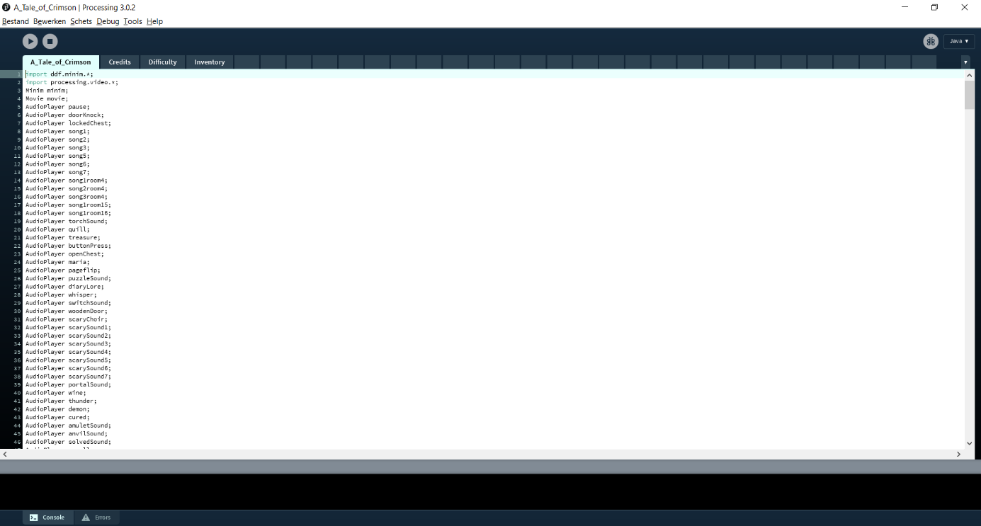

Figuur 8: het vertrouwde scherm van de programmeeromgeving Processing

Aangezien Processing dus qua moeilijkheidsgraad boven Greenfoot komt te staan, verliepen de eerste stappen van het coderen in deze nieuwe omgeving erg moeizaam. Er werd besloten een boek aan te kopen, om zo deze belemmering te overbruggen, namelijk *Learning Processing* (Shiffman, 2015) door Daniel Shiffman.

Dit boek is ook verbonden met een website waar allerhande video’s en voorbeelden geraadpleegd kunnen worden om met Processing aan de slag te gaan (Processing, 2001). Zowel het boek als de bijhorende video’s hebben gezorgd voor de eerste, succesvolle stappen naar het programmeren in Processing. De volgende stappen bestonden erin een eerste prototype van een kamer te ontwikkelen. Hierbij was het idee dat eens er een eerste voorbeeldkamer zou zijn ontwikkeld, de basiscode naar analogie ook zou kunnen worden toegepast in een andere kamer. De referentielijst van Processing, die alle commando’s bevat, was hierbij ook een grote hulp (Processing Reference, 2001). Week na week ontwikkelden alle groepsleden meer en meer inzicht en kunnen in Processing, waardoor de ervaring in het programmeren alsmaar steeg en uiteindelijk zou resulteren in de huidige versie van de game.

## Orde en structuur binnen de code

## Het gebruik van classes

Onmisbaar in een project zijn regelmaat en orde. Wanneer vijf leden van een groep moeten samenwerken aan één geheel, moet er gestreefd worden naar het vermijden van chaos.

Op vlak van code zorgde het gebruik van *classes* voor het ordentelijk houden van de code van de game. Elke kamer, alsook de *credits*, de *difficulty*, de *inventory*, de *pause menu*, de schilderijen en de puzzel, hebben hun eigen *class* met bijhorende, duidelijke naam. In elke klasse zijn een *constructor* en methodes aanwezig. Voorbeelden van deze methodes zijn roomLoad, keyCheck en showText. Elke klasse is terug te vinden een UML diagram in Bijlage 12. Per klasse zijn tevens elke boolean, int, String, constructor en methode weergegeven.

Er werd een template aangemaakt voor elke kamer die toelaat om code op een efficiënte manier te hergebruiken. Zo is de code in zijn geheel niet alleen goed gestructureerd, maar is het ook makkelijker voor derden, zijnde mensen die niet meegeholpen hebben aan het project, om deze code te lezen en te begrijpen. Het gebruik van commentaar tussen de code is een laatste, essentieel element wat de code helpt verduidelijken.

In alle klassen staan verder ook de te gebruiken *images*; *strings*, *booleans* en *variabelen* binnen elke klasse. In de constructor worden de images geladen, waarna in de methodes deze images, strings, booleans en variabelen gebruikt kunnen worden.

Naast alle klassen is er ook een *main class*, namelijk A Tale of Crimson. Deze klasse bevat alle algemene informatie, zoals de geluidsbestanden, de timer, de void setupen de void draw. In deze main class staan er, net zoals in de methode showText, *cases*.

## Het gebruik van de switch en cases

Een *switch* is een manier om lange *if…else* *statements* te vervangen. In de main class worden deze cases gebruikt om in elke *room* of kamer de methode roomLoad aan te roepen. De variabele kamer krijgt een waarde mee die refereert naar één van de cases. Op deze manier kan, wanneer de speler naar een andere kamer wil gaan, de methode roomLoad makkelijk aangehaald worden door de kamer (= naam case) te gebruiken. In de klassen van de kamers worden de cases gebruikt om tekst te laten verschijnen. Deze tekst wordt aangeroepen via loadText = “(naam case)”.

Figuur 9 toont de switch in de main class en Figuur 10 toont hoe de methode showText cases gebruikt worden om tekst weer te geven.

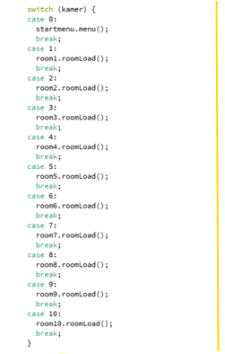

Figuur 9: de switch in de main class

Figuur 10: het gebruik van cases in de methode showText

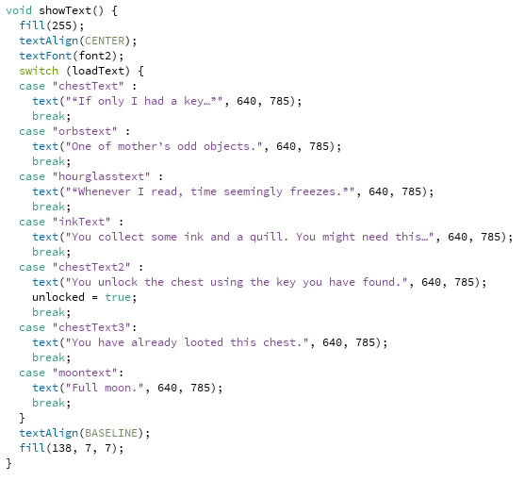

Wanneer er gedurende een aantal seconden tekst moet verschijnen op het scherm, wordt niet alleen gebruikgemaakt van de methode showText, maar ook van timers. Hier wordt dus niet alleen de methode loadText geschreven, maar ook de code *timer2 = millis()*. Dit laat de timer starten. Deze timer zal de tekst laten verschijnen gedurende vijf seconden. Daarnaast is er ook een *timer1* die de naam van kamer, gedurende zes seconden, laat opduiken telkenmale de speler een kamer binnenkomt. Deze twee essentiële timers worden geïllustreerd in Figuur 11.

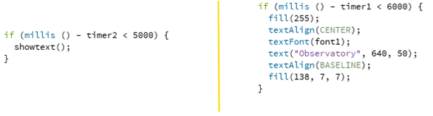

Figuur 11: rechts timer2 en links timer1

## Functionele code

## Het verzamelen van objecten

In een escape game moeten er objecten worden verzameld. In de methode keyCheck, welke terug te vinden is in elke kamer, staat het gebied waarin een object voorkomt onder de vorm van x- en y-waarden. Wanneer een speler in dat specifieke gebied klikt, zal dit object verdwijnen en toegevoegd worden aan de inventory.

## De inventory

Zoals in *1.5 De inventory* wordt verduidelijkt, is één van de functies van de inventaris om een overzicht te verkrijgen van alle verzamelde objecten. Indien de speler een object verzamelt, komt een boolean op true te staan die er vervolgens voor zorgt dat het object zichtbaar wordt in de inventory. Verder vindt de speler hier ook de achievements, de portretten, de War notes, de Lore books en de Diary entries, alsook de optie om de achtergrondmuziek te *(un)muten*.

## Jump scares

Het gebruik van *jump scares* is nog een voorbeeld van immersion. Ze hebben als doel het spel uitdagender en spannender te maken en worden veelvuldig gebruikt in *A Tale of Crimson*. Het principe van deze jump scares rust op het feit dat er *x* aantal keer gewisseld wordt tussen een zwarte achtergrond en een afbeelding die voor spanning moet zorgen. Tussen deze zwarte achtergrond en de afbeelding zitten een honderdtal milliseconden. Een codevoorbeeld is te zien in Figuur 12.

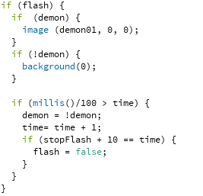

Figuur 12: het principe van een jump scare

In dit voorbeeld wordt dus tien keer gewisseld tussen een zwarte achtergrond en de afbeelding *demon01*. Wanneer de jump scare start, zal een variabele stopFlash gelijkgesteld worden aan de variabele tijd, die op zijn beurt gelijkgesteld wordt aan millis(). De millis()/100 is dus 0,1 seconde. Als de millis()/100 groter wordt dan 0,1 seconde, zal er gewisseld worden van afbeelding. Op deze manier zit er telkens 0,1 seconde tussen de afbeelding en de zwarte achtergrond en flitst de afbeelding als het ware *x* aantal keer als een *flashing image*.

# Samenwerking binnen en buiten de groep

## Samenwerking is een onmisbaar onderdeel van succes

Het creëren van een videogame vergt enige kennis met betrekking tot programmeren. Aan het begin van het project beschikten de leden van de groep hier nog niet in voldoende mate over. Elk lid leerde bij de aanvang van dit project zelfstandig met het programma Processing werken. Dit werd gerealiseerd door online *tutorials* te bekijken die expliciet het doel hebben om een amateur vertrouwd te maken met Processing. Daarnaast werd ook een boek aangekocht (cfr. *3.1 Leren werken met Processing*) om een efficiënt aan de slag te kunnen gaan met deze omgeving.

Eens elk lid over een zekere basiskennis beschikte, kon gestart worden met het programmeren. In de vroege stages van de game verliep dit vrij stroef, aangezien de online tutorials niet op alle vragen een antwoord kon bieden. Dit tekort aan informatie werd deels gecompenseerd dankzij het boek en deels opgevangen door de benodigde gegevens op het internet op te zoeken. Zo kon na enig googelen in vele gevallen toch een oplossing gevonden worden voor problemen i.v.m. code en features en werd de eigenlijke code geleidelijk aan verfijnd.

Een goede samenwerking binnen de groep kan enkel voortkomen uit een frequent onderhouden communicatie en duidelijke afspraken die op een respectabele tijd op voorhand worden vastgelegd. Een eerste manier van streven naar topsamenwerking was door wekelijkse bijeenkomsten te houden. De communicatieve vaardigheden van elk lid waren hierbij van onmisbaar belang en ondergingen tevens een merkbare verbetering in de loop van het project. Deze bijeenkomsten waren een goed moment om een stand van zaken op te stellen, wat inhield dat de leden hun progressie met elkaar deelden en bovendien in discussie konden treden met elkaar omtrent de game en zijn inhoud.

Aangezien het werken in groep niet evident is, werd binnen de groep iemand aangesteld om de leidinggevende functie in te vullen. Hij verzorgde de administratie en het uitdelen van opdrachten. Hij was tevens de persoon die de schakel was op communicatief vlak tussen alle leden. Dit zorgde voor een vlottere samenwerking en betere controle over taken die uitgevoerd moesten worden. De samenwerking van de groep rustte aldus op drie pijlers: transparantie, communicatie en efficiëntie.

## Communicatietools

Een andere manier waarop goede samenwerking verwezenlijkt kon worden, was door het gebruik van online platformen. De communicatie buiten de wekelijkse vergaderingen werd voornamelijk gehouden via *Facebook*, *Messenger* en *Google Drive*. Op Facebook werd een groep aangemaakt waarin alle belangrijke aankondigingen geplaatst werden.

Veruit het vaakst gebruikt, was Messenger. Deze chat laat toe om in realtime met elkaar te communiceren en overleggen en het contact met elkaar te onderhouden op dagelijkse basis. De gemaakte progressie kon onmiddellijk worden aangekondigd en vervolgens geraadpleegd worden via Google Drive. De Drive werd gebruikt om alle bestanden en documenten veilig op te slaan.

In eerste instantie werden verschillende mappen aangemaakt: een persoonlijke map voor elk lid en een algemene map, waarin de submappen *code*, *afbeeldingen, administratie*, *bronnen*, *game design*, *verhaal* en *presentatie* slechts enkele van de talloze mappen waren. Deze zijn te zien in Figuur 13.



Figuur 13: overzicht van de *rootmap* op de Google Drive

In tweede instantie werd een to-dolijst opgesteld. Deze lijst, waartoe elk groepslid toegang had, bevatte alle opdrachten die elk groepslid op dat moment tegen een vooraf vastgelegde datum moest zien te voltooien. In frequente mate steeg de complexiteit en de onoverzichtelijkheid zodanig dat er dikwijls een herstructurering nodig was van het bestand. Niettegenstaande de uitdaging om dit bestand gestructureerd te houden, verschafte dit een zeer goed overzicht van wat de groep reeds had bereikt en wat nog moest worden klaargespeeld. Dit bestand was dus een onmisbare schakel gedurende dit project.

Naast Messenger werd ook *Skype* veelvuldig ingezet als communicatietool. Skype biedt de mogelijkheid om met alle groepsleden in een virtuele vergadering te treden en veel efficiënter dan met chatberichten te overleggen. De groep sprak op welbepaalde tijdstippen af om dan te werken aan het project. Skype zijn praktisch nut werd ook bewezen toen er in groepen van twee of drie gewerkt moest worden. In combinatie met *Teamviewer*, een programma dat toelaat het scherm van een gebruiker te delen met anderen die aldus kunnen meekijken, konden twee of meer personen simultaan bezig zijn met éénzelfde opdracht. Het eigenlijke tonen van bv. code was ook veel eenvoudiger dan het te moeten uitleggen. Meerdere leden konden hun blikken op eenzelfde probleem werpen en zo tot een oplossing komen.

## Logboeken behouden een globaal overzicht

De progressie van ieder lid werd in een persoonlijk logboek bijgehouden. Hierin stond een beschrijving van wat werd uitgevoerd, de datum van uitvoering, de gespendeerde tijd en onder welke noemer deze bijdrage valt. Het totaal aantal uren dat een groepslid aan dit project heeft besteed, staat hier eveneens in vermeld. Dit geeft een goed overzicht van de contributie van elk lid.

## Overleg met de coach

Een goede samenwerking binnen de groep is niet het enige wat tot dit resultaat geleid heeft. Zonder de assistentie van de coach was dit niet mogelijk geweest. Leren werken met een onbekend programma en schrijven in een toen vreemde programmeertaal brengt heel wat problemen voort.

Een aantal leden ontmoetten de coach in een wekelijkse bijeenkomst om overleg te plegen. Dit moment was bedoeld om een update van de game aan de coach te geven en te laten zien hoe alles binnen de groep verliep. Verder was dit ook het ideale moment om vragen in verband met code aan de coach te stellen en te kijken of er een eventuele oplossing bedacht zou kunnen worden. De coach kon tijdens deze gesprekken vaak ook tips meegeven aan de groepsleden, wat de vooruitgang van het project sterk bevorderde.

Mevrouw A. Van Overberge stond, in overleg met de groep, toe dat er gewerkt kon worden vanop een zelfgekozen locatie. Op deze manier werd het werken in groep niet alleen eenvoudiger, maar ook aangenamer. Deze locatie zou de bibliotheek op de campus Schoonmeersen worden. Alle verwezenlijkingen werden als bewijs steeds nauwgezet bijgehouden in het tabblad *statusverslagen* op de website, wat de vertrouwensband tussen de coach en de groepsleden behield en zelfs sterkte.

# De website als handleiding

Tijdens het project werd de website wekelijks nauwgezet bijgehouden en geüpdatet. Deze website is de basis en “fundering” van de game. Hij dient zowel voor het publiceren van de game over het hele web, als voor het ter beschikking stellen van de achtergrond en essentiële informatie van de game. De website kan worden bezocht via de URL [www.ataleofcrimson.com](http://www.ataleofcrimson.com) en is weergegeven in Figuur 14.

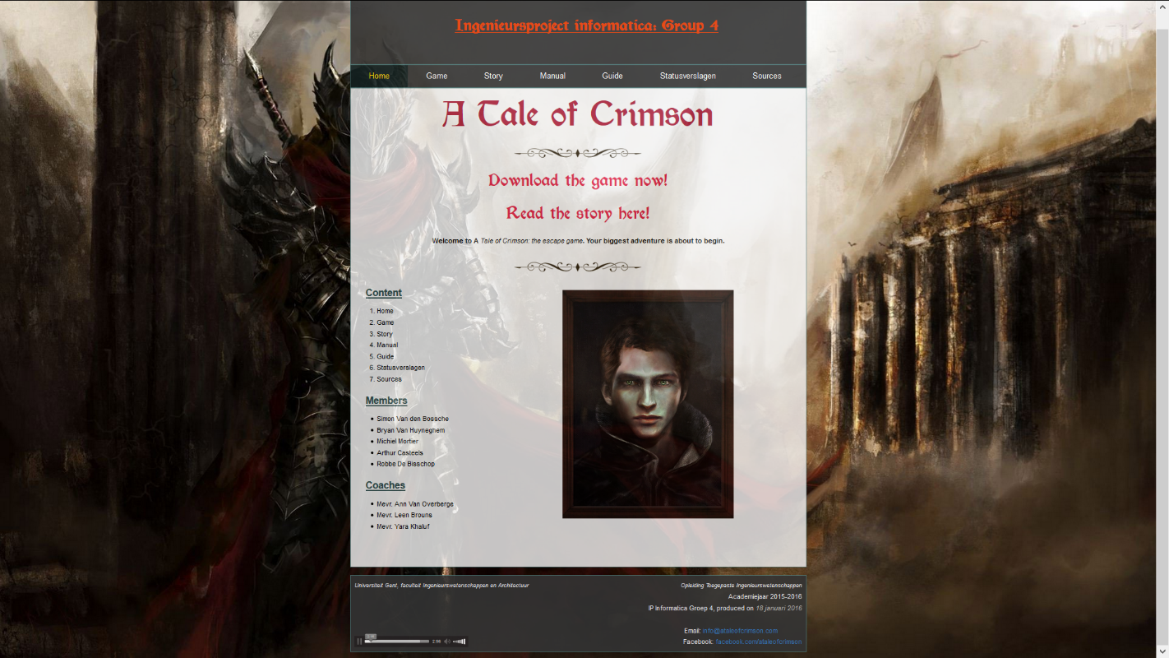

Figuur 14: de website als fundering van de game

Gezien het feit de game vrij veel prestatievereisten met zich meedraagt, worden bij het downloaden van de game enkele systeemvereisten voorzien. Ingeval er zich problemen zouden voordoen bij het downloaden of spelen van de game, kan de bezoeker hulp aangeboden krijgen via de gelinkte Facebookpagina of via het vermelde e-mailadres, dewelke beide beschikbaar zijn in de *wrapper* onderaan de webpagina.

Verder beschikt de website over een tab *Story*, waar het verhaal te lezen is en ook een kort overzicht met beschrijving voorzien is van de personages. Alle Diary entries, War notes en de tijdslijn zijn eveneens beschikbaar in deze tab. Deze documenten kunnen eveneens geraadpleegd worden in Bijlages 4, 5, 6 en 7.

Mits een paar muisklikken kan de speler of bezoeker een gedetailleerd beeld krijgen van de game in de tab *Manual*. Hier zijn handleidingen ter beschikking gesteld, alsook een korte beschouwing over de werking van de achievements en de verschillende moeilijkheidsgraden. Als laatste wordt er in de manual tevens een gedetailleerde beschrijving meegegeven met bijhorende illustraties over wat er allemaal te verzamelen of te doen is in elke kamer. Deze handleidingen kunnen eveneens geraadpleegd worden in Bijlages 9 en 10.

Een volgend onderdeel van de website is de *guide*. De speler kan deze guide consulteren indien hij geen manier meer vindt om verdere vooruitgang in het spel te boeken. Hierin staat namelijk stap voor stap uitgeschreven hoe de game op de meest efficiënte (en dus snelste) manier kan worden uitgespeeld. In deze guide wordt er ook een onderscheid gemaakt tussen de *mandatory* (noodzakelijke) en *optional* (optionele) stappen van de game (cfr. *1.6 Optionele en verplichte stappen*). Zo is het voor de speler duidelijk welke acties er in de game essentieel zijn om de hem uit te spelen. Het verzamelen van bv. sleutels is een optioneel, maar draagt – zoals eerder reeds werd vermeld – bij tot het behalen van een hogere eindscore.

De laatste twee onderdelen van de website zijn respectievelijk de administratie en de gebruikte referenties.

# Conclusie

Het doel van dit ingenieursproject informatica was om een escape game te ontwikkelen die aan een aantal vooraf afgesproken normen moest voldoen. Naar eigen keuze kon geopteerd worden om enkele uitbreidende functies te creëren en beschikbaar te maken in de game.

Groep 4 koos ervoor zich te focussen rond het begrip immersion of onderdompeling. Centraal hierbij is de inleving van de speler in de game. Het schrijven van een verhaal en het implementeren van deze teksten onder de vorm van Lore books, Diary entries en War notes droegen bij tot deze immersion. Veder werd ook gewerkt met jump scares of flashing images, alsook muziek en muziekeffecten om een beklijvend effect te simuleren.

Als antwoord op de verschillende problemen omtrent het coderen in Processing werd een boek aangekocht die dienst deed als naslagwerk. Dankzij dit boek en de goede ondersteuning en begeleiding van de coach kon er snel ingespeeld worden op problemen van alle soorten en maten. Er werd bovendien geopteerd om met commentaar en duidelijke naamgeving te werken om de code zo duidelijk mogelijk te houden voor derden.

De samenwerking van de groep rustte op drie pijlers die zorgden voor een gezonde samenwerking: transparantie, communicatie en efficiëntie. Aangezien het werken aan een project in groep niet evident is, werd binnen de groep iemand aangesteld om de leidinggevende functie in te vullen. Hij verzorgde de administratie en het uitdelen van opdrachten. De communicatieve vaardigheden van elk lid waren hierbij van onmisbaar belang en ondergingen tevens een merkbare verbetering in de loop van het project. Dankzij het gebruik van verscheidene communicatietools werd het mogelijk om thuis op een efficiënte manier te werken en in samenwerking te treden met elkaar.

Er werd besloten om een website te ontwikkelen die zou fungeren als fundering van de game. Deze website dient zowel voor het publiceren van de game over het hele web, als voor het ter beschikking stellen van de achtergrond en essentiële informatie van de game.

Tot op heden zijn aanpassingen en updates aan *A Tale of Crimson* mogelijk. Dit wordt door alle groepsleden overwogen te doen bij wijze van leerervaring en ontspanning tijdens hun vrije tijd. *A Tale of Crimson* was voor alle vijf de groepsleden een eerste grote stap in de wereld van ontwerpen en programmeren en zal een bron van inspiratie blijven gedurende de opleiding tot industrieel ingenieur in de informatica.

# Referenties

**A**

Achievement lore & Reborn, geraadpleegd op 27 maart 2016 via

<http://www.iheartwells.com/Portfolio/BHG/Icons240_15.jpg>

Alchemical room, geraadpleegd op 10 maart 2016 via <http://vignette3.wikia.nocookie.net/bpc/images/5/50/Wiki-background/revision/latest?cb=20150702055027>

Arrow, geraadpleegd op 23 april 2016 via <http://www.pd4pic.com/images/arrow-bow-old-shoot-weapon-feathers.png>

Astronomer’s room, geraadpleegd op 3 maart 2016 via <https://celestialdivination.files.wordpress.com/2014/12/room_astrologer_by_abzac666-d6l4m6q1.jpg>

Azreal (humanoid), geraadpleegd op 29 febrauri 2016 via

<https://pbs.twimg.com/profile_images/431706529872355328/IQI94RjV.jpeg>

# 

**B**

Background, geraadpleegd op 29 maart 2016 via

<http://echomon.co.uk/wp-content/uploads/2013/07/Red-Victorian-Wallpaper.png>

background difficulty, geraadpleegd op 11 april 2016 via

<https://breakinginthehabit.files.wordpress.com/2016/01/texture-background-dark-spot-hd.jpg>

Battle1, geraadpleegd op 24 maart 2016 via

<http://41.media.tumblr.com/e65d90b22abfaf42461ad5cdea755b46/tumblr_nhtptgmYsq1shal57o1_1280.jpg>

Battle with Pyres, geraadpleegd op 9 maart 2016 via

<http://lordhayabusa357.deviantart.com/art/Dark-Times-439210729>

beast bedroom, geraadpleegd op 3 maart 2016 via

<http://pre12.deviantart.net/cd78/th/pre/f/2012/188/f/0/beast_bedroom_by_wolfewolf-d56ahmm.jpg>

Blackjohnny0 (2011, november 14). TES V Skyrim Main theme – OST soundtrack – DRAGONBORN [HD] [Video file]. Retrieved from <https://www.youtube.com/watch?v=eVVXNDv8rY0>

Blood, geraadpleegd op 29 maart 2016 via

<http://pngimg.com/upload/blood_PNG6089.png>

Books, scrolls, general icons, geraadpleegd op 16 maart 2016 via

<http://orig12.deviantart.net/05e7/f/2010/354/d/5/d57a7fcbef0ca8be5c80a302b4d88cf0-d35asyt.jpg>

Book of Eye, geraadpleegd op 29 maart 2016 via

<http://1.bp.blogspot.com/-C3M1_XOouVE/UB5dhhoQlfI/AAAAAAAAE8c/qXso_aP2ICU/s1600/Fallen+Angel+-+Handmade+Book+2.JPG>

Brief, sleutel, boek, geraadpleegd op 16 maart 2016 via

<http://read.html5.qq.com/image?src=forum&q=5&r=0&imgflag=7&imageUrl=http://mmbiz.qpic.cn/mmbiz/0DSXLNibvwCD53X1kjqCHm5eXKjhkia2H0dZwQ1neiagwmrw5kDiatTLR3BpiauSQyjDWftMP2IO0JXBmjU2uPX7qSQ/0>

Buiten (fantasy castle), geraadpleegd op 10 maart 2016 via

<http://img11.deviantart.net/1939/i/2012/008/c/7/fantasy_castle_night_by_djsaman-d4lk8cm.jpg>

**C**  
cabin inside, geraadpleegd op 3 maart 2016 via

<http://pre13.deviantart.net/89cc/th/pre/f/2015/024/3/3/cabin_inside_by_vityar83-d8f9vys.jpg>

Candles, letters, geraadpleegd op 16 maart 2016 via

<http://www.gamedev.ru/files/images/114208_1453455849_screen_1.jpg>

Candle top, geraadpleegd op 29 maart 2016 via

<https://c1.staticflickr.com/5/4097/4737671276_dda807b78d_b.jpg>

Comedy and Tragedy, geraadpleegd op 27 maart 2016 via

<http://bloximages.chicago2.vip.townnews.com/maysville-online.com/content/tncms/assets/v3/editorial/d/8c/d8c9c1ed-1e6e-588f-a314-c2da42684776/554a5b1984164.image.jpg>

Cross icon, geraadpleegd op 23 april 2016 via

<http://www.clipartbest.com/cliparts/aTq/bEA/aTqbEAxac.png>

Cursor, geraadpleegd op 25 februari 2016 via

<http://pixeljoint.com/files/icons/full/curseur3.png>

**D**

Dark Dungeon, geraadpleegd op 10 maart 2016 via

<https://d.wattpad.com/story_parts/92992388/images/13b6145da34c5239.jpg>

Demon01, geraadpleegd op 24 maart 2016 via

<http://furyon1989.deviantart.com/art/Capra-Demon-452237624>

Demon02, geraadpleegd op 24 maart 2016 via

<http://41.media.tumblr.com/a1f49d468c5c98aeb196fead5730daab/tumblr_nxcgzr7gFT1utsphuo1_500.jpg>

Demon03, geraadpleegd op 24 maart 2016 via

<http://pre11.deviantart.net/4d96/th/pre/i/2015/319/e/7/necro_knight_by_deadxcross-d9grcy5.jpg>

Demonfight, geraadpleegd op 7 april 2016 via

<https://i.ytimg.com/vi/VnRDX0IsW-U/maxresdefault.jpg>

Demonhouse, geraadpleegd op 24 maart 2016 via

<http://www.hdfondos.org/file/17028/1920x1200/crop/arte-demonio-con-alas-y-cuernos-en-la-casa.jpg>

Demonic button, geraadpleegd op 29 maart 2016 via

<https://cdn.shopify.com/s/files/1/0078/0442/products/RAPB_large.JPG?v=1398971035>

Demon lord, geraadpleegd op 25 maart 2016 via

<http://ic.pics.livejournal.com/flashzoom/12663189/322714/322714_900.jpg>

Diary background, geraadpleegd op 23 april 2016 via

<http://atextures.com/paper-grunge-background-seventy-two/>

Diary entry background, geraadpleegd op 23 april 2016 via

<http://orig09.deviantart.net/bb31/f/2008/172/c/6/blood_hounds_book_blank_page_by_wightzombie.jpg>

Difficulty icons, geraadpleegd op 11 april 2016 via

<http://media.diablofans.com/images/news/2012/march/patch14/newdif.jpg>

Dracula window, geraadpleegd op 20 april 2016 via

<http://img11.deviantart.net/2b4f/i/2014/314/9/3/dracula_castlevania_by_janvalek666-d85zb24.jpg>

Dungeon corridor, geraadpleegd op 10 maart 2016 via

<http://static1.squarespace.com/static/5563eac8e4b0c0ea1b0601ca/t/55666df6e4b0bd199a89b704/1432623603926/Dungeon_Corridor_01.jpg?format=2500w>

Dungeon fountain of truth, geraadpleegd op 10 maart 2016 via

<http://cloister.deviantart.com/art/Dungeon-level-1-level-concept-C-Fountain-279161406>

Dungeon level 1, geraadpleegd op 10 maart 2016 via

<http://sybaritevi.deviantart.com/art/Dungeon-level-1-level-concept-A-tunnel-278820059>

dungeon level 2, geraadpleegd op 3 maart 2016 via

<http://pre03.deviantart.net/c510/th/pre/f/2013/008/7/9/dungeon_level_2___level_concept_b__storage_rooms_by_cloister-d5qx4ei.jpg>

**E**

Eden, geraadpleegd op 24 mei 2016 via

<http://vignette3.wikia.nocookie.net/rsroleplay/images/6/67/A.jpg/revision/latest?cb=20141110225953>

Eden and Olivia ending kiss, geraadpleegd op 20 april 2016 via

<http://cdn.vectroave.netdna-cdn.com/wp-content/uploads/2014/10/Photography-by-Laura-Makabresku-3.jpg>

Eden arrows, geraadpleegd op 28 februari 2016 via

<http://i58.tinypic.com/j7tcms.jpg>

Eden flashing lightbringer, geraadpleegd op 24 mei 2016 via

<https://images4.alphacoders.com/122/122006.jpg>

Eden infected, geraadpleegd op 24 mei 2016 via

<http://img14.deviantart.net/987f/i/2014/201/c/8/dnd_character_portrait__ameris_santraeger_by_hidennka-d7rjmqh.png>

Eden on the brink of war, geraadpleegd op 9 mei 2016 via

<http://juggernaught9900.deviantart.com/art/Rule-of-One-Forward-Unto-Dawn-245770084>

Eden vs. Azrael (true form), geraadpleegd op 9 mei 2016 via

<http://droot1986.deviantart.com/art/Monsters-Dreamscene-511506764>

Eden vs. Pyres, geraadpleegd op 29 februari 2016 via

[http://g01.a.alicdn.com/kf/HTB1J2XeLXXXXXb3XFXXq6xXFXXXY/warriors-demons-creatures-war-hell-font-b-medieval-b-font-3-Sizes-Silk-Fabric-Canvas-Poster.jpg 29/02](http://g01.a.alicdn.com/kf/HTB1J2XeLXXXXXb3XFXXq6xXFXXXY/warriors-demons-creatures-war-hell-font-b-medieval-b-font-3-Sizes-Silk-Fabric-Canvas-Poster.jpg%2029/02)

Eden website background, geraadpleegd op 28 februari 2016 via

<http://sf.co.ua/16/01/wallpaper-cd2e.jpg>

Elder Sage, geraadpleegd op 9 mei 2016 via

<http://plavidemon.deviantart.com/art/Portals-507445797>

# 

**F**

fantasy workroom, geraadpleegd op 3 mei 2016 via

<http://pre03.deviantart.net/c776/th/pre/f/2009/318/6/3/fantasy_workroom_by_ere4s3r.jpg>

Flip page arrows, geraadpleegd op 6 april 2016 via

<http://cache3.asset-cache.net/gc/504816073-hand-drawn-arrows-gettyimages.jpg?v=1&c=IWSAsset&k=2&d=FcTYWvmpDjL0TV60LW3rxq0aRE9OJa3OT0A%2FzQPjJfQgFI4mVAdypPp3pBU9iLL1>

Frame, geraadpleegd op 25 mei 2016 via

<http://pre13.deviantart.net/cc7f/th/pre/i/2012/240/9/c/antique_scroll_frame_rectangular_creation_ekduncan_by_eveyd-d50t8wj.png>

Fry, B. & Reas, C. (2001), Processing. Geraadpleegd op 11 april 2016 via <https://processing.org/>

Fry, B. & Reas, C. (2001), Processing Reference. Geraadpleegd op 11 april 2016 via <https://processing.org/reference/>

**G**

Ganex and Ganymede, geraadpleegd op 10 mei 2016 via

<http://cp14.nevsepic.com.ua/224/22338/1396296690-allday111.jpg>

Ganex, geraadpleegd op 24 mei 2016 via

<http://thelurkerchronicles.com/content/images/2014/Feb/cb47a057b4db8dc9ee96442bd2dfc69e_d67y0ry.jpg>

Ganymede, geraadpleegd op 24 mei 2016 via

<https://s-media-cache-ak0.pinimg.com/736x/96/c3/9f/96c39fc2f5ff5db22d57cc1557eee25c.jpg>

General Eden, geraadpleegd op 29 februari 2016 via

<https://i.ytimg.com/vi/OAm2rsIibOw/maxresdefault.jpg>

Glove, geraadpleegd op 26 mei 2016 via

<http://t14.deviantart.net/e3TYKFKvZ2MOOF2Bgldngfq92WM=/300x200/filters:fixed_height(100,100):origin()/pre06/6011/th/pre/f/2015/177/6/3/fantasy_gloves_by_kifir-d8yugim.jpg>

Golden background, geraadpleegd op 29 mei 2016 via

<https://s-media-cache-ak0.pinimg.com/736x/c8/81/a0/c881a08aa9398a457118e98cd31adbee.jpg>

**H**

Hint icon, geraadpleegd op 10 april 2016 via

<http://cdn.mysitemyway.com/etc-mysitemyway/icons/legacy-previews/icons/worn-cloth-icons-alphanumeric/132121-worn-cloth-icon-alphanumeric-question-mark.png>

Hints background, geraadpleegd op 23 april 2016 via

<http://www.poluoluo.com/sc/UploadFiles_2845/201302/20130216155912316.jpg>

HolophonicStudios (2013, januari 29). Scary Audio Illusion 3D (must use headphones) [Video file]. Retrieved from <https://www.youtube.com/watch?v=rChtfkjNYOw>

Hooded figure, geraadpleegd op 10 mei 2016 via

<http://3.bp.blogspot.com/-HczrnPA6yts/VbQO19rlSgI/AAAAAAAABNU/Teh2gvczqNo/s1600/Fotolia_39001160_M.jpg>

hunter’s house, geraadpleegd op 3 mei 2016 via

<http://img05.deviantart.net/2acb/i/2013/143/4/4/hunter_s_house_by_abzac666-d669rvk.jpg>

**I**

Inventory icon, geraadpleegd op 16 mei 2016 via <https://www.tf2buy.com/img/cache.php?f=48922e31e5770098f20d99a96350f6ee.png>

**J**

John Hunyadi, geraadpleegd op 24 mei 2016 via

<http://orig02.deviantart.net/fd36/f/2015/042/8/f/cullen_by_skin_dancer-d8hkal9.png>

**K**

Keys, random objects, geraadpleegd op 16 mei 2016 via

<https://s-media-cache-ak0.pinimg.com/736x/23/ae/8a/23ae8a72512e126e651ce36a2d07a81d.jpg>

Key chain, geraadpleegd op 16 mei 2016 via

<http://other00.deviantart.net/7595/o/2010/285/2/b/2bc6bbd55dfcbd7634c9ef252391a378.jpg>

Knife, vials etc., geraadpleegd op 16 mei 2016 via

<http://www.cruzine.com/wp-content/uploads/2010/07/070-icons.jpg>

**L**

Lange dungeon met deur, geraadpleegd op 10 mei 2016 via

<http://i.imgur.com/WZssH.jpg>

Large room, geraadpleegd op 25 februari 2016 via

<http://pre00.deviantart.net/4ec9/th/pre/f/2011/278/9/3/medieval_science_room_by_gurgur-d4bvx27.jpg>

Lightbringer zwaard, geraadpleegd op 16 mei 2016 via

<http://www.polyvore.com/cgi/img-thing?.out=jpg&size=l&tid=37327757>

Lore_icon, geraadpleegd op 16 mei 2016 via

<https://s-media-cache-ak0.pinimg.com/236x/43/b3/4f/43b34fcdb27c14582ccacd7a50b69022.jpg>

Lucius Rufus, geraadpleegd op 24 mei 2016 via

<http://orig05.deviantart.net/f39d/f/2013/343/c/4/c4f367c959197eee9f6fb55f07dc2e80-d6xevj3.jpg>

Lyre (music), geraadpleegd op 16 mei 2016 via

<http://i.istockimg.com/file_thumbview_approve/27471833/5/stock-illustration-27471833-illustration-with-the-diamond-harp-icon.jpg>

**M**

Magical portal flash, geraadpleegd op 29 mei 2016 via

<http://movies.homeofthenutty.com/albums/TronLegacy/TronLegacy3317.jpg>

maids_room, geraadpleegd op 3 mei 2016 via

<http://orig01.deviantart.net/f47b/f/2012/188/d/4/maids_room_by_wolfewolf-d56ahdw.jpg>

Malice Crimson, geraadpleegd op 26 mei 2016 via

<http://samlib.ru/img/b/black_outsider/skazkaomirohodce/62450787.jpg>

Malice Crimson 2, geraadpleegd op 26 mei 2016 via

<http://cdn.obsidianportal.com/assets/91136/49.jpg>

Mansion corridor, geraadpleegd op 10 mei 2016 via

<http://hqwallbase.pw/images/bigest/1280x800_mansion_corridor-1568577.jpg>

Marcus Aetherius, geraadpleegd op 24 mei 2016 via

<https://cdn1.artstation.com/p/assets/images/images/000/186/949/small/andrey-vasilchenko-war-general.jpg?1443929597>

Mattashi (2015, augustus 24). Mattashi - Infiltrate [Video file]. Retrieved from <https://www.youtube.com/watch?v=f-iLBiYrpeI>

More shields, geraadpleegd op 16 mei 2016 via

<https://s-media-cache-ak0.pinimg.com/736x/9b/ee/4f/9bee4f522ff18cdd49efc132538fdd59.jpg>

**N**

Note to myself background, geraadpleegd op 23 april 2016 via

<http://www.pptbackgrounds.org/uploads/advanced-blank-scroll-paper-powerpoint-backgrounds.jpg>

**O**

Open book 1, geraadpleegd op 16 mei 2016 via

<https://abidurrahman.hotglue.me/?Reading+Real.head.144763164389>

Open book 2, geraadpleegd op 16 mei 2016 via

<http://vikont.ucoz.ru/_ph/33/3038342.png>

Orb, geraadpleegd op 27 mei 2016 via

<http://t14.deviantart.net/AF2WvjnI4dCNB0KVhem5WOuD8ec=/300x200/filters:fixed_height(100,100):origin()/pre08/a722/th/pre/i/2006/225/7/b/yellow_orb_by_r4v1.jpg>

Olivia1, geraadpleegd op 24 mei 2016 via

<http://s1299.photobucket.com/user/Shagotte/media/ROL/female_portrait_by_matija5850-d91bzru_zpsdsi6hy32.jpg.html>

Olivia2, geraadpleegd op 24 mei 2016 via

<http://manmonster.m.a.pic.centerblog.net/Maxima-Ault2.jpg>

Olivia3, geraadpleegd op 24 mei 2016 via

<http://3.bp.blogspot.com/-65rWHgGGMz4/VauZs72SH-I/AAAAAAAAFcQ/jPBhfXHThtg/s1600/lost_ashes__video__by_selenada-d8ueswt.jpg>

Olivia4, geraadpleegd op 24 mei 2016 via

<http://mamietitine.m.a.pic.centerblog.net/0_108c05_3c07e679_orig.jpg>

Olivia5, geraadpleegd op 24 mei 2016 via

<https://s-media-cache-ak0.pinimg.com/736x/bb/ed/3f/bbed3fd39d595815e64c1a56dc853484.jpg>

# 

**P**

Paper, geraadpleegd op 16 mei 2016 via

<http://birgitmummu.vikki.fi/Joulu/Askartelu/Pergamentit/pergamennti6.jpg>

Phantom of the opera, geraadpleegd op 10 mei 2016 via

<http://www.desafiosphotoshopbrasil.com.br/wp-content/uploads/2013/02/phantom_of_the_opera__library_by_kidy_kat-d31i0as.jpg>

Portal, geraadpleegd op 29 mei 2016 via

<http://vignette2.wikia.nocookie.net/technicpack/images/9/9d/Portal.png/revision/latest?cb=20121110065624>

Puzzle box, geraadpleegd op 29 mei 2016 via

<https://www.yourprops.com/movieprops/original/yp55c7d728a74114.08706405/Hellraiser-Inferno-Screen-Used-Lament-Configuration-Puzzle-Box-4.jpg>

Puzzle box 2, geraadpleegd op 25 mei 2016 via

<https://i.ytimg.com/vi/vdYhkjARO0Q/hqdefault.jpg>

Pyres, geraadpleegd op 25 mei 2016 via

<https://lh3.googleusercontent.com/-yOSMa1PS7DI/VEqQ86A5IQI/AAAAAAAAKCc/wr3Udy40zVw/w1920-h1080/hellguard_general_by_balaskas-d7yvub6.jpg>

Pyre hand, geraadpleegd op 27 mei 2016 via

<http://wiki.guildwars.com/images/thumb/f/ff/Demon_hand1_cape_emblem.png/120px-Demon_hand1_cape_emblem.png>

**Q**

Quill, geraadpleegd op 17 mei 2016 via

<http://cliparts.co/cliparts/kcM/byn/kcMbynqgi.png>

Quill2, geraadpleegd op 29 mei 2016 via

<http://www.polyvore.com/cgi/img-thing?.out=jpg&size=l&tid=27314768>

**R**

Renaissance_room, geraadpleegd op 3 mei 2016 via

<http://wallpapers.wallhaven.cc/wallpapers/full/wallhaven-148294.jpg>

Rope, geraadpleegd op 2 april 2016 via

<https://db1736767dbd5e7094bb-d61bbc5d0b342a54145a236e2d5d1ebf.ssl.cf4.rackcdn.com/Product-800x800/18701984-0b8f-4625-8d96-977a3fb3d79d.png>

Ritual book, geraadpleegd op 26 mei 2016 via

<https://s-media-cache-ak0.pinimg.com/736x/76/49/1f/76491f79b51a9f186800b52ad8307683.jpg>

Ritual hand, geraadpleegd op 26 mei 2016 via

<https://s-media-cache-ak0.pinimg.com/736x/d8/11/ea/d811eab318dd801aeac84d6a6ffa5958.jpg>

**S**

Scene corridor, geraadpleegd op 10 mei 2016 via

<http://pre12.deviantart.net/ffd6/th/pre/i/2014/274/b/6/scene_corridor__for_social_hidden_object_game__by_denusb-d8171cc.jpg>

Scroll, geraadpleegd op 16 mei 2016 via

<http://celitel.peichev.ru/images/scroll-stock.jpg>

Shield, geraadpleegd op 16 mei 2016 via

[http://other00.deviantart.net/7595/o/2010/285/2/b/2bc6bbd55dfcbd7634c9ef252391a378.jpg](http://other00.deviantart.net/7595/o/2010/285/2/b/2bc6bbd55dfcbd7634c9ef252391a378.jpg%2016/03)

Signature, geraadpleegd op 23 april 2016 via

<https://upload.wikimedia.org/wikipedia/commons/thumb/c/c4/Rufus_king_signature.svg/579px-Rufus_king_signature.svg.png>

Shiffman, D. (2015). *Learning Processing*. Burlington: Elsevier.

Skyrim cover, geraadpleegd op 29 mei 2016 via

<http://vignette4.wikia.nocookie.net/elderscrolls/images/8/8d/HighPolySkyrimBook.png/revision/latest?cb=20121024005813>

Sparkle, geraadpleegd op 26 mei 2016 via

[http://api.ning.com/files/A8I8pebmYzpMYpcIEkxYQ1*mE6W1hzNR4ZvR4gZ9OZ7sC7Zclp9Yqx7CCM-bf9aH2CiIJa105k0D0OOyZ4mjHLXke15lCFGj/Sparkle_PNG_by_PVS_by_pixievamp_stock300x300.png](http://api.ning.com/files/A8I8pebmYzpMYpcIEkxYQ1*mE6W1hzNR4ZvR4gZ9OZ7sC7Zclp9Yqx7CCM-bf9aH2CiIJa105k0D0OOyZ4mjHLXke15lCFGj/Sparkle_PNG_by_PVS_by_pixievamp_stock300x300.png%2026/03)

Stylish background, geraadpleegd op 25 mei 2016 via

<https://s-media-cache-ak0.pinimg.com/736x/83/28/15/8328156f64be106b14493fe117023646.jpg>

Sword , geraadpleegd op 25 februari 2016 via

<https://pixabay.com/p-158585/?no_redirect>

**T**

Tablet background, geraadpleegd op 29 mei 2016 via

<http://hqwallbase.pw/images/big/ancient-wallok-wallpaper.jpg>

TechTarget (2005), source code. Geraadpleegd op 7 april 2016 via <http://searchsoa.techtarget.com/definition/source-code>

TheLinkBetweenGamers (2013, december 17). The Legend of Zelda: A Link Between Worlds – Puzzle Solved Jingle. [Video file]. Retrieved from <https://www.youtube.com/watch?v=YTy17_APDFA>

ThePrimeCronus (2013, november 6). Axl Rosenberg - Spiro [Video file]. Retrieved from <https://www.youtube.com/watch?v=cabPyVnXhUE>

Tome cover, geraadpleegd op 29 mei 2016 via

<http://orcz.com/images/7/7e/SkyrimSpellTomeDestruction.jpg>

Torch, geraadpleegd op 24 mei 2016 via

<http://vignette1.wikia.nocookie.net/play-rust/images/4/48/Torch_icon.png/revision/latest?cb=20151106061512>

Torch cursor, geraadpleegd op 31 mei 2016 via

<http://vignette1.wikia.nocookie.net/play-rust/images/4/48/Torch_icon.png/revision/latest?cb=20151106061512>

Trailer Music World I (2015, juli 22). Audiomachine – Being Alive (Epic Powerful Choral Uplifting Orchestral) [Video file]. Retrieved from <https://www.youtube.com/watch?v=GE5s-Xd0ibw>

**V**

Vlad 3 castle, geraadpleegd op 9 mei 2016 via

<http://rich35211.deviantart.com/art/Fantasy-Castle-3-506982299>

Vlad Dracula, geraadpleegd op 24 mei 2016 via

<https://cdn0.artstation.com/p/assets/images/images/000/995/784/large/filip-ivanovic-dracula-12x16.jpg?1437787661>

Vlammen difficulty, geraadpleegd op 11 april 2016 via

<http://abload.de/img/forumgazelpngatesresipjj4l.png>

**W**

Wine, geraadpleegd op 27 mei 2016 via

[https://s-media-cache-ak0.pinimg.com/236x/4c/1c/46/4c1c463aa7e691e81f2866307a9b6702.jpg](https://s-media-cache-ak0.pinimg.com/236x/4c/1c/46/4c1c463aa7e691e81f2866307a9b6702.jpg%2027/03)

Wine cellar, geraadpleegd op 3 mei 2016 via

<http://img12.deviantart.net/4ee6/i/2012/266/a/7/medieval_wine_cellar_by_spoonybytes-d5fohcd.jpg>

Wood background tablet, geraadpleegd op 29 mei 2016 via

<https://s-media-cache-ak0.pinimg.com/736x/7b/c3/a3/7bc3a3b5e1fd74354b6a5b5317b940a5.jpg>

# Bijlage 1: Scan tussentijds verslag ingenieursproject informatica









# Bijlage 2: Reflectie over de Belbintest

*De Belbintest kent mij in hoge mate de rollen* ***voorzitter****,* ***vormer*** *en* ***bedrijfsman*** *toe.*

*Testen die ik in mijn vorige opleiding afgelegd heb, gaven mij een gelijkaardig resultaat. Ik vind groepsdynamiek gedurende een project van cruciaal belang, dus het spreekt voor zich dat ik met liefde het nodige wil doen om een aangename en open atmosfeer te creëren waar ruimte is voor verbetering, inspraak en takenverdeling.*

*Ik tracht steeds het beste in mensen naar boven te brengen en hen (vanuit mijn opleiding als leerkracht) positief stimuleren en intellectueel te prikkelen. Het nemen van (moeilijke) beslissingen en het verhelderen van de methoden en oplossingen zijn slechts enkele redenen waarom ik een voorliefde ken voor het leiden van groepen. Ik vind het belangrijk om gestructureerd te werken, veel te brainstormen, vervolgens ideeën te praktiseren en te streven naar de absolute limiet van je eigen capaciteiten.*

*Aldus sluit mijn persoonlijkheid vrij goed aan bij de uitslag van deze test en aanvaard ik graag mijn rollen.*

***Bryan Van Huyneghem***

Student UGent Industriële wetenschappen

Ingenieursproject: informatica

Alumnus Howest Secundair Onderwijs AV Nederlands/Engels

*De Belbin-test was voor mij een andere manier van evalueren, maar dit  wel met oog voor de samenwerking en teamrollen van een groepswerk. De test zelf vond ik wel niet zo eenvoudig, er worden diepgaande en naar mijn mening lastige vragen en keuzes voorgeschoteld. De teamrol die mij werd toegekend is ‘groepsvormer’ en op 1% na ‘vormer’. En deels kan ik mij daarin wel vinden, ik probeer altijd het uiterste uit mezelf en uit mijn groepsleden te halen om dan uiteindelijk een zo goed mogelijk resultaat te bekomen. In mijn opzicht moet het niet voldoende zijn, het moet zeer goed zijn, vandaar mogelijks mijn ongeduld indien de werking ergens vastloopt.*

***Simon Vanden Bossche***

Student UGent Industriële wetenschappen

Ingenieursproject: informatica

*Het invullen van deze test was niet zo een gemakkelijke opdracht. Het evalueren van mezelf vind ik persoonlijk moeilijk. Aangezien het veel subjectiever is, en je niets weet hoe anderen het zien. Na het invullen van deze test bleek ik zowel bedrijfsman als groepswerker te zijn. Ik kan mezelf hier volledig in vinden aangezien ik graag in groep weer maar liever de leiden functie aan andere laat. Binnen een groep probeer ik me altijd voor de volle 100% te geven.*

***Michiel Mortier***

Student UGent Industriële wetenschappen

Ingenieursproject: informatica

*De belbintest vind ik een interessante manier om je rol binnen de groep te ontdekken. Soms werden vragen gesteld die voor mij moeilijk te beantwoorden waren aangezien ik mij daarin niet herkende. Mijn 2 hoogste scores zijn ‘bedrijfsman’ (22.86%) en ‘voorzitter’ (17.14%). Wat de ‘bedrijfsman’ betreft herken ik in mezelf vooral het concretiseren van doelen waarbij systematisch werken centraal staat. Ik denk vooral nuchter en praktijkgericht en neem verantwoordelijkheid voor de mij toebedeelde taken. Ik herken mij in de rol van ‘voorzitter’ in het zoeken naar consensus en het benadrukken van de sterke punten van iedereen. Ik kan bovendien goed knopen doorhakken, wat een typisch kenmerk is voor de ‘voorzitter’.*

***Robbe De Bisschop***

Student UGent Industriële wetenschappen

Ingenieursproject: informatica

*Het maken van de Belbin-test was geen gemakkelijke opdracht. Dit komt volgens mij omdat een zekere hoeveelheid zelfkennis vereist werd, en omdat het geen gemakkelijke opdracht was om de 10 punten evenwichtig over de gegeven opties te verdelen. Na de test gemaakt te hebben is mij als eerste de rol als voorzitter, als tweede de rol als bedrijfsman en als derde de rol als groepswerker toegekend. De derde rol past het beste bij mij, omdat ik er alles aan ga doen om een conflict binnen de groep te voorkomen en omdat ik er op sta dat iedereen zijn eigen mening mag voorleggen zonder genegeerd te worden.*

***Arthur Casteels***

Student UGent Industriële wetenschappen

Ingenieursproject: informatica

# Bijlage 3: Onderteken verslag voor akkoord d.d. 12/05/2016

Hierbij verklaren onderstaande leden zich volledig akkoord met de inhoud van het eindverslag voor het ingenieursproject informatica “A Tale of Crimson”.

Bryan Van Huyneghem

Simon Van den Bossche

Michiel Mortier

Robbe De Bisschop

Arthur Casteels

# Bijlage 4: Het verhaal (Lore books)

***A Tale of Crimson***





**W**ritten by

***B****ryan Van* ***H****uyneghem*

**“If you know the enemy and know yourself, you need not fear the result of a hundred battles.**

**If you know yourself but not the enemy, for every victory gained you will also suffer a defeat.**

**If you know neither the enemy nor yourself, you will succumb in every battle.”**

**― Sun Tzu, The Art of War**

**Bruges, 2016**

**Chapter 1**

Some say that *Eden*'s birth on the 28th of January of the year 1424 marked the end and beginning of both Darkness and Light. Though, entangled into the boy's soul a corruption sprung when the world heard his first cries.

That same moment, *Marcus Aetherius*, the Earl of Clovershire, killed the only remaining Upper-Pyre in this world: *Malice Crimson*. As *Lightbringer* severed Crimson's head from his body, the Pyre was banished into the unknown along with his armies. During his final moments, the skies turned blood-red with sunlight so dazzling it burnt through eyelids. No man whom had witnessed the true appearance of Malice Crimson ought to live. His name, that had been lost in ancient scripture and forgotten in old books before, again faded with time - along with his spirit... Or so mankind thought.

Confronted with the disappearance of thousands of soldiers, including Marcus Aetherius, whose name stood synonymous to *the Paladin of God*, the Royal Council of England, who was acting on behalf of the two-year old English King, Henry VI, cockily claimed victory over its enemies. All that remained was *Lightbringer*, broken in numerous pieces, but with each piece still connected to every other through an unknown, mystical force.



Ink dripping from our quill shapes an unknown month in the year 1434. An Elder Sage stumbles upon a ruin somewhere near the western beaches of the Black Sea. He discovers a rather common book with no immediate traits that show its true, concealed power. Drawn to the tome by an unknown force, the Sage picks it up and blows the dust off its cover. As his hands touch its rough outsides, he immediately senses that a spell or curse is preventing him from looking inside. Try as he might, though, he fails to unlock the book time after time. Suddenly, he notices a set of letters engraved in the back of the book. It reads, and he whispers: "*Azrael*". As the Sage's tongue touches the roof of his mouth just behind his front teeth, the book unseals itself, revealing but blank pages to the old man. He decides to take the dusty book nonetheless to subject it to closer inspection. Returning home, not even he could have foreseen what had now been set in motion.

Not long thereafter, the Sage died a gruesome death of which none shall ever know the truth. All but the book had turned to ashes... It is unsure whether or not he had discovered anything of interest within the book's pages. Though what can be said, is that from these days on the world would never be the same again.



The only child of Henry V, Henry VI succeeded to the English throne upon his father's death at meagre age of nine months, and succeeded to the French throne on the death of his grandfather Charles VI shortly thereafter. He inherited a long-running conflict in France, known as the Hundred Years' War. Coronated in 1429 at Westminster Abbey, all nobles swore loyalty to the young king. Their sword would defend his throne and vision at any cost.

The now thirteen years of age monarch was very much aware of the existence of such a divine weapon and claimed it as one of his rightful belongings. He had his brightest minds and most talented smiths closely examine the longsword. Alas, a year passed but not one mortal soul had been able to reforge the once powerful blade that had brought an end to *him whom they called Azrael*.

Angered by the failure of his own people, Henry sought to find an answer in the mystic. *Ganex*, a Dark Sage known to flirt with the rather wicked magic, that according to many other Sages was a blight to their wisdom and the bringing of balance, was summoned to court. A master of deceit, he informed the king of the existence of a small creature whom could perhaps help him restore Lightbringer's powers. Considering war with France was all but a far-fetched imagination, the king's hand was forced even more, though the lust for power had already convinced him to agree to Ganex's plan. At the time, many people had heard stories about gnomes, but naturally referred to them as figures from silly tales.

They were wrong. It did not take long for the king's search party to find him whom Ganex had spoken about. *Ganymede* agreed to reforge the sword on two conditions. The first spoke of riches beyond countable numbers, to which the king quickly nodded as he waved his hand impatiently, awaiting the second condition. "You shall have your might, cometh with blight. Though it shan't be you to wield Light; I name it Trinity, for it fuses Tenebris with Lux. I define these two as *Balance*, but know, that the last sprite within this sword calls upon *Imbalance* though brings it power. It corrupts the soul and makes its wielder fight with unimaginable Strength. That is the last of Trinity's. His name is Eden; he whom shall succeed in leading forces of faint souls to war. He cannot be stopped, yet his allegiance to you is engraved in the Depths of his soul. It must be him. It shall be him."

King Henry turned to Ganex, exchanging a mutual understanding. Impressed by the gnome's skilfulness and words, it was set in stone: Eden was to be found as soon as possible. "Rid me of the gnome. He whose appearance disgusts me is not worth a single breath, let alone my gold". And so it would be. The search for he who ought to wield *Trinity* had begun. Ganymede's execution was merely the beginning of a crimson-coloured field that would haunt those corrupted by blight, deep into eternity. Ganymede's last gaze fell upon Ganex.

"You! You may have been able to fool them, and even me, but do not think that you will fool a Fellow, Crimson."

"Crimson. I haven't heard that name in a while", Ganex said as he crushed the gnome's skull. "We shall see, dearest friend."



**Chapter 2**

The name Marcus Aetherius had been familiar to Eden for as long as he could remember. A hero to many, Eden had read countless books about him. After his mother's death, his father took the task to raise his son upon himself and swore to the gods that Eden was to become a better man than he ever was. Eden's father, Lucius, had been part of an early Templar order until his exile. The image of a beheaded knight stood burnt into his memory. He could not recall whether he had drawn the blade to end this man's life or if insanity had. Because of his bravery and heroism in the past, Lucius' life was spared yet stripped from everything it encompassed, be the belongings weak to touch or not.

Unlike many of his friends, Eden had learnt to read and write at a fairly young age. At the time, it was quite uncommon to grasp either of skills. The likes of priests, Sages and most noblemen were amongst the only people to turn to this art and master it. Despite Lucius' banning from the city world, he succeeded in teaching his son the skills that he had acquired throughout his life. Eden was a quick learner. Merely eight years old, his eagle-eye shot was acclaimed by many. He befriended a boy named Elliot, whose parents owned a large farm yet were all but wealthy and often struggled to meet the landlord's set demands. Elliot and Eden spent a lot of time together hunting wild animals, exploring unknown and rough terrain, and climbing tall hills. They collected any and everything they found to be unique, cherished it and kept it stashed in a cavern that only they knew the location of.

Eighteen years had gone by since Eden's mother died giving birth. It is rare to be able to recall anything from our childhood, yet Eden's mind often dwelled on images of indistinguishable shadows and figures that appear out of nowhere. They scream. Loudly. And then vanish equally fast. Until now, no words Eden had ever read, allowed for emotions to be this realistic. "Here lies Lucius Rufus, husband and father. Hero to many, legend to all. 1391 - 1442."



Eden's eyes opened wide. Awoken by the feeling of a thunder bolt sharply crossing his heart and stomach, the young man raised from his bed. The frigidness of the floor numbed his feet as he turned towards the only window in his room. Eden knew that looking outside would bring an end to his youthful innocence. It did indeed, and was equally crushing as the sight of Elliot's fate. He was buried the very next day, in the presence of the landlord, whose false tears would enrage even the calmest of men. Having nothing left but fury.

Eden closed the wood door to the house his father and he had lived in for what seemed to be a whole lifetime. It ended a chapter, but opened his mind and willpower. He fled England and sought a new life near Varna in the Eastern mainland of the Roman Empire. Soon thereafter, he joined John Hunyadi, commander of the combined Christian forces, in the Battle of Varna. Unaware of the path he had decided to take, Eden's life would forever change. As all men who wage war do, Eden spent many nights drinking with his fellow soldiers.

"My parents named me Olive, God knows why, but people call me Olivia. What's your name?"

"Lucius. My name is Lucius."



Words need not be written about Olivia and Eden, for there are no words to describe their wholehearted love for each other. Olivia knew that in due time Eden would be out on the fields, amidst the many whom wage war for the purpose of crimson. She feared she would never see him again and gave Eden her amulet. "It will shine light in dark times when you need it the most." Enamoured, Eden swore he would never let harm overcome her. And every morning, Olivia did not know whether Eden would return or be forever lost in between the numerous fallen soldiers on the battlefield. Alas, she also did not know who Eden truly was. Why would distrusting Eden even cross her mind, she thought.

He felt sorry for not telling her whom he really was. His motives were sincere, however, the past would remain the past. He could not afford to dwell on it, let alone have it affect his present days. Nevertheless, a mere nine months later, born into this world was Sophia. Despite Eden's regular absence, he spent as much time with her as he possibly could; loving her, caring for her. To him, she was the absolute combination of Olivia and Eden's most beautiful features, in any and every way thinkable, expressible, possible. For the most part, though, it was Olivia whom would care for their baby girl.



**Chapter 3**

As time went on, John noticed Eden's skilfulness and curiously approached the young man. Eden had been taught to respect his superiors and took a bow before the commander. It would not take long before both got along well enough for John to invite Eden to join him for dinners with the Fellows. They were a group of powerful individuals; their tongue as skilled and sharp as their blade's movements, with each member as skilled in war and diplomacy as the former. Excellent diplomats who could truly enforce, have always been rare to come by.

All Fellows were trained in the *Arts of War*. Around a thousand years ago, Sun Tzu's book *The Art of War*, containing but thirteen chapters, reached the West where it was expanded upon and merged with Western warfare and sword fighting. Thus, the Arts of War were born. A set of rules, skills and techniques to be taught to only those who were proficient enough to impress an early Order, later to be called the Fellows. If a novice was able to impress the Order, he would be allowed to join as an apprentice to one of its members.

The Order soon learnt about John's wish to teach Eden and have him join as an apprentice. "It shall be", said the eldest of members, "but if Lucius is to skip his novice rank, he is to prove himself out on the fields of war. There have been sightings of them, John. Sultan Murad II has found a way to control them and my God, may the Heavens stand by us. Have Lucius find one. Have him slaughter it. If he is as powerful as you claim, surely, a Pyre is no match for him, am I right?"

Despite the tense atmosphere, most Fellows burst out laughing. Murmured words such as 'death', 'loss', 'unlikely' could be heard through the halls where the leaders resided. Had Eden been present that day, he would have accepted this assignment without hesitation.

"He is not yet ready. Allow for me to train him first. I am sure if he masters 始计, Shǐ jì, Laying Plans, he shall succeed in his quest."

"You would break the codex to allow this man entry to our Order? I should kill you myself for even considering this atrocious thought..."

"Lucius carries the mark, Lenncester. You and I both know what that means, or have you forgotten about Marcus' warnings?"

"The man is dead. You speak of his words as though I should fear them. Let it be known that even Crimson cannot shiver my bones enough for them to break. If Lucius is to join our Order, you shall have him fight and defeat a Pyre to prove his worth. Only then will I put trust in your claims, John. That is the way and we shall follow it."

"So be it. Thank you". Words to quickly be discarded, as John's mind had been set. Following the teachings of his Master, Marcus Aetherius, John would secretly train Eden in preparation of what would be Eden's first encounter with the Depths. This was to be the very beginning of every nightmare that would haunt him into his mind and unlock the *half-soul* within him.



John had expected Eden to progress well, but was truly amazed at how quickly he learnt. Anything and everything John taught and asked Eden to do, was executed with extreme precision and tactfulness. What other apprentices would acquire after having trained for a year, Eden achieved in a mere two weeks’ time.

When John told Eden what the Order had requested of him, but one thought prevented him from shouting an immediate *"It shall be done"*: his beloved Olivia and daughter Sophia. What is a man worth to their loved ones when his corpse is dragged across the fields of Justice?

"These creatures are a threat to everything we deem humane. They seek but bloodshed and murder. The Order wants you to kill one, not only to prove yourself but to see if it can be done. Although they would never admit it, they know that if anyone would find out how to, it would be you. As much as they claim not to fear Marcus' words, they very much understand the value of them."

"I was predicted? What you're saying is that my life's only purpose is to deal with some unspeakable horror that only legends before me have been able to slay? And you reckon I can stop this? Is this a joke?"

"Everything we love, would die, Lucius. I do not have any other way of bringing this to you. I am sincerely sorry."

Having forced his hand, Eden accepted.

"Olivia and Sophia leave for England, and you shall see to it that they arrive safely. I do not want them to be anywhere near this place."

"As you wish. I shall see to it that they stay at a wealthy friend's unused manor. *Lovecraft Manor* has everything your family could ever wish for. When this is done, I shall ask no more of you."

Olivia did not take Eden's decision lightly, though understood that the reason behind it was one of protection.

"Promise me you shall join us when you are done here. Hurry. And Lucius... Don't you dare die on me."

"I shan't."



**Chapter 4**

Eden's first encounter with a Pyre was all but fair. Anyone who knows the story will tell that the true nightmares began right here. Eden succeeded, as expected and - truthfully said - hoped by all of his kind, though the fight was one lasting several weeks. A hunt, in which it is unclear who the predator is. Eden may have slain one dreadful creature, ten others took its place. He was nowhere to be found. Only the Pyre's corpse remained - heavily crippled. Although it was now sure that a Pyre could be killed in present day, it was still not known how to do it. That secret remained Eden’s for quite some time.

Varna fell. Sultan Murad II had defeated the Polish and Hungarian armies with what seemed to be ease. The combined Christian armies were quickly overrun, though held strongly near their fortresses and fortified cities. The nearby swamps also provided excellent defence against Pyres. The Western armies’ frontline may have been pushed back slightly, but their forces held thanks to great leadership within the Fellows.



The hunt was on for Eden. He had personally seen what these Pyres could do and therefore swore it would be his mission to find their roots and end them. Annihilate them. Slaughter them like the beasts they were. He quickly tracked two more down, and took a hundred times less time to defeat them. His bloodlust drove him to find four more, until the word had been spread to both the combined Christian forces' leaders as well as Sultan Murad II.

And thus, this was to be the beginning of the end of Eden as we knew him. The Sultan ordered his assassins to learn about the man behind the slaughtering of his Pyres. It did not take very long for them to uncover whom Eden loved and have them hunted down like wild animals. Pay a man enough money and he shall talk. It does not make his profession that of a spy. As a *war*ning sign, the Sultan ordered for "... the child to be killed and her head to be sent to the palaces of these unholy dogs. One way or another Lucius will find out about it. Then we shall have a confrontation. I will deal with him myself."

The news spread quickly and though Eden had avoided most human contact to allow him to focus on the mission he had taken upon himself, his grief reached beyond anything imaginable and bearable when he came to learn what had happened. The message that had been spread, had been altered significantly. It spoke of the horror of two deaths: a mother and her child. Not knowing Olivia was still alive, everything reasonable in Eden snapped at the very same time, thus unlocking the half-soul - fed by anger and hatred. It was then that Ganex felt that same rage in his soul, for within him lived the other half-soul: Malice.

"It is... alive."

For another five years, enraged by the half-soul, Eden would continue hunting his enemies down. No mercy was to be shown and everything he deemed unworthy was to be slaughtered in his path to finding the root to this cancer.

Every now and then, the Eden we knew as caring and loving would briefly return. It took several years until he was able to control his enraged forms. Unfortunately for him, he did not realise that every time he would enrage himself, he was building the foundation for a mental illness that slowly crept upon him - splitting him in nearly two identical selves, one fed by rage and by the half-soul, the other fed by the love he had for the people he cherished deeply.



"At long last we meet, Lucius. You have caused quite the scene, haven't you? I am sure you will agree that it is more than a shame that others must die for one's sins. Poor... Sophia, was it not?"

Eden was staring right into the eyes of the man who had caused him inexpressible pain and anger. Flanked by two bodyguards with their scimitars out, Sultan Murad II unsheathed his own gold plated sword.

"Let us have some fun first. Why don't you show me what you can do. Perhaps I will spare your life. Add you to my collection."

Eden could see a small, odd object hanging from Murad's belt, but could not exactly make out what it was. It reflected the sunlight unlike anything he had seen before, nearly blinding him. Blinded or not, Eden felt a dark radiance vibing off of the object. In an instant, he drew a small dagger from his belt and blocked one of the guard's attempted slashes. With one tremendously accurate counter, Eden drew a second dagger from his belt with which he ended the man's life in one quick and agile move towards the neck. Taken aback by the death of his comrade, the second guard dashed towards Eden but quickly met the exact same fate as the former. Eden remained emotionless and calm as he cleaned blood from his daggers.

"Shame. Murad, is it not?"

"Ah, well, humans never disappoint, do they? Beyond useless. Meat for war. Tell me, Lucius: Have you heard this little story that goes around the desert? Nightmares. Are they real or not? Is one staring into the eyes of a human or a Djinn?"

Murad's eyes turned vantablack - so black that it appeared as if one was staring into the deepest unknown parts of the universe. Before long, a morphed creature stood in front of Eden. Its mouth widened as it let out a high-pitch, unworldly and deafening screech. Eden attempted to draw his sword, but was knocked back in a flash of rage. The monster seemingly dashed from one position to another in a split second and smacked a near helpless Eden backwards. One hit. Two hits. Three hits. Four... Eden's eyes turned crimson with rage. The Djinn's fourth hit was blocked with but the raise of Eden left hand. An unmoveable mountain, he drew his sword: it met the gold plated scimitar right away. As agile as the Djinn was, Eden's powerful counters meant the end for both blades as they spat apart with the release of a shockwave that knocked both fighters back. A cunning and bright warrior, Eden's attention turned towards the object he had seen dangling from the Djinn's belt.

Eden recognised it as a relic from the same stories that spoke of Djinn - evil spirits that lived before humans and swore to haunt us mortals inside our dreams. Creativity and equal hatred towards the Djinn meant humans searched for a way to end the reign of terror brought upon them by these ghouls. Sages discovered that these spirits could be captured in artefacts such as statues and lamps. The *genie lamps* proved to be the most successful option, which explains their widespread existence in *the Lands of Sands*. Djinn would trick humans into releasing their spirit from these objects by promising to grant a wish. "This must be the lamp in which Murad was captured."

This thought was set in stone as quick thinking and decision-making allowed an enraged Eden to quickly overpower the Djinn. The demons' claws drew a set of three deep flesh wounds across Eden's chest as he ripped apart the chain that attached the lamp to the Djinn's belt. The mere touch of Eden's hand on the lamp's handle caused a whirlwind that engulfed both him and the Djinn. Murad's last breath before being pulled into the lamp called an ancient curse upon Eden.

"You carry the half-soul within you. May Crimson's soul be allowed entrance to yours. Your death awaits you, Lucius! It is filled with horror and phantasms that will eat at the very core of your brain! Bring upon thee ordeals from the Depths and die."

"Funny, because that is exactly what you are going to do right now, Murad. Die!"

With one last screech, the Djinn was pulled inside of the lamp, which resulted in a powerful blast of air that blew Eden back. The lamp laid in a near tranquil heap of sand, with Eden knocked unconscious.



**Chapter 5**

"Lucius. Lucius can you hear me?"

A high-pitch ringing and bright light were the first things Eden could hear and see. He slowly got up and partially covered his eyes and forehead with his hands. As the noise faded and vision returned, Eden noticed he was in a ward with John bedside to him.

"We found you about six days ago. We heard an insanely loud blast with a light beam radiating downwards from the sky to the planes where humans walk. You were heavily wounded and did not respond to anything. You were nearly given up upon, but a Sage within the Fellows told the nurses to keep looking after you. And here you are. How are you feeling?"

"Like someone just ripped the guts right out of my stomach, but overall I suppose I have had worse days. I have heavy chest pains, though."

"Let me tell you about that, Lucius. You were found with deep markings of claws deep in your flesh. We also found a gold lamp. I suppose we are all in luck that the man who found the lamp near your body actually had an idea of what it could possibly be."

"Where is it now? You have not the slightest clue of what is inside that thing, John."

"Calmly. It is here, on your bedside stand. We discovered the closer we bring it to you, the faster the wounds heal. If we remove it from your side, your flesh hollows of blood spills. Even our Sages aren't quite sure what is going on yet, although this smells of curses."

"Murad is inside that lamp. I banished him into it after I fought him. By no means must anybody else touch this artefact. He cursed it and bound it to something inside of me. The Djinn called it a half-soul."

"How odd. Then it is set in stone. You will carry the lamp with you until we find a solution. Lucius... I am dreadfully sorry... You have been away for nearly five years. I have awful news."

"I already know, John. I am being haunted by nightmares. I can see them in my dreams. Dead. It feels as if I carry a curse upon me now - even before I fought that Djinn, Murad. I have been having alterations, too. Enraged moments where I crave for blood spilling. It took me a while to learn how to control them, but these ordeals began when I first laid eyes upon a Pyre. I killed many of them, but I can still sense their presence in this world, John."

"We know. The Order has been awaiting you for some time now. If you still care to join, I shall bring you to them. Lucius, what do you mean 'see them'? Olivia is still alive."

"WHAT?"

"Calmly, now. There is a problem. The Assassins that killed Sophia forced Olivia to drink a potion. She is alive, but has been in a coma for as many years as you have been away. We tried our hardest, but we do not know how to wake her. There is one..."

"Take me to her, John."

"She is still in England. At Lovecraft Manor. Do not worry, she is under heavy guard and has the best nurses and Sages looking after her. I promised you I would look out for..."

"Them. Them, John. You promised me I would fight your filthy creature if you could guarantee Olivia and Sophia's safety. My daughter is dead and you are reminding me of the dead promise you made?"

"Our guards... They were no match for these Assassins, Lucius. We tried our best. They murdered everyone except for Olivia. But why?"

"To toy with me. Murad spoke of Crimson to me. I thought Marcus Aetherius ended his reign of terror before I was even born?"

"He did. But days before he left for war, he warned the Order that there was a chance he would not succeed. He definitely killed him, which banished him back to the book out of which he was summoned into this world. Lightbringer allowed for Marcus to fight Crimson, but he needed a second piece of the puzzle to defeat Crimson as a whole. They had everyone search for it, but it could not be found. They needed to find what Sages dubbed *Armour of the Night*, a full-body suit that disallows Crimson's soul to split in half. Though thought of as a myth, he told the Order that there was a possibility that it existed, and... if it did, and he would fight Crimson, it would merely split his soul in two pieces and temporarily tranquilise him. Marcus said that *the boy to carry the scar of Kyth will have his soul infused with the second half-soul*.

"My scar..."

"You may be that person, Lucius."

"Eden..., John. My name is Eden. Lucius is my father's name. When I first met you, I fled exactly that which I confront every night. Nightmares. It was a new beginning for me, so I tried to leave my past behind me."

"What does it matter now, ... Eden. You know what to do. This task was brought upon you by something divine. I can but guide you, my boy."



"Lucius, my dear son. Or is it *Eden* now? Not a rat's ass does it matter. Lenncester is but a nickname, too. The bravest among us wear them. Wear a nickname with pride. From now on, yours shall be Lucius. *Bringer of Light*. Lucius. Let us get to the point. People have been talking about you. Praising you. I know very well what happened. John has informed me and has told me you would still take our offer to become an apprentice to the Fellows. What say you, dear boy?"

"I have a mission. I shall do whatever it takes to wake Olivia and destroy Crimson for good. Your will is my command, though know that I have my own targets carved within my mind, too. I will not stop nor be stopped until my mind is clear."

"The Fellows have always safeguarded the mightiest of artefacts and weaponry. It would be a lie to discard the idea of Master Thieves as members of the Order. After Marcus Aetherius' disappearance, our informants told us that the Royal Council obtained Lightbringer. I am sure you have heard about it before. They kept it hidden until King Henry VI claimed it; what is a Fellow to do when a King claims it? He had it restored by Ganymede, whose skeletal remains were all we found. I need not explain that the blade in fact belongs to the Order of Fellows. Master Cyn, here, spent a few years infiltrating the court of King Henry VI. We have always been on excellent terms with the King and his followings, but ... let us just say that the sword is now here."

"Trinity", Eden said without controlling his own thoughts. "I can feel its presence. It is communicating with me, though I cannot make out most of what it is saying. Its name is Trinity.

Suddenly, Eden's eyes rolled back in his head and Ganymede's deep voice could be heard.

*"I name it Trinity, for it fuses Tenebris with Lux. I define these two as Balance, but know, that the last sprite within this sword calls upon Imbalance though brings it power. It corrupts the soul and makes its wielder fight with unimaginable Strength. That is the last of Trinity's. His name is Eden; he whom shall succeed in leading forces of faint souls to war. He cannot be stopped, yet his allegiance to you is engraved in the Depths of his soul. It must be him. It shall be him."*

"Master Cyn, if you would be so kind to..."

Eden's first encounter with Trinity was that of immediate Darkness in his mind, with flashing images of Olivia mixed with Crimson's eyes. Pyres, Djinns, the Depths... In seemingly one glimpse, Eden saw the sword's entire history.

*"You. You may have been able to fool them, and even me, but do not think you will fool a Fellow, Crimson."*

"Eden. I welcome you to the Order. Take Lightbringer to be your companion on your journey on the path of light. Do not dwell on what your missions are. Master John shall teach you our ways and guide you. If ever needed, the Order shall be at your side. Go now."

"Eden, war wages on. Constantinople is at the brink of defeat. The Order has been called upon to fight the invasion by the unholy. The defeat of Djinn Sultan Murad II was but the beginning of events that are unfolding as we speak. A new Sultan has risen to power. Within the six days of your unconsciousness, he pushed hard into the lines of our allies of the Holy Cross. Our spies claim to have seen him wear a type of armour unlike anything they have ever seen before. This is what I had tried to tell you earlier. We believe it to be the Armour of The Night, which would explain the sudden accelerated turnout of events. Mehmet II, the Conqueror, was a general under Sultan Murad II; now freed from the Djinn, we believe he is using the armour's might to lead his forces into battle with great success. The last couple of weeks, though, Mehmet has been awfully quiet and undertaken little to none. We must prepare while Mehmet is not doing anything and let the Fellows hold for as long as they can. Let us continue your training, Eden."

"John, I mean no disrespect, but I have practised in the Arts of War during the past years while I hunted Pyres. Though, I wish to know how perfected my knowledge is, I am not sure if there is anything that I could still learn from the books you gave me years ago..."

"Do not let your cockiness and pride take the upper hand of you, Eden. Things are different than before. Much different. You now know of the half-souls and Crimson's plan. Better yet... You have *Trinity* now."



**Chapter 6**

"Wait, let me write the date on these letters, just in case... 1453. There, go ahead, bring these to England."

"Will do, Master Eden. Anything else?"

"Send word to Vlad's castle. I need to see him at dawn."

"Right away."

Trinity radiated as Eden put his quill to the side and stood up. He could not believe the news when he heard Olivia had slowly woken from her seemingly eternal sleep. Vlad's Sages had succeeded in brewing a concoction that relieved Olivia from her must to dream. Who could tell what she had seen in the past seven years. For all Eden knew, she could have been sharing his nightmares.

Eden had completed his training with Trinity some time ago. Following the death of Master Thief Cyn, the Fellow who had returned Trinity to the Order, its members unanimously decided that Eden would take his place as the next, new Master Fellow. As commander of a significant group of soldiers, word of Eden's influence quickly spread to England and reached King Henry VI's court. Whilst the King was infuriated by the disappearance of his sword some odd years ago and called upon his court to retrieve Trinity, Ganex had set a different plan in motion. At long last, he knew Eden's exact position in this *"... demonforsaken world."*

"Soon this world shall yet again be overrun by ghouls, Pyres, Djinn and other creatures from the Depths. Humans shall be part of history. The world as it once was before those greedy creatures set foot on this earth and blighted it with their presence. Cleyus, my servant, pack my items. We are leaving for Constantinople. In some years’ time from now, the Tehm Dahnat shall rise. My plan will not fail."



As foretold by Ganymede, Eden was indeed unstoppable during war. By the near dozens at once, Trinity would slash its way through its enemies. Only when necessary would Eden enrage himself. His meditations during training had allowed him to take full control of his transformations.

The combined Christian forces were quickly gaining terrain on Sultan Mehmet II's soldiers. Fighting his own war, alongside the Armies of God and the Fellows, was Prince Vlad III "The Impaler" Dracula of Wallachia. While all war is cruel and bloody, raining death upon many, Vlad Dracula had his own ways of frightening his enemies. As his cognomen *The Impaler* suggested, his practice of impaling his enemies was part of his reputation; one that spread abroad to many other countries, bringing fear into the hearts of many.

Friend to Eden, after he had his Sages help awaken Olivia, Vlad's forces ploughed through the Sultan's troops, forcing Mehmet II to rethink his strategy. Although his armour had secured him a firm position in the war, part of its power seemed to be neutralised by Vlad's presence. Unaware of the fact that the armour was in fact one to be used for Good, it did not occur that Vlad's neutralising powers ought to stem in the Dark. Though fighting alongside the banners of *peace and purity*, Vlad's true intentions would remain unclear until many years later.

Gilded furniture, fine gem encrusted jewellery and riches that could blind the eyes of the greedy adorned Mehmet II's war office. Infamous for his hidden collection of rare items, the Sultan had set his mind on finding passive Djinn lamps; lamps with sleeping evil spirits in them, locked away for their cruel deeds. Though Mehmet remained faithful to his god, he considered himself a demi-god - one in need of a mighty, supernatural army that would fight his cause.

"My Sultan, we have been collecting Djinn lamps as per your request, but have been unable to activate them. We do not know what powers them. We ..."

Dripping with blood, Mehmet sheathed his blade. "I don't tolerate failure. It... displeases me. Heavily."

"Then I do believe I have the answer to all your problems, my Sultan", spoke a voice in the same room as the ruler.

"Show yourself. Who are you and what has you believe you can unearth the roots of my trouble?"

"Who I am, does not matter. Rather, whom our enemies are, does. In fact, we share the same hatred towards the same enemies. Let us help each other."

Ganex walked from the shadows into the light and took all but long to convince the Sultan to work together and defeat their common enemies.

"You may have all you wish and want, my Sultan, but Eden is mine to kill."

"Very well. I shall have my men prepare war immediately. We assault Constantinople at morrow, as long as you ensure the clear passage to the city, as agreed upon.

"Do not fear, my dear friend. All shall be well." Ganex' voice altered slightly to Crimson's as he spoke his final words of that night.



"The outer lines of the city defence has been breached! Send word to the Fellows and Vlad right away; we are in dire need of their assistance."

Taken by surprise, every available member of the Order readied themselves for war. Sultan Mehmet II had attempted major assaults in the past, but never had he put his entire force to the test. Something must have changed his mind... It quickly became clear that his armies had become much stronger since their last exchange of blood. Something else was playing a part in this game of brute force chess.



"Eden. Eden over here. *Come here...*"

Eden had been gearing up for war, so he was in near full combat attire. As though paralysed and bewildered by the voice that was calling him, Eden obeyed. It lead him through secret passageways of the castle he resided at. Outside, into the swamps and through them. The voice halted him in front of an old ruin.

"Eden."   
"Father!"

"Eden... Daddy!"

"Olivia! Sophia! I am coming."

"Welcome, my dear friend. Welcome to my playground, in which you are but a chess piece. To be moved when I say so. Tell me, how does it feel to be so close to death?"

"You."

"I need but your soul, Eden. Ha-ha."

Crimson shapeshifted from Ganex' body to an upright walking, winged lizard. Hurling at Eden, he drew Trinity; the faces of his beloved family carved in his eyes, they turned crimson with rage. Unaware of the force at play, Eden had walked exactly into Crimson's cunning trap to reunite his half-soul with Eden's. The shapeshifter knew exactly what was coming and turned his living body to a cloud of fumes. As though horror would turn to air Eden inhaled Crimson's spirit, fusing both half-souls inside of Eden's mind.

As Constantinople burnt in the background, Eden's mind recalled upon all horror and nightmares that had been consuming his soul and played them over and over and over. Lifelessly, Eden laid on the temple's floor with Trinity at his side. As though the sword could feel its master in trouble, Eden's hand opened, allowing Trinity to raise up in the air and strike at Eden's chest, missing the heart by a bare inch.

Eden gasped for breath as his eyes opened wide. His irises released its crimson colour into the whites of his eyes and froze at bright green. Eden's scar had disappeared, too, with his skin colour resembling that of the dead for a split second before fusing with the crimson that spread from his eyes to his flesh. He got up sideways and pulled Trinity from his chest, as the pain paralysed his whole body. Any scream of agony that he had wanted to cry out, was frozen in time as Eden fell to the ground again. Still breathing, yet any Sage would have declared him dead.

Suddenly, Eden's amulet shone with bright light, which beamed through the temple ruins' walls, high up in the air.

"Eden!"

Calm and controlled, John pulled his blade from the man he had just killed. War cries could be heard all around him. His face was unrecognisably covered in the blood of his enemies. As men around him gasped for air, John started moving towards to light beam. Once he arrived inside the temple, John saw Eden laying in a puddle of blood on the floor, with a crimsoned, non-glowing Trinity next to him. John ran down the ancient staircase and dropped next to Eden. He put his ear to Eden's nose and mouth, in the hopes to hear him breathe. Eden was very much alive, despite the amount of blood he had lost.

"Ugh. How? Why?"

With one quick and fast blow, Eden's dagger pierced John's heart. His former master's muscles released as his eyes stared into infinity. Eden's eyes rolled back into his head. Images of John froze on his retinas, as did images of Marcus Aetherius.

"We meet again, Crimson. Let it be known for once and for all, to both you and I, that I dwelled the earth looking for a soul to capture and stop you. If you thought our war ended in Peak's Deep, then you were gravely mistaken. It is too late, Eden shall overcome this."

"Eden is past helpable. I have found my second half-soul. It is only a matter of time until his mind breaks and allows me to shapeshift into his. I need but a body to exist now. Let it be known for once and for all, Marcus, that every effort to stop me from tainting this world is meaningless. Your useless race shall be annihilated off the face of this planet before long."

"I may be but a remnant of what I once was, but I still own my soul. Every step of the way, I will remain there to hinder you. Every step of the way, I will fight you. Every. Step. Of the way. You underestimate the strength and purity of my spirit, Crimson."

The Paladin of God would give the remnants of his power to contaminate the soul of Crimson, weakening it significantly. Crimson's supressed soul continued to live inside of Eden's mind and feed off the cruelty that his eyes would witness. Slowly but surely, Eden would regain control of his own body. Thankfully, the genie lamp that he carried on his belt, had rapidly healed the deadly wound that Trinity had inflicted to Eden.

*"When cometh a threat to all humans, Trinity - infused with Eden's mind - had decided it would kill its host and stop Crimson's terror. When cometh a hero, whom decided the war was not yet past, the blade sensed the presence of its former master and accepted his decision as rightful and just. How does it feel to be so close to death?"*

*(Whispered)* "John."



**Chapter 7**

"We have arrived, Master Eden. Welcome to Lovecraft Manor. You can see it in the distance, over there."

Eden could see a few silhouettes waiting near the stairs that lead to the massive front door of the manor. Amongst them, an unforgettable beauty whom Eden had been longing for, during all the time that had past. Olivia. Time had been gentle towards her. Eden's victories and rank had allowed him to provide wealth to her from afar through his servants, whom were all good friends to him. He was not the type of person to let his achievements get the better of him. John had warned him about this - remain noble, for one mustn't ever forget where one's roots lay. It is but a small thing that can change lives for the better, yet it is often forgotten and lost between the words and promises of an all but honest man. Eden's amulet glowed strongly.

"For many years, I thought I had lost you. For good. Then I lost you again. Forgive me, for I could not return home sooner. I have seen the very bravest get swept off their feet, though I knew that if I could hold on just a little longer, I would one day see you again. I am so sorry. I have brought nothing but suffering upon you."

"I could not have felt this sorrow and pain, had I not been able to compare it to something more beautiful that I had felt before. Something much stronger that would keep me from giving up. You haven't brought me pain, Eden. You could not have known. I knew the duties and tasks that had been laid upon you. What difference would it have made? For all I know, we wouldn't even been having this conversation had you not stopped those monsters from harming our people. It is not your fault that Constantinople has fallen. It had been on the verge of collapsing for some time now. It was merely a matter of time... Come. Let me show you around the house. I have been growing a flower for you ever since I got news of your return to England. It is this wonderful, crimson-coloured rose. You'll love it, sweetheart."

"I have missed you, so very much, love."

Olivia and Eden married a few months later, during the beautiful, calm spring of 1454 at Lovecraft Manor. Though the Eastern Roman Empire had fallen, many forces were still fighting the invasions by those whom came from the East. It took Eden some time to recollect what had happened the day he flirted with and cheated Death. Not one soul - not even Eden's - would ever know, learn or remember the fate that came to John Hunyadi, but it was clear that the forces of light and dark were battling inside of Eden's soul. Every day and every moment.

Trinity's disappearance had left the Council in great doubt about Eden. They feared they had been fooled and misguided. Eden was to be excused from the Order of Fellows at once. John's death raised many questions and some even -rightly so - suspected Eden, though because this could not be proven, Eden was not held accountable of what had happened to his Master.

The Order itself had had to deal with many losses. They had lost nearly half of their members, both Masters and apprentices, during the battle for Constantinople and were forced to rethink their strategies, preparing for the next face off with Sultan Mehmet II. He had been forging plans to take the West by storm now that it had weakened significantly.

Through Crimson, Mehmet had been given access to *curses* or black magic to assist his cause. Extensive experiments on his soldiers lead them to become empowered and much tougher than before. But the ultimate weapon Crimson had given him was yet to be revealed...



"Vlad, my dear friend! We have been awaiting your arrival. Welcome to my humble home. Please, join us inside for dinner. I will have my people look after your bags."

"No rush, Eden, have you forgotten my eternal love for the night? It is where I draw my energy from. Imagine a world with no darkness - I cannot bear the thought, ha-ha."

"You haven't changed a bit, you old man."

"Be careful who you call old. Time flies when you're having fun... How's your dearest?"

"She is wonderful. I have thoroughly enjoyed these past few years of peace and tranquillity. My mind and spirit needed a rest."

"Glad to hear. I will certainly talk to Olivia tomorrow morning. You have spoken too many kind words about her for me to not expressively talk to her. Eden, I have come here with a reason far more important than our friendship. Let us just say, for the sake of keeping this house clean from blood... I have been spilling some."

"So the stories are true, then. You have been having your fun. What is it exactly you are on about, Vlad? Slaughtering everyone who disagrees with your policies, aye, good friend?"

"Don't believe everything the people are gossiping around the cities. Just empty words, as none have been where I have been, or stood where I have stood. They haven't seen what I have witnessed. Times have been harsh, Eden. It is my duty to protect my people. And yours. By any means necessary, because, frankly nobody has the guts to undertake anything. Cowards. Where is the Order when you need them? As if they have all been killed. As if they don't know that I have seen the supernatural, too. Mehmet is drawing closer and closer again, but not one king or emperor has given word of their allegiance to my cause to stop this madness."

"So you are contemplating of hitting back hard? What has changed since we fought over Constantinople some six years ago? Mehmet still controls an army that we cannot defeat. You know that I no longer have Trinity in my possession."

"Oh but I know where it is. Better yet. I have brought it with me."

As though every honest thought inside him died, Eden froze to the ground in fear as a sharp bolt of pain crossed his brain.

"There, there, my friend. Are you not happy that I have returned the sword to its rightful owner. Don't tell me its presence brings you... off-balance, now does it?"

"No, not at all. Thank you. Today has been a long day, so I may just withdraw to my bedroom. We shall continue this discussion first thing in the morning."

"Oh, but I would love to speak to your dearest Olivia, first thing in the morning. I hope you don't mind. There are plenty many hours in a day for you. Not so much for me, ha-ha."

"Certainly, as you wish. You are my guest after all. One of my servants shall accompany you to your... resting place. As per your request, your own should be installed by now."

"Oh but it is. Fear not, I am a most quiet sleeper, Eden. I close my coffin and ta-daa. Very simple, very my-style. Good night then."

As Vlad's dark figure left the room, Eden poured himself a glass of wine. *Product of Lovecraft*, it read on the label. Eden's mind turned as dark as the wine, as he took a sip. And another. And another. Until it felt like it was burning his inside.



**Chapter 8**

"My dear Olivia, oh child, you understand that I would never ask this of you, were it not for the sincere danger the world is in right now."

"No, of course. I do understand, it's just that..."

"There, there. Do remember that my Sages are the reason Eden can lay eyes upon you. Please, I beg of you. I know what must be done. I have prepared this so many times now, but I am missing the final piece to make this plan succeed: Eden. I deeply need his assistance. I even went through the trouble of finding his sword. He absolutely loves it with all of his heart, trust me. It belongs to him. Come now, I have never once broken a promise. I simply don't make promises I know I can't keep. I promise you I will return Eden safe and sound to you. I just need him to fight one last time alongside me and defeat these vile creatures once and for all. Let us drink to this to seal this promise with truthfulness."

Without Olivia noticing, Vlad slipped a tiny drop of blueish liquid in her drink. It was settled. She would convince her Eden to help Vlad one last time. She felt morally required to do so, as she owed her life to him.

"I shall... kiss you goodbye now, dear Olive. Tell Eden I will await his arrival at Castle Dracula. He knows which roads to take, he-he."

As Vlad gently moved toward Olivia to kiss her goodbye, he kissed her mouth and then dug his fangs deep inside her neck's thin layer of flesh.

"A form of security on my end. Preventing the worst from happening, am I right? Chat soon, love. Tha-tha."

Like the 21st of March, Vlad's dark cape was the last thing Olivia saw when he left the room. She sat there, frozen in time and empty inside.

It was only when Eden knocked on her door that she regained herself. Aware of what just happened, she hid the fang marks beneath her long, brown hair. She looked down at Trinity that had now begun humming harshly due to the presence of its Master...

"Where did you get that sword from?"

"We need to talk, Eden."

"This is Vlad's idea, is it not? He spoke to me about this last night, too. I am not leaving you behind ever again, Olivia. No way."

"Then I will come with you."

"No, because I am not fighting this war. I don't ..."

His eyes fell upon Trinity's blade; it was covered in blood. He looked back at Olivia's face, only to find that of John. Fear was being portrayed, regardless of his empty eye sockets, but at the same time, he saw bravery in them. They were calling him to war.

"Eden? Eden? Eden, talk to me."

"You're not coming with me. I will go, but not for him. I am going to end this tale. Everything appears crystal clear to me now."



"One last gift... Hero. Rot and corrupt. Gaaaaah!"

Vlad's Night Attack had been successful. He had never questioned Dracula's intelligence or power, but rather his intentions. Whose side is he really on?

Eden pulled Trinity from Mehmet's chest. Blood poured from his body as his whole attire lit up and transformed into a sphere of pure light. It reached his chest, returning to its original form. Eden was now wearing the sought-after Armour of the Night and was radiating beams of purity. Every ray that escaped his chest plate, caused a disturbance in his mind. Over time and during war, Eden's mental state had got progressively worse. Crimson had been successfully corrupting his mind from the inside, fuelled by the imbalance brought upon Eden by Trinity's Magics. He had made it till dawn, when the ground started shaking heavily. The sound of distant horns could be heard. It was as if Atlas was to fall to his knees any second now.

Without thinking, Eden's eyes turned black and he spoke but two words: "Tehm Dahnat".

Surrounded by thousands of soldiers - whose leader may have been defeated, but were still inflicted by the curses their master had placed upon them - Tehm Dahnat slowly moved towards Eden. He was the size of mountains. A colossal otherworldly being that appeared unstoppable to anyone but Eden.

He transformed. Every final bit of rage left within him was unleashed upon the monster. Crimson's creation only held strong because of its sheer size. But it was no match for Eden's ultimate strength. Calling upon the forces of both light and dark, Eden drained the souls of the tens of thousands of humans and monsters, reaching as far as hundreds of kilometres and stored them in Trinity. With the might of a god, Eden threw his sword toward the creature. As if a star was slowly moving through space, Trinity absorbed the sound of everything around it, creating total quietness before raging with a final blow upon impact.



*"Return home. That's it, my boy. You have done well... I am so proud of you. One last thing remains, but you already know of this. Face yourself, my son. Do not be afraid of what you will encounter. Know that by enraging your soul to the fullest, you have set free Crimson as well as yourself. Hurry now. You are in danger of losing yourself and allowing Crimson to bring terror upon this planet in his true form.*

*Save yourself from yourself. Save Olivia. You were cheated, but there was no other way. This path had been carved in the tablets of the Universe that were forged inside of stars, long before you or I were born. No one can see them, but I can and have. Use your willpower. Use your mind. Use her love. Use what John taught you. Use what I taught you, son.*

*Use Trinity now free from Ganymede's curse and blessing. Use Lightbringer, Eden. Find it and face your nightmares. Some people drink to escape. For once, do the same - trust me. For just this one time more."*

"For her."

# Bijlage 5: Note to self

**Note to myself**

I am here with one purpose and one purpose only: *to rescue Olivia*. Throughout the many years, I have found myself corrupted with darkness and demons. *Malice* *Crimson* lives inside of my head and the only way to destroy him – once and for all – is to cleanse myself with the Ritual. I need some vital items to complete it, however, but I have forgotten which…

This house looks like Lovecraft Manor, yet it is not really. This blighted version of my and Olivia’s home exists solely inside of my head. Haunted by nightmares, I know this will bring me to the edge of what I can muster. I must not forget, though, that I am the one; I carry the mark.

The corruption has tainted my memory. Considering these rooms and doors act like parts in my brain, thoughts and memories I should look to see if I can’t learn more about the past, who I am and what happened to me.

I can use the arrows in the rooms to navigate through them. Items that I collect will be available and ready to use in my inventory. I don’t have to drag any items; merely clicking will tell me whether or not I can use an item or not. For some reason the thought of *wine* is dominating my mind right now…

It is time to face my Nightmares and save the woman I love.

# Bijlage 6: War notes

**WAR NOTES 01: THE GREAT FALL**

*November 1444*

*This is what father had prepared me for. As I continue his legacy, it weakens me when I am reminded of him. Therefore, I must stray from my emotions, for they are ill-minded thoughts, and remain focused on why I have joined these legions. With every cut and every slash I sense Elliot's gaze as if he were looking down on me. Judging me. Angering him... but why?*

*John has spoken highly of me towards his fellows. They took me for a fool when I suggested the use of wagons on the battlefield. Why not? These wagons can serve our purposes greatly. We have been advancing slowly and appear to be tightening our grip on these lands, however - and I can't explain why - I sense a glitch in the Universe. I don't know how to describe it, but it feels as if something is drawing me towards these fields of justice. The Battlefield is what strengthens my soul. It severs all emotional connections from my body. As should be.*

*Every other night, I have these nightmares. I wake up in cold sweat but can't remember what it is I see in them. I shall try to delve deeper into my thoughts.*

**WAR NOTES 02: DWELLERS**

*1450*

*It has been six years since our defeat at Varna. Many men died protecting that which we value the greatest: our freedom and way of living. The blood of countless enemies still drips from my hands and sword.*

*To whomever reads this: their eyes haunt my dreams and find their way into the deepest parts of my soul. I am not talking about the men I killed, but the creatures I slayed. They were not human. I'm not sure what to think of them, but I have been lost in space and time ever since meeting one for the very first time. They ripped through the flesh of my fellows as if it were butter, slaughtering many brave men with ease. My sword could not hurt them, as though they were immune to the sharp metal that formed my blade. Their cries were deafening, numbing the bravest of soldiers with just a stare before being slashed to shreds by their powerful claws.*

*They are huge. I have heard some men call them Pyres, creatures who live among the stories of locals. That is what I have come to name that which I have been hunting for some years now. Pyres. I am lost in time and space, having dwelled these lands searching for these unspeakable horrors. So far I have killed twenty-two of them. I have yet to find their source. This is the mission I have brought upon myself.*

*Who knows how many more there are? Where in God's name do they come from and what is their purpose on this world? I shall end their existence before they hurt what I love even more. Curse them.*

**WAR NOTES 03: TRINITY**

*April 1453*

*Some say my heart burns cold at night when I lead empty souls into battle, yet my spirit rages on with fire. I will not go gentle into that good night. I will not feign strength unlike many before me. I do not fear Death, for I glorify it. I am Strength. My blade shall slice their flesh as I raise it to war.*

*Out amidst those who defy our laws, Trinity is my sole companion. Good men crumble to the Depths. Their brief life was but a glitch in the Universe. I know many will mourn over these men, yet their names shall forever be forgotten and nevermore slide along the lips of their loved ones. Their faces, however, will be remembered uncrimsonedly, unlike how we see them when their soul slips between their lips and dissolves into the Night. To know that no man shall ever look like them ever again, inspires some and fears many.*

*They shall be mourned in due time. I pray to the Heavens that one day I will be released from my duty. Cleansed and forever bound to the Gardens of Eden - my sins to be forgiven.*

*Bring me their heads.*

**WAR NOTES 04: AXELESS HALBERDS**

*1461*

*I know what he has been up to. I know that I have been cheated. Though he does not side with the Dark, he feeds off darkness. Your heart thinks otherwise, but his eyes will convince you nonetheless, regardless of what you deem good or evil. This is my path. There is none other to take; I have to travel down this road if I wish to see her again.*

*He corrupts his men to strengthen them. It makes him no different from Mehmet, yet he believes he is. A friend, living in his vast, ruined castle, from whose tall black windows came no ray of light, and whose broken battlements showed a jagged line against the sky.*

*He doesn't just murder them... he has them excruciatingly killed by slowly driving blunt stakes through their stomachs. I know he has witnessed horror, as have I. Perhaps that is why he befriended me. Perhaps he knows that I carry the same remorse and pain ingrained in my bones. He was betrayed by those who served his father and while out for revenge lost himself amidst the killing and blood spilling.*

*He shall die if I find his betrayal towards me to be true. I will happily accept his invitation to his castle when this war is past tense. Then he shall be the one to burn alive. Impaled like the thousands at the Forest.*

*But what better of a man does this make me?*

# Bijlage 7: Diary entries

**DIARY ENTRY 01: LETTERS TO OLIVIA: "NEVERMORE"**

*7th May 1444*

*My love*

*I cannot come to describe the emotion that rushes through my veins when I hear your name, though I cannot bear hear it. Guilt floods my mind and I grief our love. What has become of me, oh fairness? If my pen is the only sharp object left that does not kill, then why does it feel like I am dying on the inside while writing to you?*

*If ever this frigidness ends and fades away. If ever the sun would hold Earth tighter than ever before, I would live one more day and place my heart inside of yours. Overcoming the greatest fears of all, I would deceive complexion to remain tall. Help me maintain the sunlight that burns these fiends that teach but darkness and dread. I know that no Man is everlasting; not in his deeds, not ever in his words, but I promise you I am.*

*Only God knows if your eyes will ever lay sight upon these words that I have shamefully written with the blood of men. How much longer can I hold this dreadfulness they call Pyres.*

*I wish I was there with you, right now. Await me. My task is incomplete. I beg of you. Await my arrival. I shall return.*

*Eden*

**DIARY ENTRY 02: LETTERS TO OLIVIA: "MY FAIREST BIRD"**

*24th April 1447*

*My fairest bird*

*Far too long have I yearned for your touch. The war has ripped my earnest soul to shreds and scarred my eyes for an eternity. I do not wish to dwell on the unspeakable horror that I have witnessed first-hand, though forget, I cannot. My dreams are blood-red and so is my love for you.*

*I struggle to perceive time as the reality it is supposed to be. For months, the sun guided me and seemed like my sole companion. The souls of thousands that surrounded me had already been forsaken by Death. Death does not show mercy. Death does not feel. You feel Death as it creeps upon you and lusts for your every breath. It does its task dreadfully well – who can blame Death?*

*But as nights grew much colder, even Heaven’s Eye had abandoned me. They appeared to last an eternity. Nobody cares for one's well-being. Do they care for their own? What remains of my sanity tells me they ought to. They should, should they not? Why shouldn’t they? I dwell.*

*How are you? I can’t help but pray that you are safe. Sometimes I catch stories. They say it is as crimson as Varna.*

*Yours*

**DIARY ENTRY 03: PERSONAL DIARY: "THE SULTAN OF DARKNESS"**

*February 1450*

*I know who he is. I know who murdered my loved ones. He thinks he is safe from me. That he is protected by his soldiers. Hear these words: I care not if it was his blade that took the air away from Olivia and Sophia, or if it was that of one of his men. It does not make any difference.*

*Sometimes my mind tricks me into believing this is my fault. Maybe it is... No, it isn't. There is nothing I could have done to help them. I took the task the Order had given me upon myself and I knew the potential outcome.*

*I shall look him in his eyes and strip him from anything humane. I am going to treat Murad like the monster he truly is. If I am to end this nonsensical war over whose God loves its people the most, then it shall begin by cutting the head from the serpent. A quick fix from his own potion.*

*The palace guards were talking about him last night. I should prepare myself well, because even though it feels like I am unstoppable, I don't know how powerful he really is. Therefore, I will eavesdrop on his servants and acquire whatever information I can get my hands on...*

*This ends soon.*

**DIARY ENTRY 04: LETTERS TO OLIVIA: "OLIVIA"**

*March 1450*

*My dearest*

*Your well-being lit my heart like a bonfire. I dwelled through the darkness for what seemed to last a lifetime. I felt old, but the news of you being alive re-ignited a spark within my soul and brought fresh air into my lungs. I mourn Sophia. That same spark burns my inside and I remain in mixed emotion about life and love. If ever I rip time and space, I shall bring her back - even if it is to cost me my life. She outlined my existence, while you defined my life.*

*If ever you awake from this sleep you are captured in, know that I shall be with you in thought and seek to find you when God allows me to. You have wonderful people who care for you. You are safe now. Remember the name Vlad. I owe him a lot now; I am in his debt, for without you, Death would have found me.*

*The creature responsible for the horror that fell upon us is dead. No more shall his terror rule supreme. No longer shall I allow harm being done to my Fellows. It is for that reason that I will join John to fight those that wish to destroy our way of living and stand in the way of peace. They are human like us, but are corrupted by Darkness. The Depths rule their mind and body and we mustn't allow it to spread.*

*Forgive me. The blood of many drips from my hands. If I am to carry that burden, so be it. In the end, justice shall prevail. It must be me.*

*My deepest love to you.*

**DIARY ENTRY 05: PERSONAL DIARY: "THE BURDEN"**

*March 1450*

*It has been done. Murad is dead. The stories were true: Djinns are real. To be frank, with all the hellish beings I have seen in the past years, I cannot imagine anything that could not be realistic. They say that if the human mind can think of it, it exists. Father taught me that the Greeks found out that we are all made from these objects called atoms. It is the smallest piece. It is the building block and key to our existence. Whose work is this? God's? Are humans the universe that is trying to understand itself? We should teach more people about life and nature. We don't appreciate the gift of life enough.*

*Why, God, do you test my patience? Why do you burden me with these tasks? War rages on in Constantinople as we speak. John has asked me to join his side once more and fight for our right to freedom and birth right to bring peace amongst the people. Are our enemies not people? They are meat to my sword and with every dying face whose eyes lay a final glance upon me, I die a little less on the inside. The killing gets easier. The adrenaline kicks in and allows you to survive. Though, sometimes it feels like it completely takes over. I must continue the training that Master Shen had started with me. Control your fears, angers and emotions. In order to be happy, you must know sadness and pain, for else, there would be no happiness and all would seem dull.*

*Rest your soul, old man. God has it now.*

**DIARY ENTRY 06: PERSONAL DIARY: "TRANQUILLITY"**

*1456*

*This feeling had died alongside my father. Never had I dared imagine I would be reliving it. I fled England for the very reasons I finally dared to confront years later.*

*Through Olivia I have regained my willpower to live. She cares for me deeply and I know that without her my mind would turn to madness. Every nightmare, every scream and every corpse - all of them are carved into me. No one but me knows what happened at the temple. Keep it that way. Gah, why do I break my own tranquillity.*

*Sleep-less nights, count-less fights, locked away with so much fright. Start bleeding, Eden.*

*Something is wrong with me. Whenever I attempt to regain my focus and suppress that which haunts me, I fail. I didn't have this before. It feels like I am slowly losing control. Perhaps I should seek Vlad's help - he may know what to do.*

*Die from the inside.*

*If ever I lose total control of myself, I will put an end to it. Whatever is inside me should die too.*

*Finally, it feels like Spring has come.*

**DIARY ENTRY 07: "PERSONAL DIARY": CRIMSON**

*1463*

*The fear of death follows from the fear of life. A man who lives fully is prepared to die at any time. With every man's death, his life is placed in the memory of the living. The ones whom cared for him; before war dehumanised him and turned him into a grain of sand in a mountain of which its only purpose it dominate the inferior hills.*

*Vlad's deed has been done. In this moment of control, I am already an old man on the inside - dying from within. Crimson evaded me once, but I won't let this happen again. This time I will be the one who brings war to his doorstep. I have the armour now. Mehmet is dead.*

*As I am writing this, I return home to a place of wonderful memories. A tranquil place. A spot where my mind can rest. Being there will allow me to enter my own mind and stop that which swore to search and destroy all that opposes the Depths from which it came. My fight with Crimson will either be known by all through death or remain a secret forever more.*

*I now finally remember what happened that day at the temple. Marcus spoke to me through John. I carry your name in my heart, good friend and shall put your teachings to the final test that awaits.*

*I am here now. Time and space no longer exist. Vlad's sages had warned me. If I stopped taking the potion, it would be a matter of a day before I would enter a fully enraged mode. This is the only way I can bring Olivia back and banish Crimson from my soul and the face of this world.*

*May Lightbringer guide me and once more be my companion on the quest that exists only through the memories and thoughts in my brain. Face Trinity, Crimson. Face me.*

# Bijlage 8: Guide

This guide will provide the player with the quickest way to complete the game. It features mandatory and optional steps. The mandatory steps are to be executed to complete the game. The optional steps, on the other hand, are steps that may yield the player achievements and a higher high score or provide more insight towards the game’s story. They are not required to complete the base game.

Step 1:

**Mandatory:**

* Click the *ink and quill*. This item will allow you to copy diary entries to Eden’s diary.

**Optional:**

* Read the *Note to myself* by clicking the scroll in the top right bookshelf. This note will tell you more about some of the functions, such as the movement through rooms and utilisation of items, in the game.

Continue to the next room “Eden’s hideout” by clicking the arrow in the bottom left corner.

Step 2:

**Mandatory:**

* Pick up the *shield* on the left-hand wall.
* Collect the *key* (Key 01) that hangs from one of the iron pins underneath the shield.
* Collect the *key* (Key 01) that hangs from one of the iron pins underneath the shield.
* Look at the centre *portrait* to acquire the code ‘1424’.

**Optional:**

* Read the *book* (Lore book 01) on the chest below the portraits.
* Look at the remaining four portraits.

Go back to the room “Observatory” via the door to the right.

Step 3:

**Mandatory:**

* Use the key to unlock the chest and obtain the *Book of Eye*. This item allows you to keep track of all the lore books you will have collected throughout the game. Find it in the centre part of your inventory.

Use the arrow in the bottom left corner to go back to ‘Eden’s hideout’ and click the arrow in this same corner to proceed to the next room ‘Hallway’.

Step 4:

**Mandatory:**

* Take the *Amulet of Piercing Light* hanging from the curtain on the bottom left.

Continue outside to the next room ‘Balcony’ via the big door.

Step 5:

**Mandatory:**

* Take the *rope ladder*.
* Click one of the lanterns to lift the curse in the ‘Hallway’. This curse was preventing you from continuing to the ‘Study’.

Go back to the Hallway by clicking the door and go through the broken door on the right side, a bit further down the hallway. This leads to the next room ‘Master bedroom’.

Step 6:

**Mandatory:**

* Take *Eden’s Diary* laying on the floor. This item allows you to keep track of all the diary entries you will have collected throughout the game. Find it in the centre part of your inventory.
* Collect the small *puzzle box* laying on the floor next to the four-poster’s left leg.
* Take the puzzle box to the table on the right side, near the candlestick to open a window. Solve the sliding puzzle.
* The trick is to first fill out 1-2-3 on the first row. Attempt to line up 4-5-6 and 7-8 next to complete the puzzle and obtain the *Lovecraftian dagger*.

**Optional:**

* Look at all five portraits.

Click the red curtain to proceed to the next room ‘Chambre of Wisdom’.

Step 7:

**Mandatory:**

* Collect Djinn Murad’s gold *genie lamp*, found on top of the chest next to the entrance.

**Optional:**

* Collect the *key* (Key 02) hanging from the knight statue’s halberd.
* Pick up the *note* (War note 01) on the floor in the bottom left corner.
* Pick up the *book* (Lore book 02) laying inside the circle on the floor.

Use the passage on the left to return to the Master bedroom. Use the arrow in the bottom left corner to head back to the Hallway and go through the window all the way in the back to enter the room ‘Study’.

Step 8:

**Mandatory:**

* Click the bookshelf at the right back-end side of the room to obtain the first *diary entry* (Diary entry 01).

**Optional:**

* Take the *key* (Key 03) hanging from the desk’s drawer.
* Read the *note* (War note 02) on the desk in the middle of the room.
* Click the *chest* to the left, front-end of the room to obtain lore book (Lore book 03).

Click the spiral staircase to head to the next room ‘War room’.

Step 9:

**Mandatory:**

* Read the *paper* (Diary entry 02) on the floor next to the desk in front of the window.
* Click the *statue* to activate a magical *portal*.

**Optional:**

* Read the *note* (War note 03) on the desk.
* Read the *book* (Lore book 04) next to the candle in front of the door to the right.

Use the portal to head to the room ‘Library’.

Step 10:

**Mandatory:**

* Collect the *Aetherian glove* on the right hand of the left statue.
* Read the *letter* (Diary entry 03) on the floor, front-end of the room.

**Optional:**

* Collect the *key* (Key 04) hanging from the right statue’s right hand.
* Search through bookshelf on the far right on the main floor to find a *book* (Lore book 05).
* Read the *book* (Lore book 06) on the right, front-end of the room by clicking the page with writings on it.
* Click the *chess piece* to see a Pyre.

Click both the *statue’s heads* to unlock a portal that leads back to the War room. Click the door on the right to continue to the next room ‘Basement corridor’.

Step 11:

**Mandatory:**

* Collect a *torch* by clicking on one of the braziers.

Use the arrow in the bottom left corner to return to the War room. In that room, use the same arrow to return to the Study. Click the green window to go to the Hallway. Go outside, through the big door.

Step 12:

**Mandatory:**

* Pull the *sword*, *Lightbringer*, from the wall using the Aetherian glove. Due to your history with this sword, it transforms to *Trinity* upon your touch. You can find this item in the centre inventory.

Return to the room ‘Basement corridor’.

Step 13:

**Mandatory:**

* Use the Lovecraftian dagger on the left wall’s dark part to uncover a secret passage. Enter it to proceed to the room ‘Dungeon corridor’.
* The *Amulet of Piercing Light* will reveal a *demon* who will demand a code from you. Enter the *code* *‘1424’* as found on the portrait in Eden’s hideout.

Click the exit to continue to the next room ‘Path of Truth’. There is nothing in this room. Click the hole to continue along the path and reach the room ‘Fountain of Truth’.

Step 14:

**Mandatory:**

* Click on the Fountain of Truth to insert Lightbringer/Trinity and obtain a *diary entry* (Diary entry 04).

Return to the Basement corridor and proceed down the stairs at the end of the room to reach the room ‘Workshop’.

Step 15:

**Mandatory:**

* Read the book near the swords to obtain a *diary entry* (Diary entry 05).
* Perform the ‘shield-minigame’ by clicking the *anvil* – repairing the shield –, then click the *furnace’s* mouth to sacrifice it. The *door*’s demon will now allow you to proceed.

Click the dragon door to continue to the next room ‘Dungeon tunnel’.

Step 16:

**Optional:**

* Pick up the *key* (Key 05) hanging from the pillar at the left front-end of the tunnel.

Click the big door to proceed to the next room ‘Basement’. Upon entering the room click the light on the right side of the room to enter the room ‘Wine cellar’.

Step 17:

**Mandatory:**

* Pick up the *wine*.
* Click the *scroll* on the floor to read a *diary entry* (Diary entry 06).

Head back to the Basement by clicking the arrow in the bottom left corner of your screen.  Click the door at the end of this room to enter the room ‘The Ritual’.

Step 18:

**Mandatory:**

* Click the *burning tray* to open the ritual interface. Perform the Ritual to cure yourself.

**Optional:**

* Click the *book* (Lore book 07).

Return to the Hallway and use the torch to light the *wall chandelier*. The floor will crack open and uncover a passage to the room ‘Eden’s Memory’. Clicking the *hole* in the floor will roll out the rope ladder. Clicking again will allow you to proceed to the room.

Step 19:

**Mandatory:**

* Read the *diary entry* (Diary entry 07) on the table.

**Optional:**

* Take the *key* (Key 06) hanging from the wood support beam on the right.
* Click the *chest* to unlock it and obtain the *Amulet of Understanding*.
* Click the *mirror* to check whether or not you are cured.
* Click the *portrait* of Olivia.

Continue to the final room ‘Two-faced’ through the door.

Step 20:

**Mandatory:**

* Click the *wine glass* to pour the wine. Drink from it to finish the game and initiate the final video.

**Optional:**

* Click the *letter* (War note 04) on the floor in front of the table.
* Click the *book* (Lore book 08) on the table next to the wine glass.
* Click the *portrait* of haunted Olivia.

# Bijlage 9: Instructions

***Difficulty***

When the player chooses to click *Play game* on the main menu they will be prompted with a *select difficulty* screen*.* The player may chooses between three options; in terms of higher difficulty: novice, seasoned gamer or hardcore.

Players who select *novice* will be given access to **hints** and **cleared**. An icon is provided in the top right corner of the screen that will prompt a **hint** if the player chooses to click said icon. **Cleared** will appear in a room if a player has collected every item or performed every action in that particular room that is necessary to complete the game.

Players who select *seasoned gamer* have the **cleared** tool available to them, but are no longer able to request hints.

Players who select *hardcore* have neither of the two options and are left to figure out what is going on by themselves.

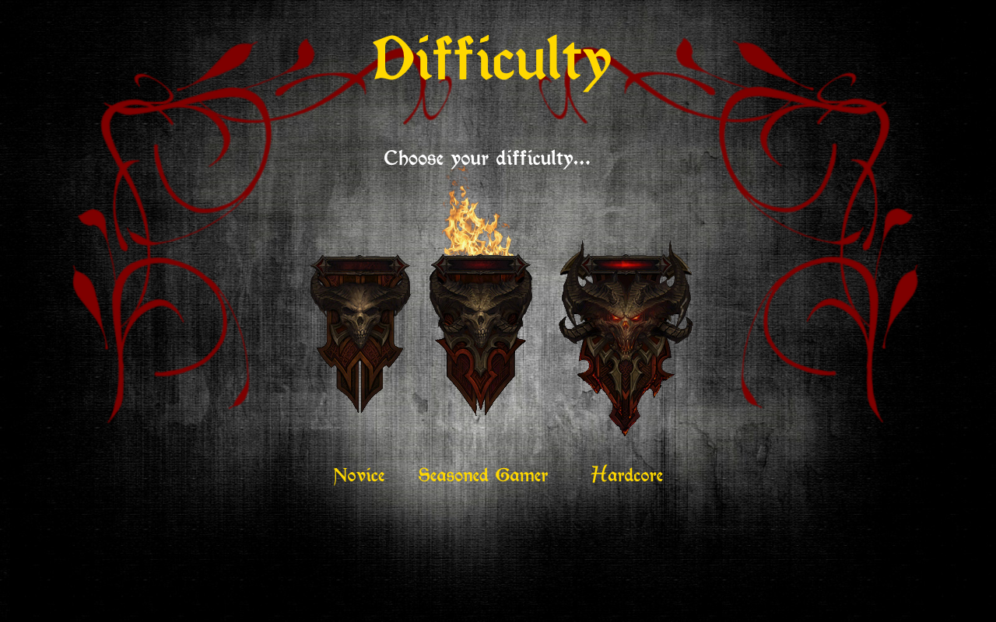

***Instructions at the start of the game***

After having chosen a difficulty level, the player will briefly be prompted with a screen that provides a set of instructions.

The game is in English, but you have the opportunity to read the instructions in either English or Dutch.

***English***

Welcome to *A Tale of Crimson: the escape game*. Your biggest adventure is about to begin.

The year is 1463. You return home to England a true hero after having fought many epic wars. Horrible images haunt your mind and nightmares corrupt your soul. Something is inside of you and is trying to escape your body. This corruption has tainted many of your memories and in various cases a white blank is all that remains. You sense that the cure lies deep within Lovecraft Manor, which is home to you and your significant other.

Although your name resonates legendary tales of mystical beings that you have defeated to protect the human race, your most important quest is yet to be completed. You are here to stop whatever is corrupting your soul and rescue the one that means the most to you. You wear what Sages call the Armour of The Night: divine battle-gear worn by the greatest of warriors.

Learn about your past and who you really are by collecting Lore books, Diary entries and War notes. These will be stored for you to read in your inventory – which can be opened by pressing **i** - along with any other item that you obtain. Collecting, searching and hunting may just yield you something extra…

The time is now: go and do not be swayed by The Depths or Darkness. Fight until your very last breathe, for time is not on your side. *Do not go gentle into that good night…*

*At any given instant, you can pause the game by pressing* ***p****; to unpause, press* ***p*** *again. To close a Lore book, click the torn page icon on the last page; to close a Diary entry, click the quill and to close a War note, click the cross.*

***Nederlands***

Welkom bij *A Tale of Crimson: the escape game*. Je staat op het punt om het grootste avontuur mee te maken.

We schrijven 1463. Je keert terug naar Engeland als een ware held na vele overwinningen. Vreselijke beelden spoken rond tussen je gedachten en nachtmerries tarten je ziel. Er zit iets in je wat probeert om te ontsnappen. Dit bederf heeft vele van je herinneringen aangetast en in verscheidene gevallen blijft slechts een wit beeld over van wat je ooit hebt gekend. Je voelt dat de oplossing in het hart van Lovecraft Manor ligt, waar jij en je geliefde wonen.

Niettegenstaande je naam resoneert in legendarische verhalen over mystieke wezens die je verslagen hebt om het mensdom van zijn ondergang te beschermen, is het moment aangebroken om je belangrijkste queeste tot een goed einde te brengen. Je bent hier om het bederf tegen te houden en je geliefde te redden. Je draagt wat Oude Geleerden het Harnas der Nachten noemen: een goddelijke gevechtsuitrusting die alleen de grootste der helden waard zijn.

Leer over je verleden en wie je echt bent door Lore books, Diary entries en War notes te verzamelen. Deze worden allemaal bijgehouden in je *inventory* – wat geopened kan worden door op **i** toets te drukken –, samen met alle andere objecten die je verzameld hebt. Verzamelen, zoeken en jagen kunnen je misschien wel iets extra opleveren…

De tijd der tijden is aangebroken: ga nu en laat je niet verleiden door de Dieptes en het Donker. Vecht tot je laatste adem, want de tijd staat niet aan jouw kant. Verga niet zachtjes in het donker van de nacht…

*Op eender welk moment kan je het spel pauzeren door op de* ***p*** *toets te drukken; om dit ongedaan te maken, druk je nogmaals op* ***p****. Om een Lore book te sluiten, blader je volledig naar het einde door en klik je op de gescheurde bladzijde; om een Diary entry te sluiten, klik je op de veer en om een War note to sluiten, klik je op het kruis.*

# Bijlage 10: Manual

A walkthrough of all the items and interactions in all twenty rooms.

**Room 1: Observatory**

As the player enters the game he finds himself in room 1: the Observatory.

1. Clicking the chest: “ *If only I had a key…*”
2. Clicking the window: “*Full moon*”
3. Clicking the orb hanging from the ceiling: “*One of mother’s odd objects.*”
4. Clicking the orb hanging from the ceiling: “*One of mother’s odd objects.*”
5. Clicking the hourglass: “*Whenever I read, time seemingly freezes.*”
6. Click the ink bottle on the desk to acquire some ink and a quill.
7. This is the clickable scroll “A note to myself.” It provides brief background information about the story and the game.
8. Click the bag to open the inventory. This can be done in every room.
9. Click here to continue to room 2.

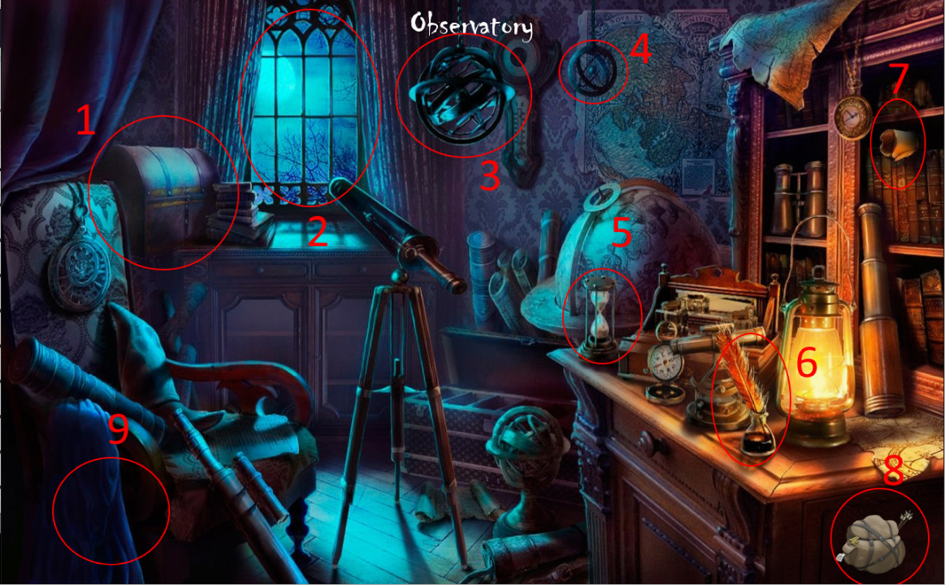

**Room 2: Eden’s hideout**

The player enters room 2: Eden’s hideout. A message appears in the middle of the screen: “*Keys are scattered throughout rooms. A voice in your head tells you that you should look for one in this room.”*

1. Click the shield to obtain it. This shield is needed to proceed from room 14 to room 15.
2. Click the key to collect it. This key is used to open the chest in room 1.
3. Clicking on the bed: “*Vlad would not like this.*”
4. Click the vial to collect it. This is the Elixir of Rejuvenation and is to be used in room 18: the Ritual.
5. This is Lore book 01.
6. These are clickable portraits that depict some of the story’s main characters. The code which is required to pass room 11 is found on the centre portrait.
7. Click here to go back to room 1.
8. Click here to continue to room 3.

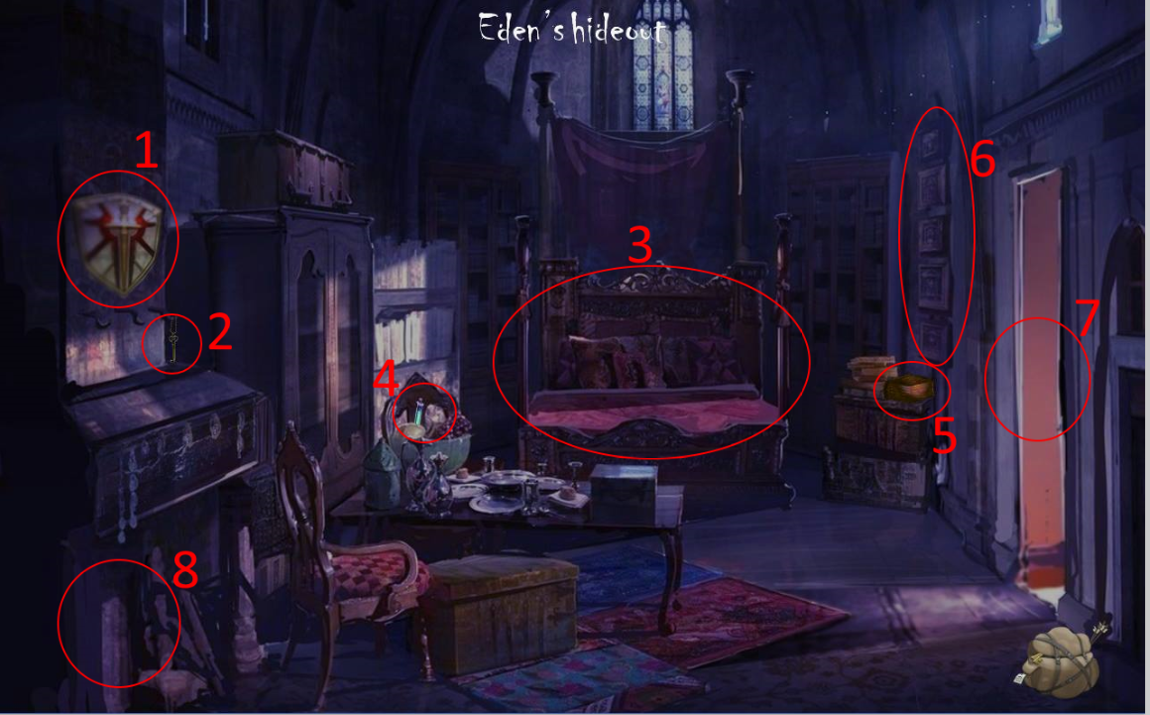

**Room 3: Hallway**

The player enters room 3: the Hallway.

1. Click the Amulet of Piercing Light to collect it. It is needed to brighten room 11 and make the demon appear.
2. The entrance to room 7 is blocked due to a curse: *“You ought to first let the Light shine upon thine eyes.”* This means that the player has to click the lantern outside in room 4, such lifting the curse and allowing the player to proceed to room 7.
3. The wall chandelier (4) has to be lit and the rope ladder, which can be found in room 4, has to be obtained to enter room 19.
4. Collect the torch from room 10 to light the wall chandelier.
5. Click the doorknob to enter room 4.
6. Click here to go back to room 2.
7. Click here to continue to room 5.

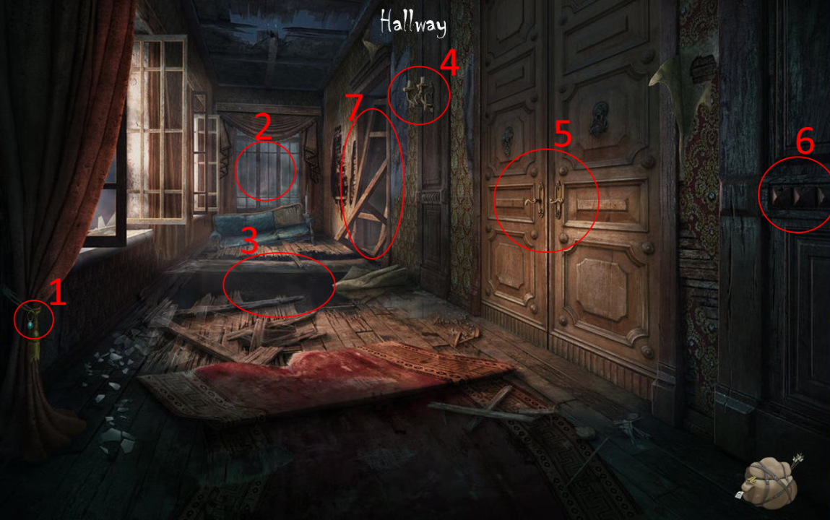

**Room 4: Balcony**

The player enters room 4: the Balcony.

1. Click one of the lanterns to lift the curse in room 3 allowing the player to proceed to room 7.
2. Acquire the Aetherian glove in room 9 to obtain Lightbringer.
3. Click here to go back to room 3.
4. Click the rope ladder to obtain it.
5. The balcony is not an exit. A demon prevents the player from escaping.

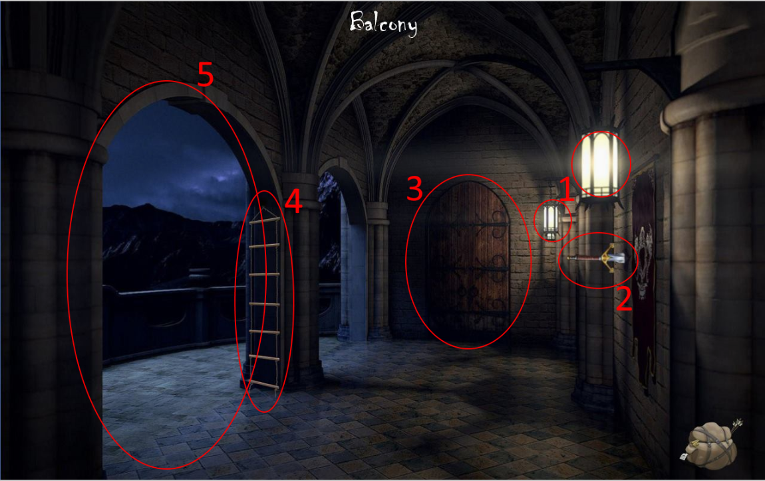

**Room 5: Master bedroom**

The player enters room 5: the Master bedroom.

1. Click here to go back to room 4.
2. Click here to continue to room 6.
3. These are clickable portraits that depict some of the story’s characters.
4. Clicking on the puzzle box: “*You acquire an unusual puzzle box. Use the table in this room to solve it.”* This is Dark Sage Ganex’ puzzle box.
5. Click the book to obtain Eden’s diary. *“This is Eden’s diary, but pages seem to be missing.”*
6. Click the table to open the puzzle. If the player solves the sliding puzzle inside, he is given the Lovecraftian dagger.

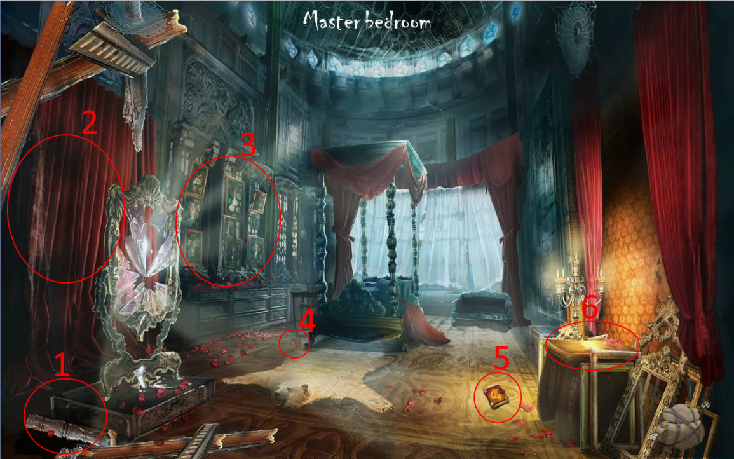

**Room 6: Chamber of Wisdom**

The player enters room 6: the Chamber of Wisdom.

1. Click here to go back to room 5.
2. Clicking the globe: *“The world as we know it.”*
3. This is War note 01.
4. This is Djinn Murad’s genie lamp and is to be used in room 18.
5. This is Lore book 02.
6. Clicking the blackboard: *“Eden must have been studying these creatures.”*
7. This is key 02.

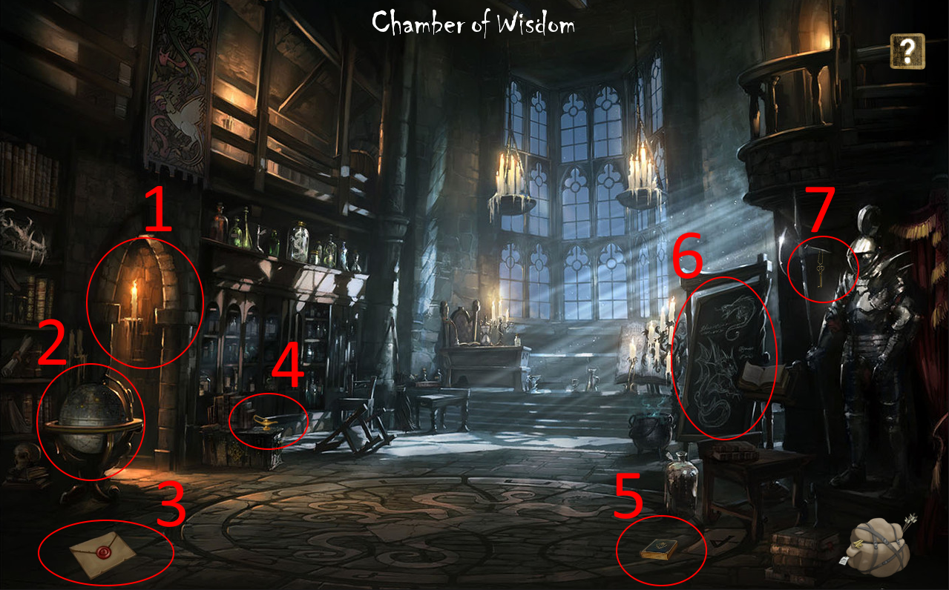

**Room 7: Study**

The player enters room 7: the Study.

1. When trying to sit on the chair: *“I don’t have time for this.”*
2. Click here to continue to room 8.
3. This is War note 02.
4. This is key 03.
5. Click the chest to obtain Lore book 03.
6. Click here to go back to room 4.
7. Click the bookcase to open Diary entry 01.

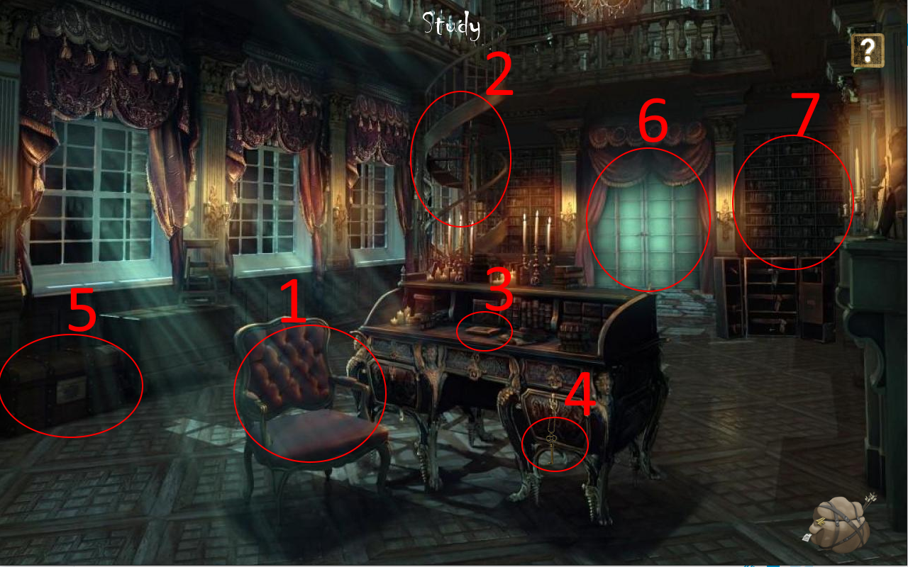

**Room 8: War room**

The player enters room 8: the War room.

1. Click here to go back to room 7.
2. Clicking the banner: *“Typical youthful protest posters.”*
3. This is Diary entry 02.
4. This is War note 03.
5. The statue slides downward when clicked, thus opening a portal that leads to room 9.
6. Clicking the kettle: *“I don’t have time for a cuppa!”*
7. This is Lore book 04.
8. Click here to continue to room 10.

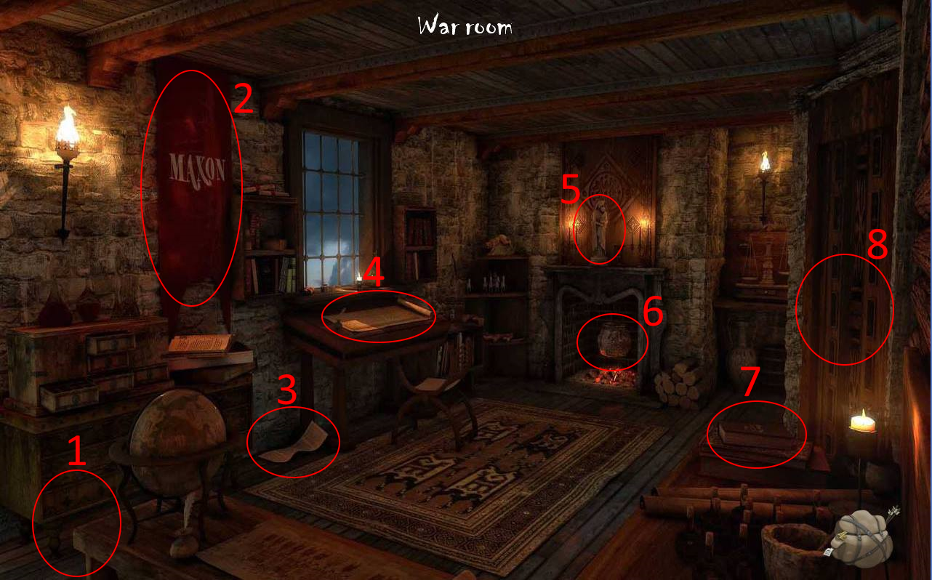

**Room 9: Library**

The player enters room 9: the Library.

1. Click the heads of both statues within 5 seconds to open a portal that leads back to room 8.
2. Click the Aetherian glove to obtain it. This object is used in room 4 to pull the Lightbringer from the wall and also finds its use in room 18.
3. Clicking on the bookcases: “*You search through the books, but can’t find anything of interest.*”
4. This is key 04.
5. Clicking on this bookcase opens Lore book 05.
6. This is Diary entry 03.
7. Click the chess piece to unlock achievement 7.
8. This is Lore book 06.

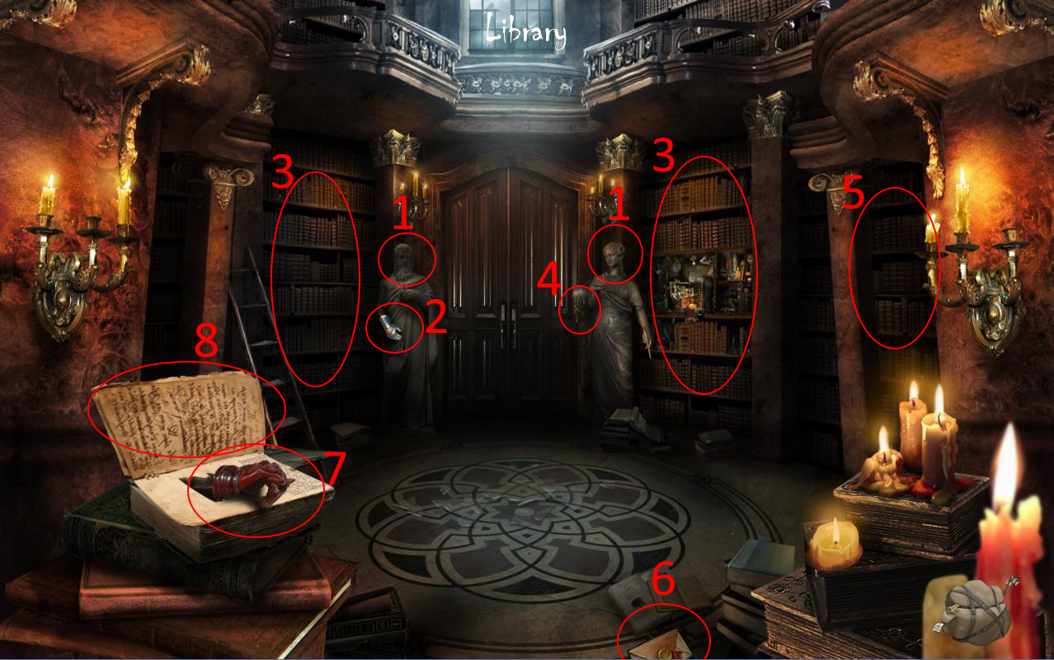

**Room 10: Basement corridor**

The player enters room 10: the Basement corridor.

1. Click one of the braziers to obtain a torch, used to light the wall chandelier in room 3.
2. Room 11 becomes accessible after the Lovecraftian dagger is obtained in room 5 by solving the puzzle. Double-click to enter room 11.
3. Click here to continue to room 14.

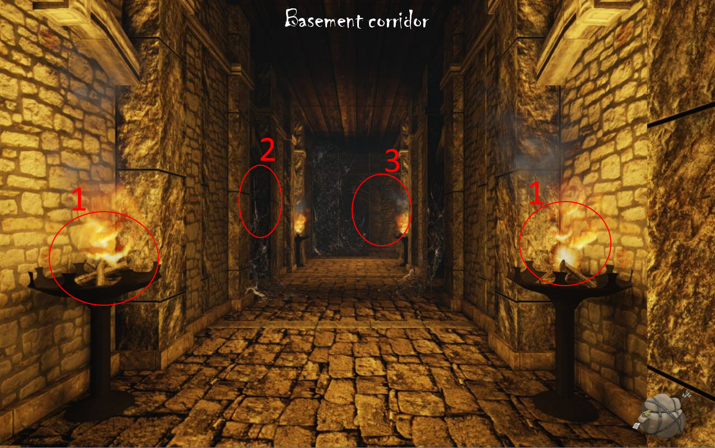

**Room 11: Dungeon corridor**

The player enters room 11: the Dungeon corridor.

1. Room 11 is haunted by dark forces that shall fade away as soon as the player has acquired the Amulet of Piercing Light, which can be found in room 3. These dark forces are embodied by a demon that requires a passcode from the player. This passcode, 1424 - Eden’s birthdate -, can be found in room 2 on the centre portrait. Click to continue to room 12.
2. Click here to go back to room 10.

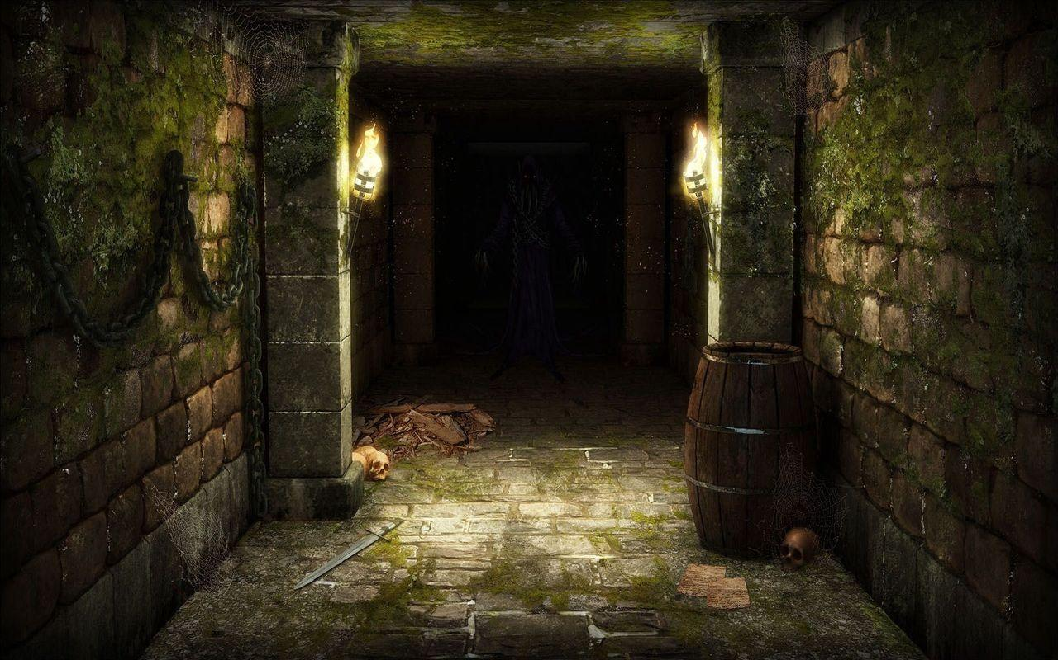

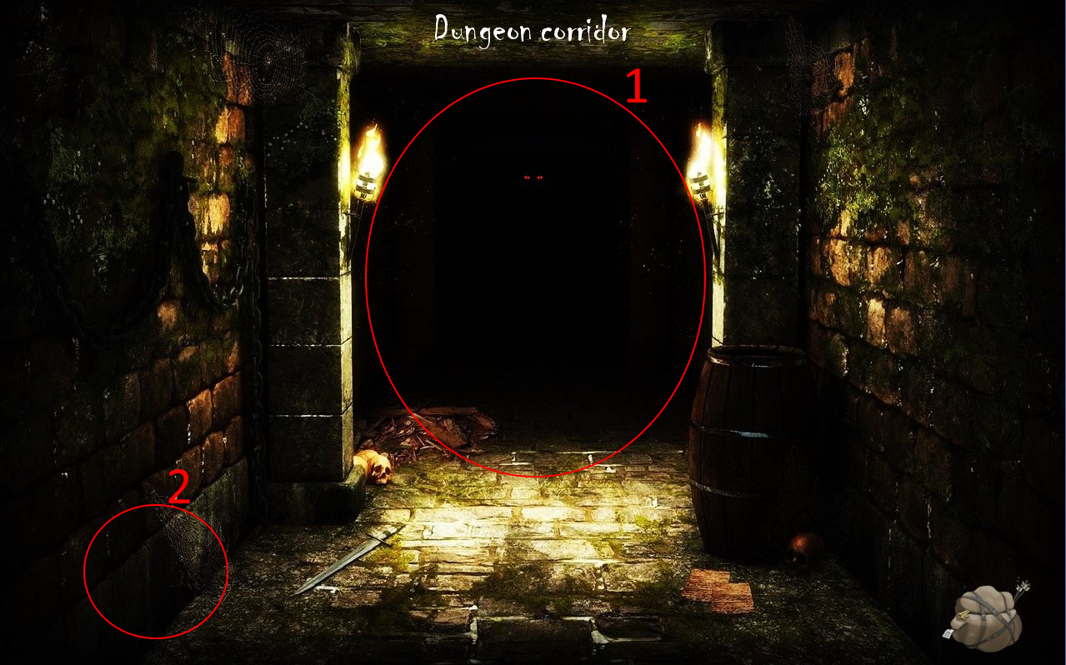

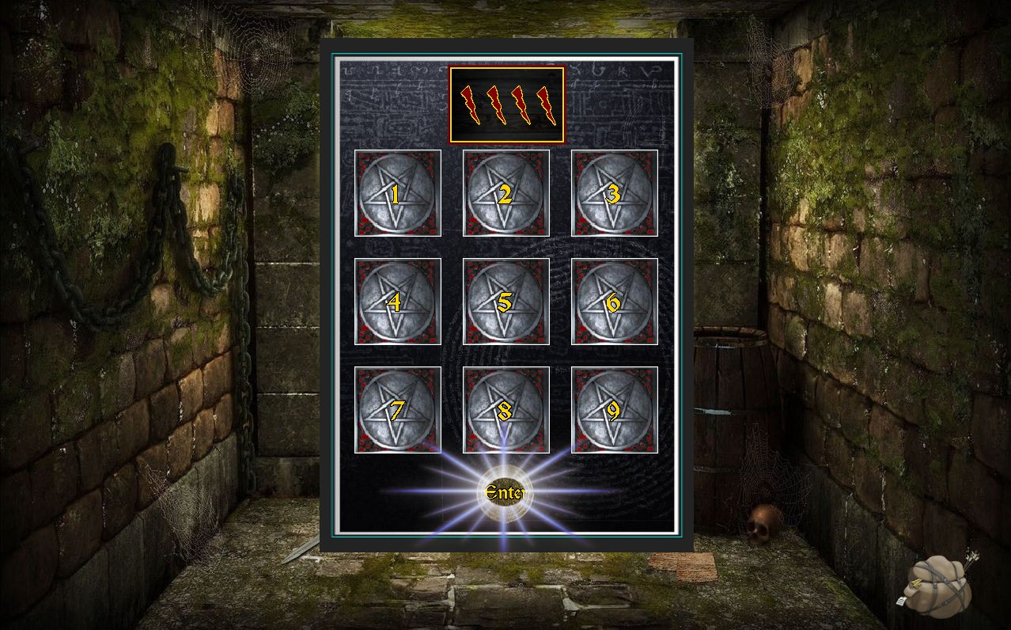  
  
  
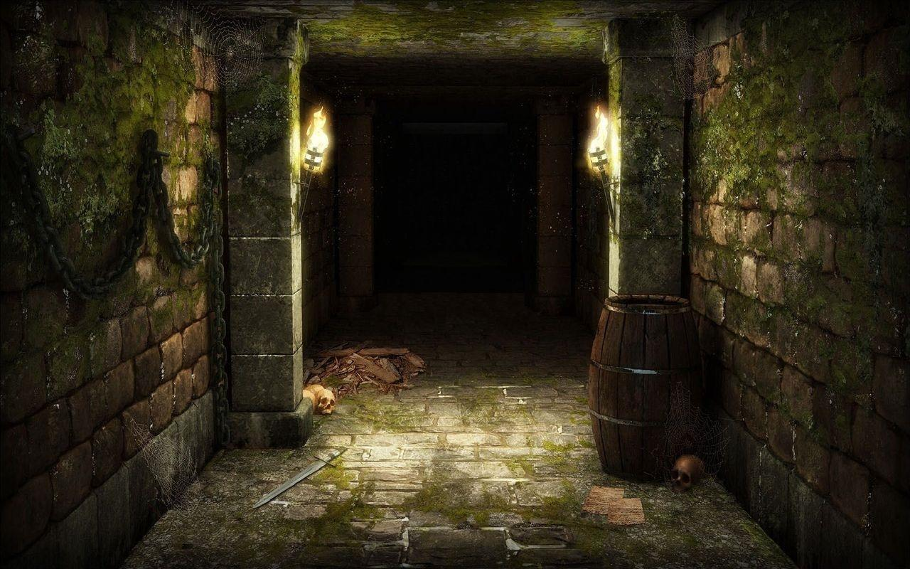

**Room 12: Path of Truth**

The player enters room 12: the Path of Truth.

1. Click here to go back to room 11.
2. Click here to continue to room 13. A jumpscare will pop.  
     
     
   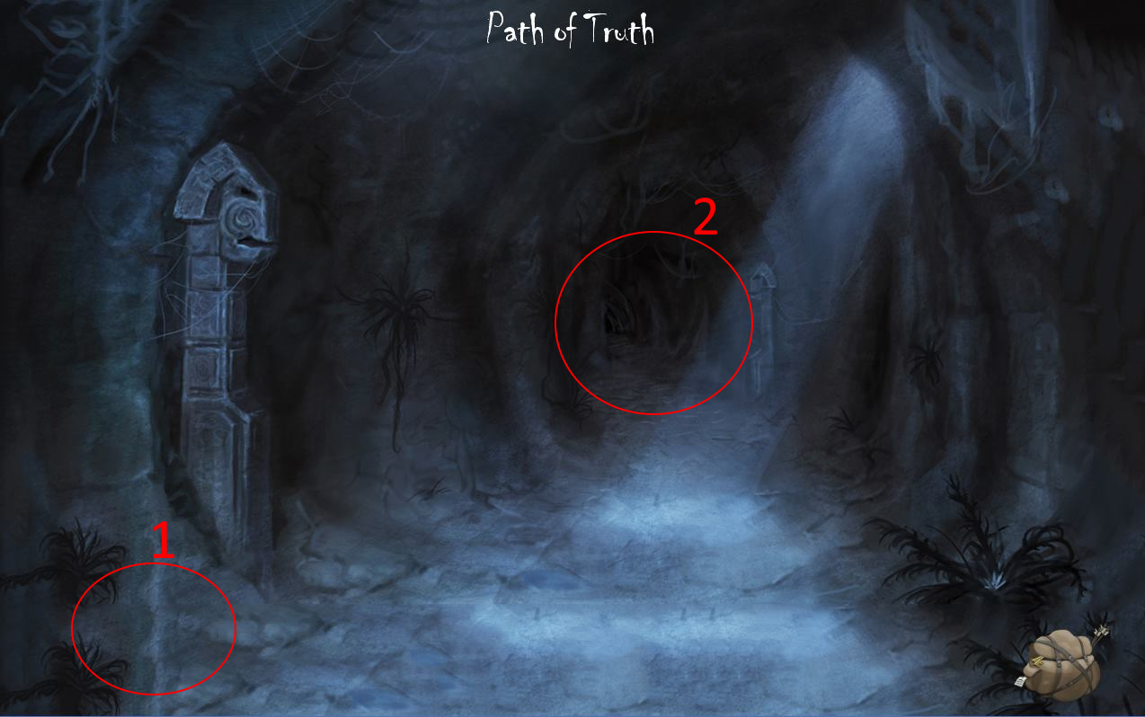

**Room 13: Fountain of Truth**

The player enters room 13: the Fountain of Truth.

1. Click here to go back to room 12.
2. Insert Lightbringer, found in room 4, in the Fountain of Truth to obtain Diary entry 04. The Fountain of Truth is henceforth activated.

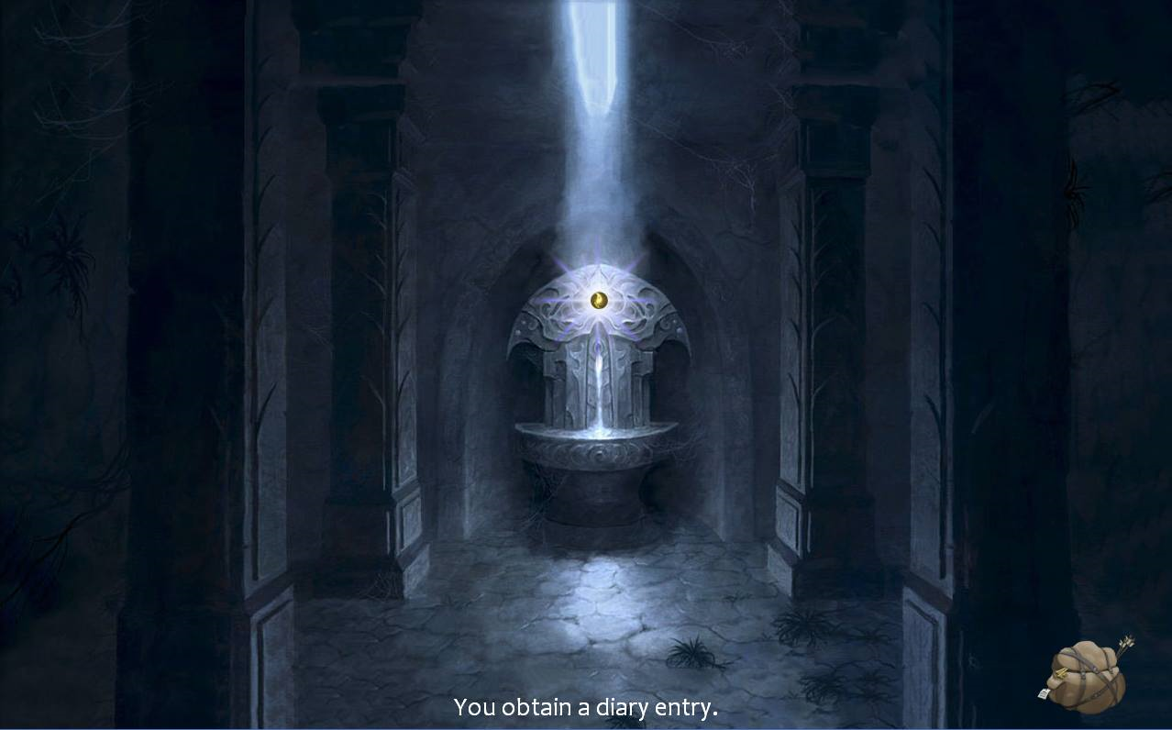

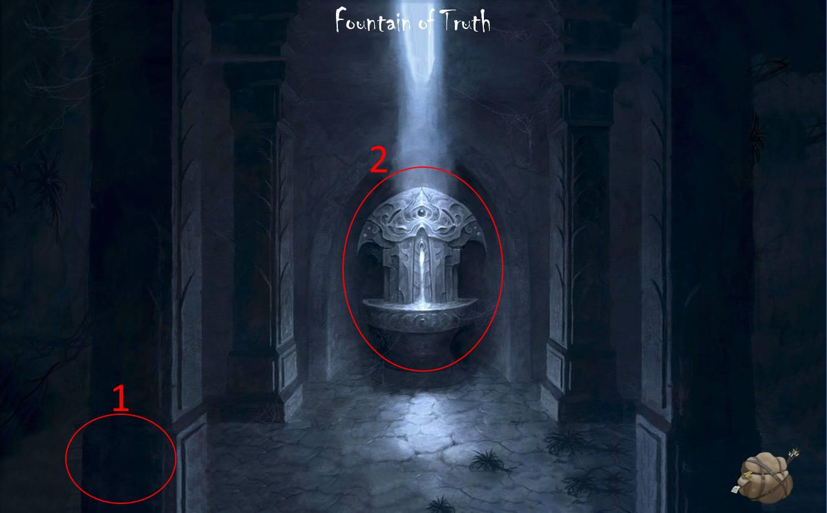

**Room 14: Workshop**

The player enters room 14: the Workshop.

1. Room 15 becomes accessible upon completion of the shield-minigame. After having obtained the shield from room 2, click on the anvil: *“You fuse your blood with the shield.”*Subsequently, click on the mouth of the furnace:  *“I am satisfied. You may pass.”* Click on the door to continue to room 15.
2. If the shield is yet to be collected or repaired: *“If I had some sort of shield or sword, I could perhaps smith something.”*
3. If the shield is yet to be collected or repaired: *“ I hunger for metal, human…”*
4. This is Diary entry 05.
5. Click here to go back to room 10.

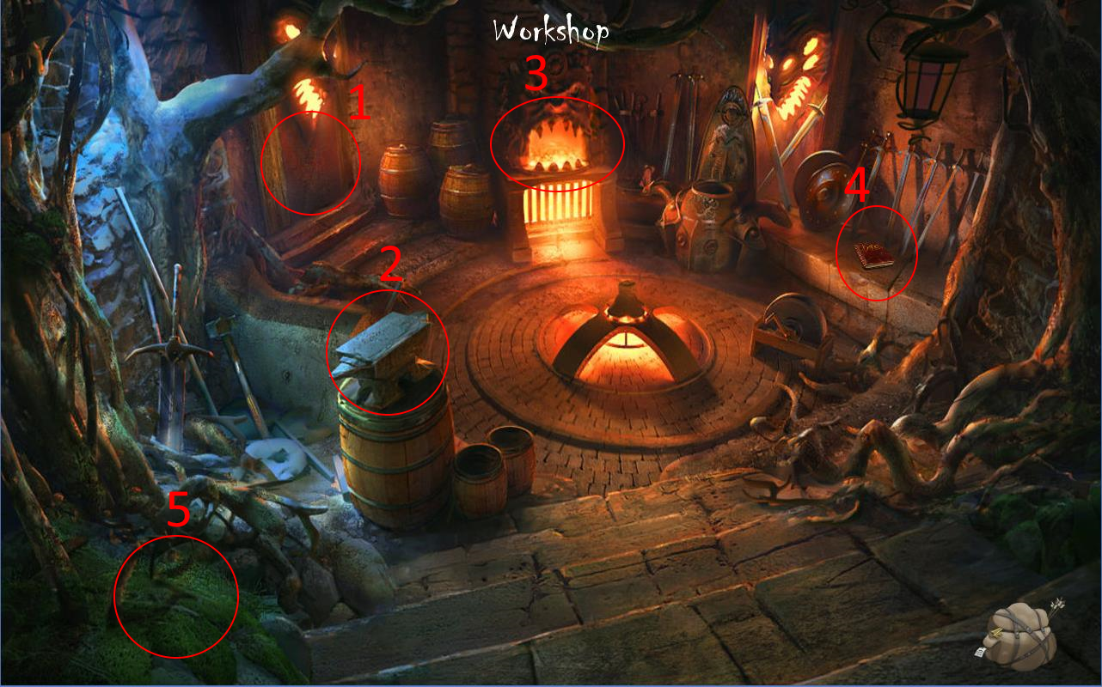

**Room 15: Dungeon tunnel**

The player enters room 15: the Dungeon tunnel.

1. Click here to go back to room 14.
2. This is key 05.
3. Click here to continue to room 16.

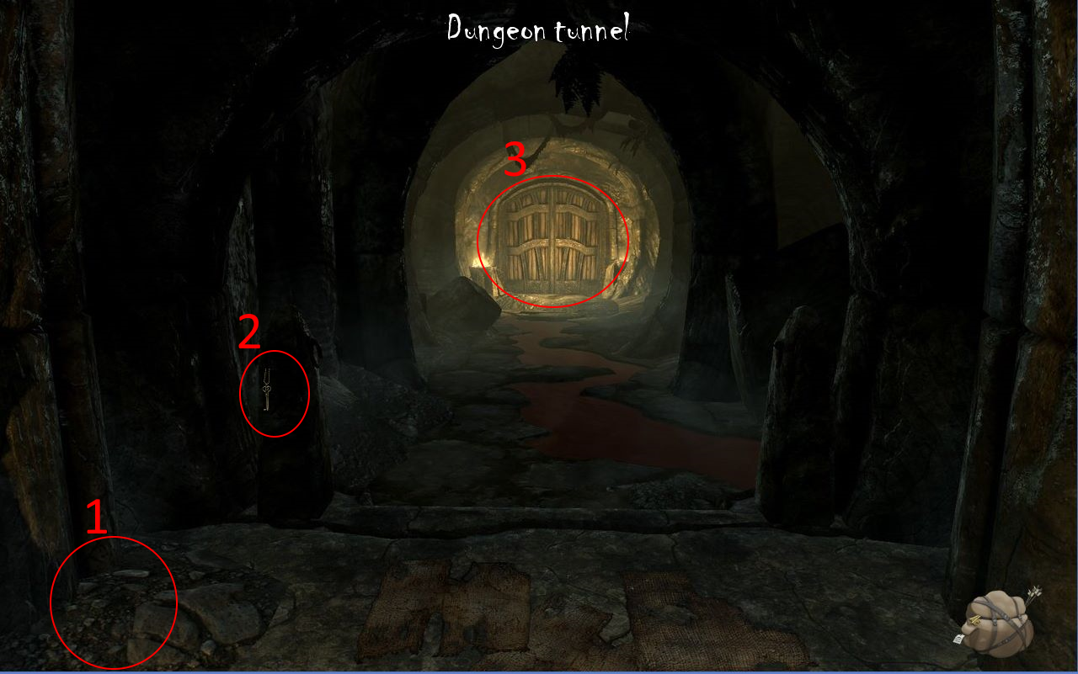

**Room 16: Basement**

The player enters room 16: the Basement.

1. Click here to go back to room 15.
2. Click here to continue to room 18.
3. Click here to continue to room 17.

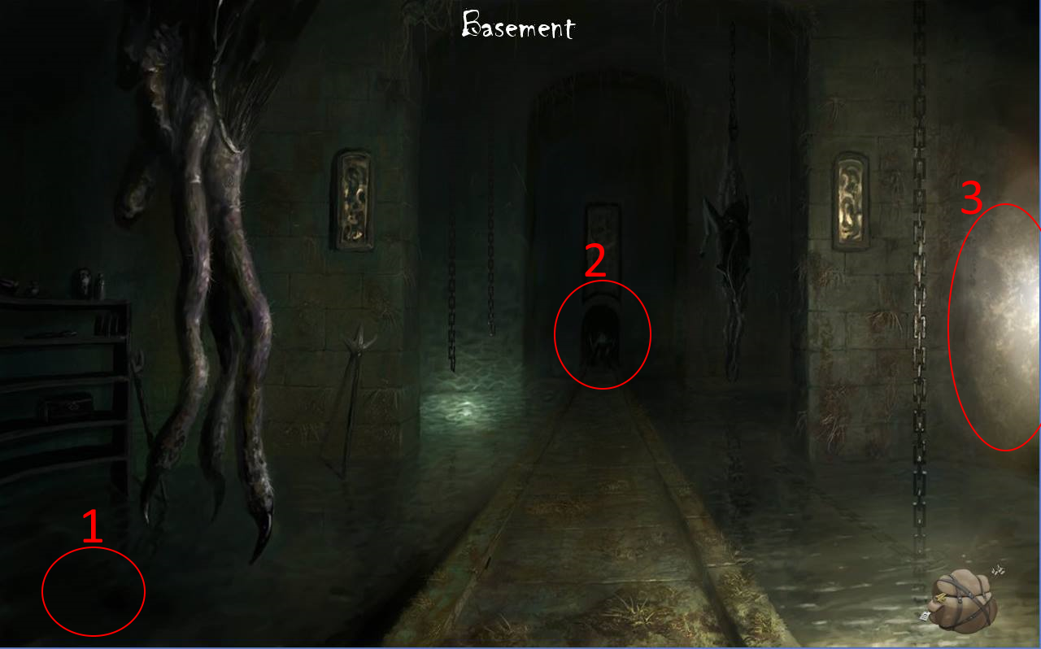

**Room 17: Wine cellar**

The player enters room 17: the Wine cellar.

1. Click here to go back to room 16.
2. Click the wine to collect it: “A fine wine.” This wine is needed to fill the wine glass in room 20.
3. This is Diary entry 06.  
     
   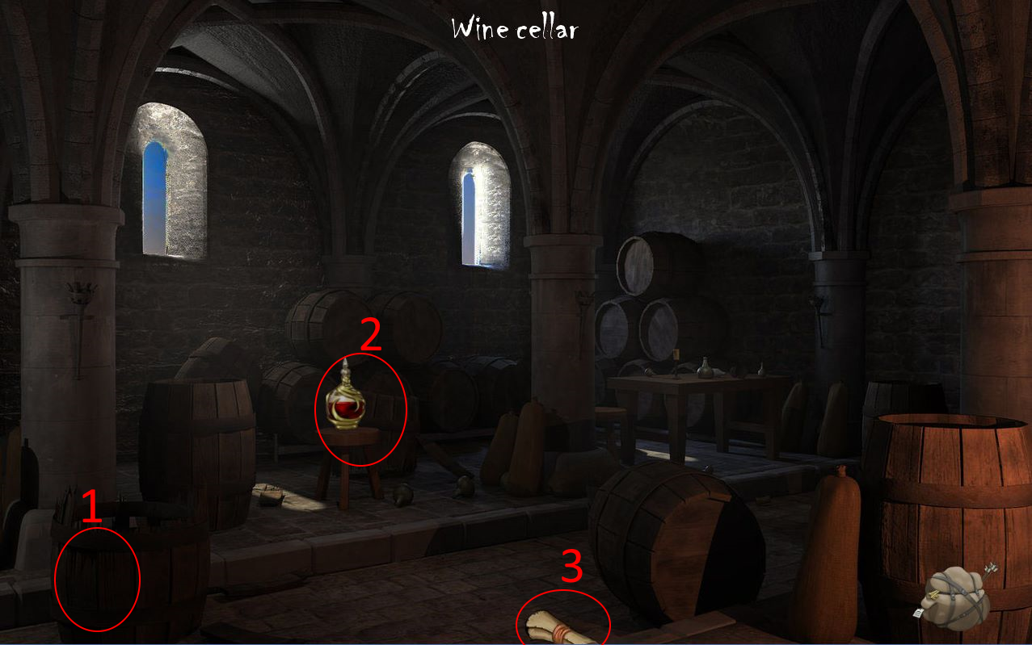

**Room 18: The Ritual**

The player enters room 18: The Ritual.

1. Click here to go back room 17.
2. This is Lore book 07.
3. This is the ritual that shall cleanse Eden. In order to perform the ritual the player will need six items:

* The Elixir of Rejuvenation;
* The Amulet of Piercing Light;
* Lightbringer;
* The Aetherian glove;
* The Lovecraftian dagger;
* Djinn Murad’s genie lamp.

Eden is now cured. This allows him access to room 20’s endgame.

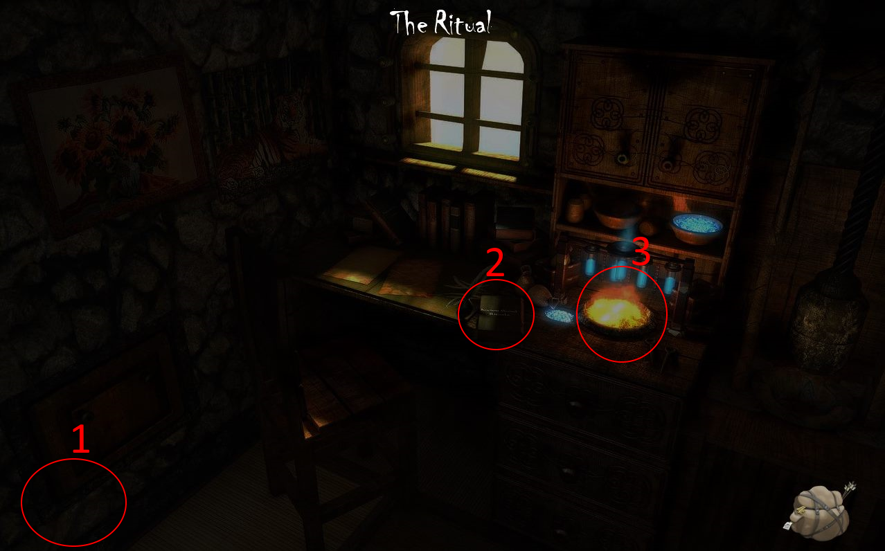

**Room 19: Eden’s Memory**

The player enters room 19: Eden’s Memory.

1. Click here to go back to room 3.
2. Click the mirror: if the ritual in room 18 is yet to be completed, a picture of cursed Eden will be shown. If the ritual in room 18 has been completed, a picture of cured Eden will be shown.
3. If all six keys throughout the map have been obtained, the chest will unlock and the Amulet of Understanding is obtained.
4. Click here to continue to room 20. A jumpscare pops: *“Djinn Murad, we meet again…”*
5. Click to view a portrait of Olivia.
6. This is key 06.
7. This is Diary entry 07.

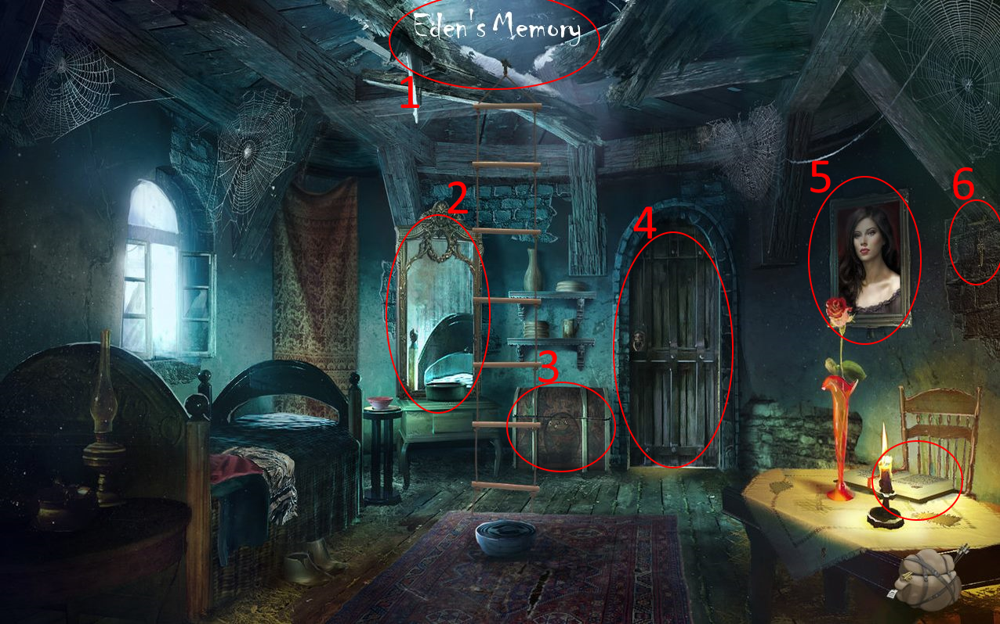

**Room 20: Two-Faced**

The player enters room 20: Two-Faced.

1. Click to view a portrait of Olivia: “*My dearest Olivia… I am coming for you.*”
2. Clicking the wine glass: Eden will pour the wine into the glass and, upon clicking a second time, will drink from it. If the ritual in room 18 has been completed and all Diary entries have been collected, Eden enters the endgame: “*You take a sip of wine. It burns your inside. Face your Nightmare.”*
3. This is Lore book 08.
4. This is War note 04.
5. Click here to go back to room 19.  
     
   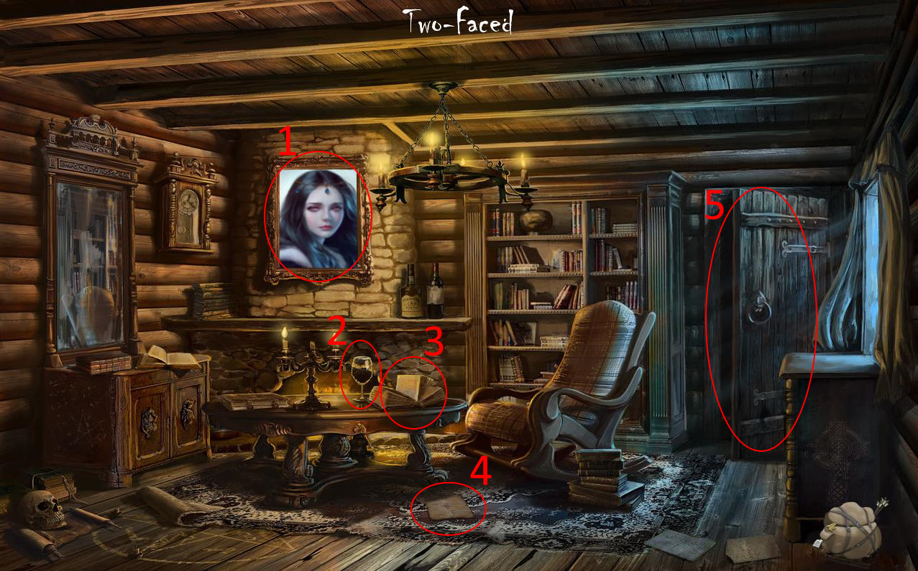

End Game

# Bijlage 11: UML diagrammen

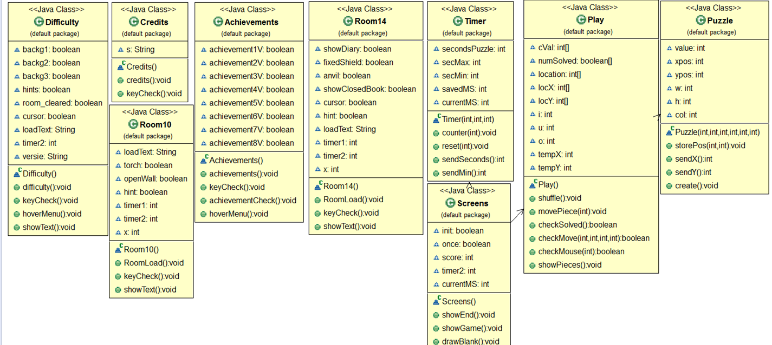

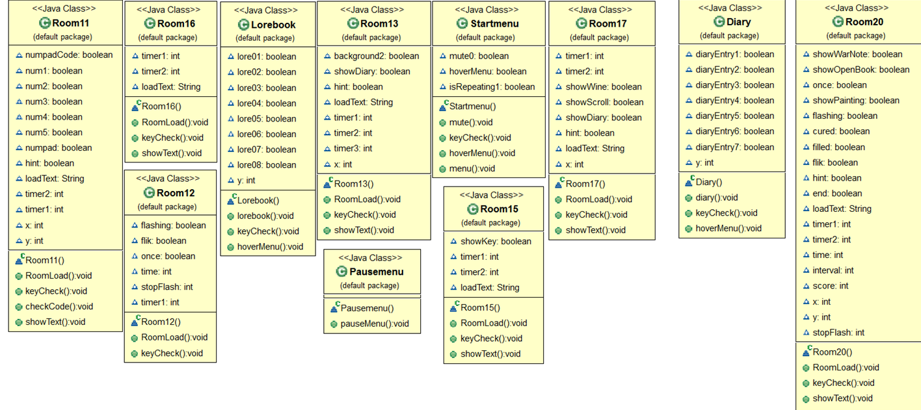

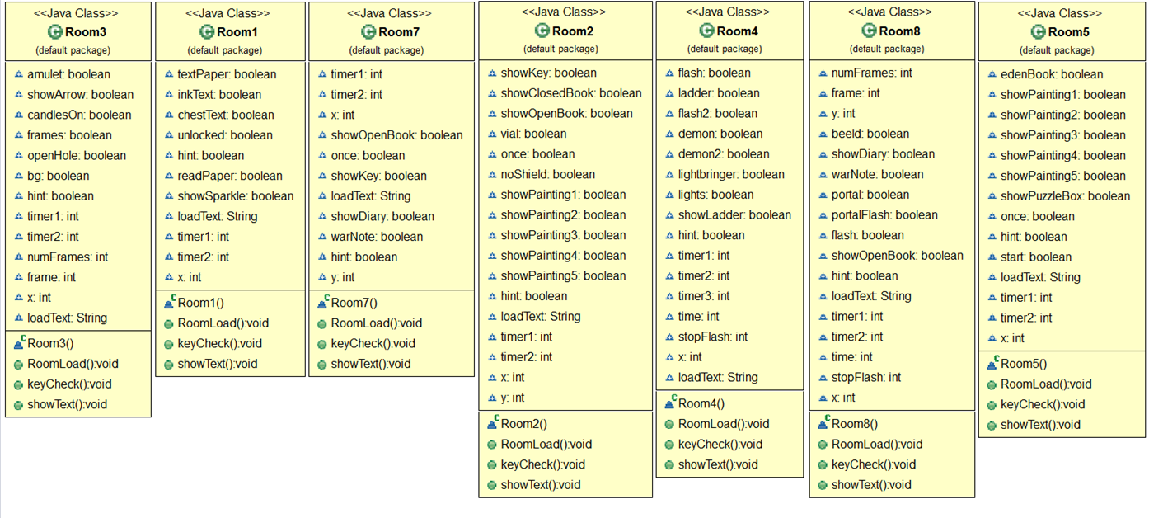

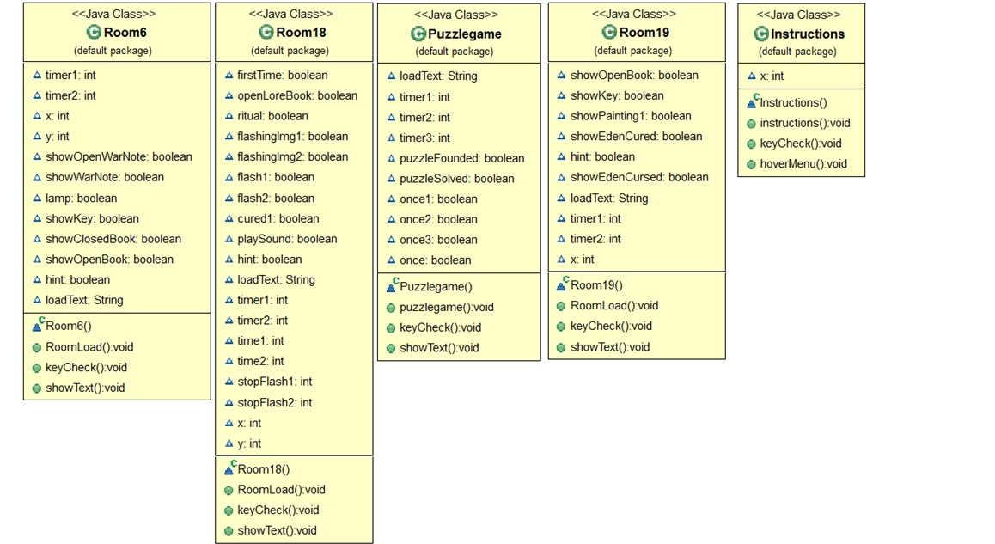

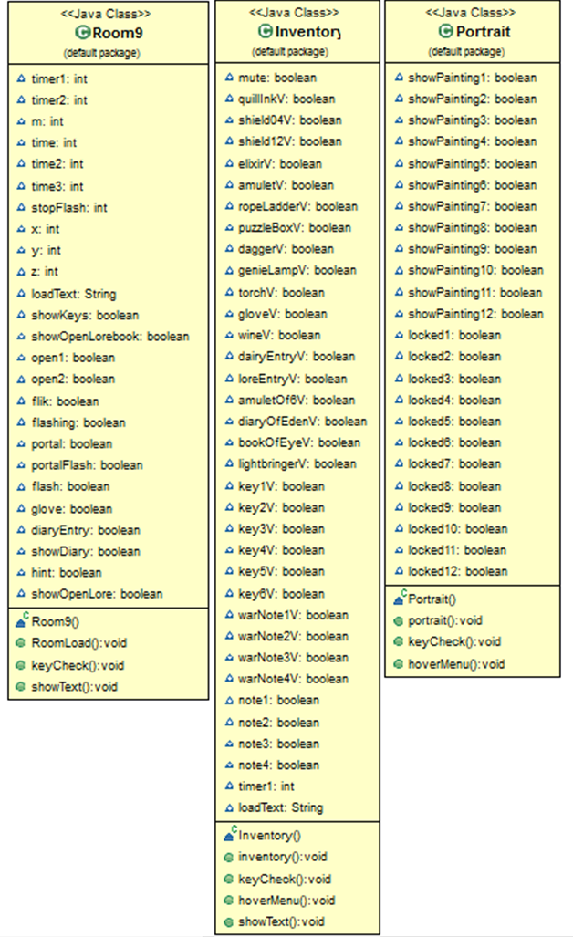

# Bijlage 12: PowerPoint presentatie (slides)

